

DAEN 690

**Project Report**

Team Members

Yumna Zaidi

Neehar Bujimalla

Sohan Bommidi

Venkata Karanveer Bejjam

Saikiran Reddy Komatireddy

Fall 2023

**Augmenting Data Catalogs by Incorporating Data Fitness Distributions**

**Contents**

**Table of Contents**

1 Problem Definition 3

1.1 Background 3

1.1.1 Data Management Techniques 3

1.1.2 Data Catalog 4

1.1.1 Metadata 5

1.2 Problem Space 7

1.3 Research 9

1.3.1 Research Summary 9

1.3.2 Defining Comprehensive Data Fitness Metrics 9

1.3.3. Ensuring Standardization and Consistency 10

1.3.4. Integration with Existing Data Catalog Systems 10

1.3.5. Facilitating User Adoption and Understanding 10

1.3.6. Opportunities and Impact 10

1.3.7. What are the hyperparameters which we can use to find data fitness? 10

1.3.8. Methods for extracting from hyperparameters and metadata 12

1.4 Solution Space 13

1.4.1 Solution Approach 13

1.4.2 Solution Space 13

1.5 Project Objectives 14

1.6 Primary User Stories 14

1.7 Product Vision 16

1.7.1 Scenario #1 16

1.7.2 Scenario #2 16

2 Datasets 17

2.1 Overview 17

2.2 Field Descriptions 17

2.3 Data Context 18

2.4 Data Descriptions 18

2.5 Data Conditioning 18

2.6 Data Quality Assessment 18

2.6.1 Data Completeness & Data Consistency for Datasets 19

2.6.2 Outlier Detection and Analysis 24

2.6.3 Statistics Summary 26

2.6.4 Categorical Cardinality 28

2.7 Data Sources 32

2.8 Storage Medium 32

2.9 Storage Security 32

2.10 Storage Costs 33

3 Algorithms & Analysis / ML Model Exploration & Selection 33

3.1 Solution Approach 33

3.1.1 Data Flow Diagram (Schematic Flow) 33

3.1.2 General Parameters 34

3.1.3 Fitness Scores based on General Parameters 38

3.1.4 Data Flow for Domain-based Feature Extraction 40

3.1.5 Features Extraction for Domain (Relevance) 41

3.1.5.1 Determining Granularity 43

3.1.5.2 Determining Epidemiological value 44

3.1.5.3 Determining Economic Significance 45

3.1.5.4 Dataset Sensitivity and Relationship Score Analysis Report 47

3.1.6 Data frame with Overall Fitness Score 50

Fig 41-Data frame with Overall Fitness Score 50

3.1.7 Thumbnail Features 50

3.1.7.1 Summarized Dataset Description using Text Summarization 50

3.1.7.2 Key Topics Extraction using Topic Modeling 52

3.2 Machine Learning 57

3.2.1 Model Exploration 57

UMAP 57

3.2.2 Model Selection 58

4 Visualizations / ML Model Training, Evaluation, & Validation 60

4.1 Overview 60

4.1.1 Data Fitness Augmentation 60

4.2 Visualizations 61

4.2.1 Loan_Default Dataset 61

4.2.2 Bank Churners Dataset 65

4.2.3 Hospital Mortality Dataset 71

4.2.4 HDHI (Hero DMC Heart Institute) Dataset 74

4.3 Machine Learning 79

4.3.1 Model Training for Topic Modeling using LDA 79

4.3.2 Model Training for UMAP 84

4.3.3 Model Evaluation 86

5 Findings 88

6 Summary 92

7 Future Work 92

Appendix 94

Appendix A: Glossary 94

Appendix B: GitHub Repository 95

Appendix C: Risks 96

Appendix D: Agile Development 101

Reference 103

**Table of Figures**

Figure 1: Data management techniques 4

Figure 2: Data cataloging process 5

Figure 3: Types of metadata 6

Figure 4: Datasets used 17

Figure 5: Missing Values: Dataset 1, Dataset 2 20

Figure 6: Missing Values By Attribute: Dataset 1 20

Figure 7: Missing Values By Attribute: Dataset 2 21

Figure 8: Missing Values By Attribute: Dataset 3 21

Figure 9: Missing Values by Attribute: Dataset 4 22

Figure 10: Duplicate Records for Dataset 1 22

Figure 11: Duplicate Records for Dataset 2 23

Figure 12: Duplicate Records for Dataset 3 23

Figure 13:Duplicate Records for Dataset 4 24

Figure 14: Outliers: Dataset 1 25

Figure 15: Outliers: Dataset 2 25

Figure 16: Outliers: Dataset 3 25

Figure 17:Outliers for 4 Datasets 26

Figure 18: Summary Statistics: Dataset 1 27

Figure 19: Summary Statistics: Dataset 2 & 3 27

Figure 20: Summary Statistics for 4 Datasets 28

Figure 21: Unique Value Counts: Dataset 1 & 2 29

Figure 22: Unique Value Counts: Dataset 2 30

Figure 23: Categorical Cardinality: Dataset 1 31

Figure 24: Categorical Cardinality: Dataset 2 31

Figure 25: Categorical Cardinality 4 Datasets 32

Figure 26: Schematic Flow 33

Figure 27: Overall Quality Score for 4 Datasets 35

Figure 28: Quality Score for Outliers 4 Datasets 36

Figure 29: Quality Score for Statistical Summary: Dataset 4 37

Figure 30: Quality Score for Categorical Cardinality: Dataset 4 38

Figure 31: Overall Quality Scores: Dataset 1 & 2 39

Figure 32: Overall Quality Scores: Dataset 3 & 4 40

Figure 33: Fitness Scores based on General Parameters for 4 Datasets 40

Figure 34: Schematic for Domain-Based Features Extraction 41

Figure 35: Viz of Information Entropy for our datasets 43

Figure 36: Word Cloud for HDHI Data – Column Matches 44

Figure 37: Word Cloud for Epidemiological Corpus 44

Figure 38: Economic Significance Metrics 46

Figure 39: Viz for Data Sensitivity of 4 datasets 47

Figure 40: Comprehensive Correlation Analysis 48

Figure 41: Data frame with Overall Fitness Score 48

Figure 42: Flow Chart for Text Summarization Algorithm using NLP 50

Figure 43: Topic distribution in Finance Domain 55

Figure 44: Topic distribution in HealthCare Domain 56

Figure 45: Data Completeness for Loan Default Dataset 60

Figure 46: Data Consistency for Loan Default Dataset 61

Figure 47: Outlier Detection for Loan Default Dataset using Boxplot 62

Figure 48: Summary Statistics for Numerical Columns of Loan Default Dataset 63

Figure 49: Categorical Cardinality for Loan Default Dataset 63

Figure 50: Quality Scores for Loan Default Dataset 64

Figure 51: Data Completeness for Bank Churners Dataset 65

Figure 52: Data Consistency for Bank Churners Dataset 66

Figure 53: Outlier Detection for Bank Churners Dataset 67

Figure 54: Summary Statistics for Bank Churners Dataset 68

Figure 55: Categorical Cardinality for Bank Churners Dataset 69

Figure 56: Quality Scores for Bank Churners Dataset 69

Figure 57: Data Completeness for HMP Dataset 70

Figure 58: Data Consistency for HMP Dataset 70

Figure 59: Outlier Detection for HMP Dataset using Box Plots 72

Figure 60: Summary Statistics for HMP Dataset 73

Figure 61: Categorical Cardinality for HMP Dataset 73

Figure 62: Quality Scores for HMP Dataset 74

Figure 63: Data Completeness for HDHI Dataset 75

Figure 64: Data Consistency for HDHI Dataset 75

Figure 65: Outlier Detection for HDHI Dataset using Box Plots 76

Figure 66: Summary Statistics scores for HDHI Dataset 77

Figure 67: Categorical Cardinality for HDHI Dataset 77

Figure 68: Quality Scores for HDHI Dataset 78

Figure 69: Dataset Evaluation Metrics for 4 Datasets 79

Figure 70: Topic modeling for HMP Dataset 81

Figure 71: Topic modeling for BankChurners Dataset 82

Figure 72: Topic modeling for HDHI Dataset 82

Figure 73: Topic modeling for Loan_Default Dataset 83

Figure 74: Key Topics and Shared Words Percentages for Healthcare Datasets 84

Figure 75: Key Topics and Shared Words Percentages for Finance Datasets 84

Figure 76: Comparison of PCA, UMAP & Weighted Avg 85

Figure 77: Viz showing Fitness Score using UMAP 86

Figure 78: UMAP Evaluation by K-Means 88

Figure 79: Screen 1 of UI 89

Figure 80: Screen 2 of UI 90

Figure 81: Screen 3 of UI 91

Figure 82: Screen 4 of UI 92

**List of Tables**

Table 1: Glossary Table 96

Table 2: Sprint 1 Risks 99

Table 3: Sprint 2 Risks 99

Table 4: Sprint 3 Risks 100

Table 5: Sprint 4 Risks 101

Table 6: Sprint 5 Risks  101

**Abstract**

**Abstract**

This study examined how to improve the overall worth and usability of data catalogs by incorporating data fitness qualities. In the current landscape, sourcing reliable datasets from various online platforms is challenging due to a lack of information about their efficiency and overall quality. Data is collected from both the healthcare domain (HDHI Hospital Admission, Hospital Mortality dataset) and finance domain (Credit Card Customer, Loan Default Dataset) which has approximately the 10,000 customers data or patients’ data in each dataset. Incorporation of fitness parameters into the data catalog improves data accessibility and efficient filtering based on specific criteria and makes it easy to identify and select the most appropriate datasets. The determination of the fitness score involved a meticulous evaluation of both general and domain-specific parameters, considering factors such as relevance, significance, and contributions within their respective domains, including research alignment, historical context, and recognition within the academic community. The concept of data fitness entailed a comprehensive assessment of data quality, relevance, and reliability. To compute the final fitness score, the UMAP (Uniformed Manifold Approximation and Projection) was employed as a Dimensionality Reduction Model. In addition to the fitness score, three thumbnail features were extracted to offer a richer context within the catalog. Leveraging the Text Rank algorithm, a dataset summary was generated, while the LDA aided in identifying dataset topics, and key descriptors were determined based on the highest information gain. These thumbnail features served as a bridge between raw data and actionable insights, facilitating more informed decision-making and a deeper understanding of the data. This model facilitates streamlined assessment of dataset suitability by allowing users to evaluate topic summaries, fitness scores, dataset dimensions (rows and columns), size, and file type, ensuring a more efficient determination of whether their specific requirements are met[[5](https://www.aises.org/sites/default/files/documents/National%20Conference/Abstract%20Guidelines%20and%20Samples.pdf)].

**Report**

# Problem Definition

## Background

In today's fast-paced and data-centric world, organizations across industries are increasingly reliant on data-driven insights to make informed decisions, gain competitive advantages, and drive innovation. As data becomes more abundant, the challenge lies not only in the sheer volume of available data but also in its quality, relevance, and fitness for specific use cases. Data cataloging systems have emerged as indispensable tools in managing this influx of data and facilitating efficient data discovery, but they often fall short in addressing a critical aspect of data usability – data fitness.

### Data Management Techniques

Effective data management is essential for businesses because it makes data more accessible and organized, which supports making well-informed decisions. It enables staff to quickly find the data they need by improving visibility into an organization's data assets. Furthermore, current, accurate data enables businesses to respond quickly to market changes and changing consumer needs. Data management also acts as a barrier, protecting against breaches, theft, and data loss. Additionally, by facilitating data expansion and reducing redundant processes, it streamlines business operations. In conclusion, data management includes a variety of methods for enhancing data use and protecting a company's digital assets.

Here are various data management techniques that serve different purposes:

* **Data Preparation:** This includes duties like combining disparate datasets, as well as cleaning and formatting raw data.
* **Data Pipelines:** These make sure that data is transferred automatically across various systems.
* **ETL (Extract, Transform, Load):** Data is extracted from source systems, transformed into a usable format, and loaded into the company's data warehouse using ETL operations.
* **Data Catalogs:** By giving specific information about data, such as modifications and locations, data catalogs assist in managing metadata by making it simpler to find.
* **Data Warehouses:** Data from multiple sources is combined in data warehouses, creating an organized path for data analysis.
* **Data Governance:** To preserve data security and integrity, standards, processes, and strategies must be established.
* **Data Architecture:** A systematic method for producing and controlling the flow of data inside an organization is established through data architecture.
* **Data Security:** Data is shielded from unwanted access and security lapses by data security procedures.
* **Data Modeling:** Data modeling involves visualizing data links and structures and documenting how data flows inside a program or organization.

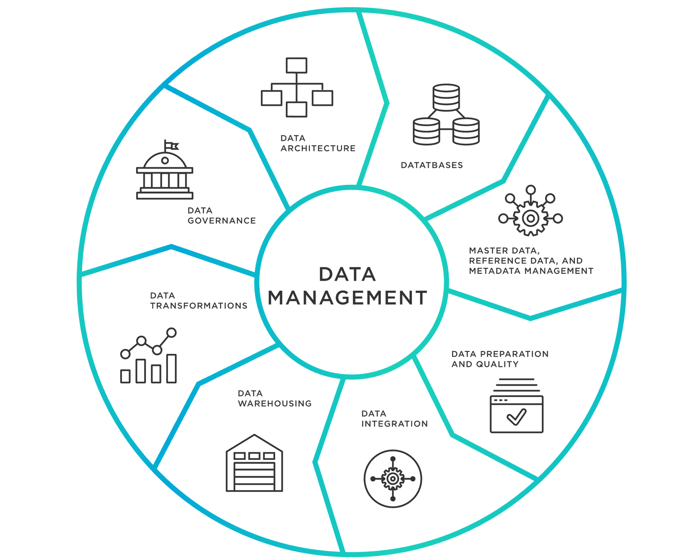

**Fig 1 –** Data Management Techniques

### Data Catalog

Within an organization, data catalogs act as centralized hubs, serving as repositories that arrange and provide metadata about the numerous datasets at their disposal. By making it easier for data consumers to quickly find and obtain the precise data they want, these catalogs play a crucial and critical role in tackling the substantial difficulty of data discovery[[12](https://www.acceldata.io/blog/data-products-are-changing-the-dynamics-of-all-industries)].

Data catalogs' core component is metadata, which offers useful details about the datasets kept by the organization. This metadata often contains important information about the data source, format, owner, and a succinct description, which together give an overview of the major features of each dataset. Let's dissect this procedure in detail:

**Centralized repositories:** Data catalogs function as a central repository, which means they provide a solitary, comprehensive source of knowledge about all the datasets that an organization maintains. The centralization of data prevents it from getting fragmented and dispersed across several systems or departments, which is essential for data management.

**Data Organization:** These catalogs arrange and store metadata in addition to storing it. Organizing datasets might entail classifying them according to departments, subjects, or any other pertinent factors to make it simpler for users to navigate the large data environment.

**Efficient Data Discovery:** Streamlining data discovery is one of a data catalog's main purposes. The catalog's search and navigation features allow data consumers, such as analysts, data scientists, or business users, to easily identify the datasets that are most pertinent to their activities or projects.

**Metadata Snapshot:** Data catalogs' offered information gives users a brief overview of each dataset's characteristics. The data's origin is indicated by the data source, its structure is described by the format, the owner is identified by the person who is in charge, and its content is briefly summarised by the description.

Although this static information is an excellent place to start for data discovery, it has certain drawbacks, especially in terms of data quality, correctness, and relevance:

**Data Quality:** Static metadata cannot accurately describe how current the data is. Users are not given any information about the data's reliability, accuracy, or timeliness—three things that are crucial in data analysis.

**Data Correctness:** In a similar vein, it offers no insights regarding the data's accuracy. Users might not be aware of how well a dataset's data matches their individual analytical requirements.

**Data Relevance:** The dynamic component of data relevance is not captured by static metadata, which is maybe most significant. Static metadata does not account for changes in the applicability of data for a certain analysis or activity over time.

To sum it up, data catalogs are crucial tools for data discovery and organization, however they largely supply static metadata that only offers a cursory grasp of a dataset's properties. Organizations should think about integrating dynamic components of data fitness, such as quality, accuracy, and relevance into their data cataloging systems to satisfy the changing demands of data consumers. This guarantees that users may not only locate data effectively but also decide with confidence if it is appropriate for their data-driven tasks.

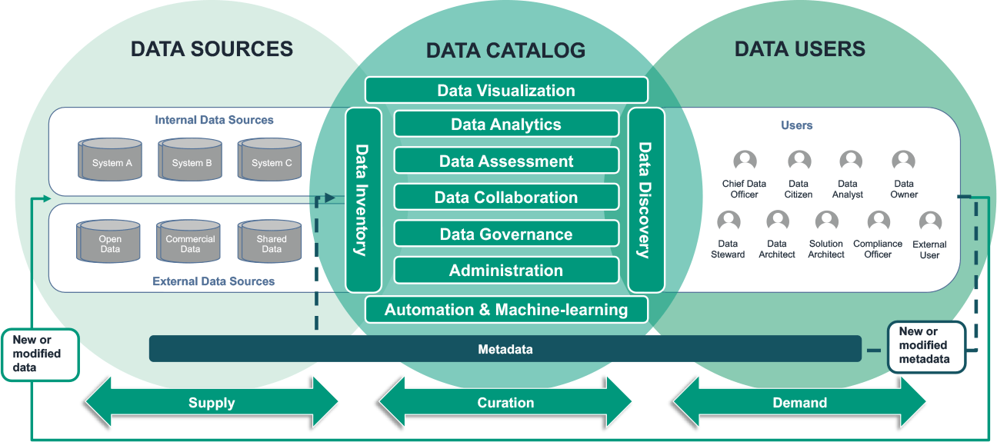

**Fig 2** – Data Cataloging Process

The concept of data fitness encompasses the multifaceted dimensions that determine the usability and suitability of a dataset for a particular purpose. It includes, but is not limited to, the accuracy of data, the completeness of information, the timeliness of updates, and the alignment of the data with the objectives of the task at hand. Recognizing and incorporating data fitness attributes within a data catalog system is a proactive step towards ensuring that data consumers have a comprehensive view of the datasets they interact with. By augmenting the catalog with these attributes, organizations enable data users to make informed decisions regarding data selection, ultimately driving more reliable analyses and decisions.

While the benefits of incorporating data fitness into a data catalog are clear, the process is not without its challenges. Designing and implementing effective data fitness metrics necessitate collaboration between domain experts, data stewards, and IT professionals to ensure the metrics accurately reflect real-world use cases. Furthermore, addressing the potential negative impacts of overemphasizing certain metrics, user resistance, or resource-intensive maintenance is paramount to the success of the endeavor[[10](https://streamsets.com/blog/bad-data-what-to-do/)].

### Metadata

When context is given to the data, it becomes easier to handle and more accessible for the achievement of business goals. Metadata essentially serves as the background knowledge that enhances our comprehension of the material it is accompanied by. Every time a document, file, or other piece of information is modified or even deleted; this contextual information is generated. Let's use a document as an example to show this. It typically has metadata attached to it that includes information like the name of the author, the creation and modification dates, and the size of the file.

It is crucial to understand that metadata is equally as important as the actual data. Extending the utility and relevance of current data is guided by precise and thorough metadata. Users are given the freedom to investigate new possibilities for efficiently utilizing the data since it offers insightful information and connections.

In the realm of metadata, there are three primary categories that serve distinct purposes:

* **Descriptive Metadata:** This kind of metadata concentrates on giving a thorough description of the data, effectively responding to the query "What is it?" Information regarding the purpose, content, and context of the data is included in descriptive metadata. It might, for instance, have descriptions, tags, or keywords that aid users in understanding the content of the data.
* **Administrative Metadata:** The logistics of data administration are the subject of administrative metadata. It includes information on the ownership, rights, access restrictions, and version history of the data. This group makes certain that the data is properly managed, safeguarded, and compatible with applicable laws.
* **Structural Metadata:** On the other hand, structural metadata describes the organization and connections of the data. It aids consumers in comprehending the relationships between various data points. For instance, structural information in a database may explain the connections between tables and fields, allowing for quick data retrieval and analysis. Metadata is essentially the unsung hero who turns unvalued data into information that is more useful, safe, and accessible in the pursuit of corporate objectives.



**Fig 3 –** Types of metadata

A substantial undertaking inside an organization, the "**Augmenting Data Catalog with Data Fitness**" project goes well beyond just improving an existing data catalog. Instead, it concentrates on a wider goal, namely, improving the overall usefulness and value of data for all interested parties. Let's examine this idea more closely:

1. **Comprehensive View of Data Fitness Attributes:** The principle behind this project is to add data fitness qualities to the data catalog. A dataset's suitability for a given purpose is determined by a variety of factors known as data fitness features. Data quality, correctness, completeness, timeliness, and alignment with job objectives are a few examples of these factors. Organizations want to offer a more comprehensive and educational perspective of their data assets by including these features in the data catalog.
2. **Empowering Data Consumers:** The organization's data consumers will primarily gain from this endeavor. These customers might be data analysts, data scientists, business users, or decision-makers. Organizations provide these people the power to choose the data they need for their analyses, reports, or other data-driven activities by enriching the data catalog with data fitness qualities. This is how:
   1. **Informed Decision-Making:** Data consumers may now evaluate the data's content as well as its suitability for their individual requirements. They develop understanding of the variables that are crucial for trustworthy decision-making, such as data quality, accuracy, and relevance.
   2. **Data Selection:** With this entire picture at their disposal, data users may pick the most relevant datasets with confidence, knowing that they are in line with their goals and uphold the necessary standards of quality.
   3. **Increased Trust:** When data users have confidence that the data they use is appropriate for their needs, they are more likely to believe the conclusions and insights drawn from the data, which promotes a culture of data-driven decision-making.
3. **Driving More Accurate Analyses and Actionable Insights:** The ultimate objective of adding data fitness qualities to the data catalog is to enhance the results of data-driven operations. It immediately leads to more accurate analyses and the creation of insights that can be used when data consumers may choose high-quality, relevant data. This has broad implications for the company:
   1. **Better Decision-Making:** By having more faith in the facts, decision-makers may make more well-informed and efficient decisions.
   2. **Efficiency:** By spending less time sorting through data and more time analyzing it, analysts and data scientists may operate more productively.
   3. **Competitive Advantage:** By efficiently using its data to fuel innovation and adjust to shifting market conditions, the organization achieves a competitive advantage.
4. **Alignment with Data Quality, Governance, and Transparency:** The project "Augmenting Data Catalog with Data Fitness" ideally complements the organization's overarching objectives for data quality, governance, and transparency. These elements are essential for success in the data-driven corporate world of today:
   1. **Data Quality:** By offering insights into data correctness and completeness, the project improves data quality and makes sure that only high-quality data is used.
   2. **Data Governance:** It supports data governance initiatives by encouraging standardized methods for choosing and utilizing data.
   3. **Transparency:** By making data fitness qualities transparent and available to all stakeholders, the initiative encourages openness, encouraging responsibility and confidence.

In conclusion, the project of adding data fitness qualities to the data catalog is a strategic effort targeted at improving data usability and value within the organization. It strengthens decision-making, empowers data consumers, aligns with important organizational goals, and prepares the company for a data-driven future in which data will be a valued asset and a source of innovation and competitive advantage.

## Problem Space

In the rapidly evolving landscape of data management, the significance of data quality, relevance, and fitness has gained prominence. Data catalogs have emerged as indispensable tools for facilitating data discovery and access, enabling organizations to navigate the ever-expanding sea of information. However, the challenge of ensuring that the data within these catalogs is not only available but also fit for purpose has become a critical concern. This forms the heart of the problem space that the project "Augmenting Data Catalog with Data Fitness" seeks to address.

**Problems:**

1. **Data Inaccuracy:** The data catalog indicates that a dataset is highly accurate, but upon analysis, it's discovered that there are significant errors in the data. This leads to inaccurate results and decisions based on that dataset. Challenge: Ensuring that the data fitness metrics accurately reflect the actual quality of the data and that they are regularly updated as data quality changes over time.
2. **Relevance Mismatch:** A data consumer selects a dataset from the catalog based on fitness metrics, but the dataset turns out to be irrelevant for their specific analysis. This results in wasted time and resources. Challenge: Defining relevance criteria that are aligned with various use cases and ensuring that the relevance assessment takes into account the context of different tasks.
3. **Outdated Data:** A user relies on a dataset that was marked as "fit" in the catalog, but the data is outdated and doesn't reflect the current state of the business. This leads to incorrect insights and decisions. Challenge: Establishing processes to regularly update data fitness attributes and ensure that the catalog reflects the most recent data assets.
4. **Inconsistent Metrics:** Different data stewards use different criteria to assess data fitness, leading to inconsistency in the fitness scores assigned to datasets. Users are unsure which metrics to trust. Challenge: Standardizing data fitness metrics and ensuring that there is clear documentation and guidelines for how to assess fitness consistently.
5. **Lack of User Adoption:** Despite the availability of data fitness information in the catalog, users continue to select datasets based on familiarity or convenience, ignoring the fitness scores. Challenge: Promoting the awareness and understanding of data fitness among data consumers and highlighting the benefits of using fitness information for decision-making.
6. **Unintuitive Visualization:** The user interface for displaying data fitness information is complex and difficult to understand. Users struggle to interpret fitness scores and metrics effectively. Challenge: Designing a user-friendly and intuitive visualization that conveys data fitness information clearly without overwhelming the user.
7. **Data Drift:** Over time, the quality and relevance of datasets may change, but the fitness information in the catalog remains static. Users unknowingly rely on outdated fitness scores. Challenge: Implementing mechanisms to detect and reflect changes in data quality and relevance in the catalog's fitness attributes.
8. **Limited Metrics for Certain Data Types:** Some data types or sources may not have easily quantifiable metrics for fitness, making it challenging to assess their quality accurately. Challenge: Developing alternative methods for assessing fitness for data types that do not fit well with traditional metrics.
9. **Overemphasis on Certain Metrics:** Data consumers may overly prioritize one fitness metric (e.g., accuracy) while neglecting other important metrics (e.g., timeliness), leading to imbalanced decisions. **Challenge**: Educating users about the importance of considering a range of fitness metrics and providing guidance on how to weigh them appropriately.

**Challenges:**

1. **Defining Comprehensive Data Fitness Metrics:** The challenge of defining precise and comprehensive data fitness metrics lies at the foundation of this project. Data fitness encompasses multifaceted dimensions, including accuracy, completeness, timeliness, and relevance. Crafting metrics that accurately capture these dimensions across diverse datasets requires collaboration with domain experts, data stewards, and users.
2. **Ensuring Standardization and Consistency:** In a heterogeneous data landscape, ensuring that data fitness metrics are applied consistently across varied datasets poses a substantial challenge. Overcoming the diversity of data formats, sources, and business domains necessitates rigorous standardization efforts to ensure comparability and integrity.
3. **Integration with Existing Data Catalog Systems:** Embedding data fitness attributes seamlessly within existing data catalog systems presents a complex challenge. The integration must harmoniously coexist with the existing metadata framework while introducing a new layer of information that enhances usability without causing disruption.
4. **Facilitating User Adoption and Understanding:** User adoption is integral to the project's success. Users who are accustomed to traditional data catalogs may exhibit resistance to embracing data fitness attributes. Designing intuitive user interfaces, conducting effective training, and conveying the tangible benefits of data fitness are essential components to address this challenge.

**Opportunities:**

1. **Empowering Informed Decision-Making:** The integration of data fitness attributes offers a transformative opportunity to empower data consumers. By providing a nuanced understanding of data quality and relevance, users can confidently select datasets that align with their analytical or operational goals, enhancing decision-making accuracy.
2. **Elevating Overall Data Quality:** Beyond catalog enhancement, the project provides an avenue to elevate overall data quality. Focusing on data fitness encourages data stewards and contributors to proactively address data quality challenges, leading to improved accuracy, completeness, and reliability of analyses.
3. **Optimizing Resource Allocation:** The project's impact extends to resource optimization. By enabling users to efficiently identify datasets that match their requirements, the project streamlines the data discovery process. This efficiency translates into resource savings and improved productivity.
4. **Cultivating a Data-Driven Mindset:** The project aligns with organizational aspirations of fostering a data-driven culture. By integrating data fitness attributes, the organization emphasizes data quality as a shared responsibility, cultivating a mindset where data is valued as a strategic asset.

In essence, the problem space of "Augmenting Data Catalogs with Data Fitness Distributions" is situated at the crossroads of data quality, usability, and organizational culture. By navigating the intricacies of data fitness metrics, standardization, integration, and user adoption, this project seeks to transform data catalogs into dynamic repositories that not only house data but also empower users with the ability to select data that truly serves their objectives.

## Research

### Research Summary

The undertaking of the "Augmenting Data Catalog with Data Fitness" project required a comprehensive examination of the obstacles, possibilities, and intricacies linked to the enhancement of data catalogs through the inclusion of data fitness features. The study team initiated an extensive investigation process that encompassed literature reviews, web inquiries, collaborative efforts, and interactions with subject matter experts. The objective of this study was to provide insights for the development and execution of a viable solution that effectively tackles the identified issues while capitalizing on the provided prospects.

### Defining Comprehensive Data Fitness Metrics

The primary stage of the study centered on comprehending the diverse aspects of data suitability, which include correctness, completeness, timeliness, and relevance. The team actively participated in broad interactions with domain experts, data stewards, and users to establish precise and comprehensive data fitness measures. To acquire insights into the evaluation of data quality across varied datasets, a comprehensive review of research papers and industry publications was conducted.

### 1.3.3. Ensuring Standardization and Consistency

The team was motivated to explore data standardization due to the difficulty of ensuring consistent data fitness measures in a heterogeneous data landscape. The research encompassed the exploration of approaches aimed at adjusting data fitness criteria to accommodate a wide range of data formats, sources, and business domains. This study analyzed industry best practices and case studies to discover effective ways for guaranteeing comparability and integrity in the assessment of data fitness.

### 1.3.4. Integration with Existing Data Catalog Systems

To address the issue of effectively incorporating data fitness qualities into pre-existing data catalog systems, the team conducted thorough research into metadata frameworks and catalog structures. The research endeavor encompassed an examination of effective cases of metadata integration and an exploration of methodologies for seamlessly incorporating additional layers of information. A study was undertaken to gather insights on user experiences pertaining to data catalog interfaces, with the objective of informing the development of user-friendly solutions that improve usability while minimizing any potential disruptions.

### 1.3.5. Facilitating User Adoption and Understanding

The adoption of the project by users has been identified as a crucial determinant of its success. The research team investigated various tactics aimed at enhancing the knowledge and comprehension of data fitness among individuals who consume data. The development of user interfaces that successfully communicate data fitness information was informed by the integration of insights from cognitive psychology and user experience design. Furthermore, scholarly investigations on change management approaches have yielded significant insights towards effectively promoting user acceptance of novel qualities.

### 1.3.6. Opportunities and Impact

During the study process, a wide range of opportunities were found that the project could take advantage of. The team investigated how data fitness characteristics could help people make better decisions, improve the overall quality of data, make better use of resources, and build a data-driven corporate culture. Case studies, real-world examples, and studies on the benefits of improving data quality in decision-making processes were used to show that these possibilities were real.

The research part of the project was based on a multidisciplinary approach that brought together ideas from data management, user experience design, cognitive psychology, and change management. The team's work led to a deep understanding of the complexities of data fitness metrics, issues with standardization, integration options, and strategies for getting users to use the system. This information was the basis for the next steps of designing and building the answer.

### 1.3.7. What are the hyperparameters which we can use to find data fitness?

1. **Data Quality Hyperparameters:**

Data Consistency: Measure the consistency of data values across different records or time periods.

Data Accuracy: Set expectations for data accuracy and acceptable error rates.

Data Integrity: Check for data integrity issues, such as duplicate records or inconsistent keys.

1. **Data Completeness Hyperparameters:**

Missing Values: Assess the percentage of missing values in each feature. Set a threshold for acceptable missing data.

Null Value Handling: Specify the method used for handling missing values (e.g., imputation or removal).

1. **Data Relevance Hyperparameters:**

Feature Relevance: Define criteria for feature relevance, considering whether each feature contributes meaningfully to the task.

Target Variable Consistency: Ensure the target variable aligns with the problem statement and is consistent across the dataset.

1. **Data Distribution Hyperparameters:**

Data Balance: Determine class balance for classification tasks and set thresholds for class imbalance.

Outlier Detection: Define outlier detection criteria and acceptable levels of outliers.

1. **Data Temporality Hyperparameters:**

Time Frame: Specify the time frame or temporal scope of the data and set expectations for data consistency within that frame.

Seasonality: Consider seasonality patterns and set hyperparameters for detecting and handling seasonality in time series data.

1. **Data Privacy and Security Hyperparameters:**

Data Encryption: Define encryption requirements for sensitive data.

Access Controls: Specify access control policies and permissions for data security.

Data Format and Schema Hyperparameters:

Data Format Validation: Ensure that data conforms to expected formats (e.g., date formats, numeric formats).

Schema Consistency: Check whether the data adheres to predefined schema expectations.

1. **Data Sampling and Size Hyperparameters:**

Data Size: Define the minimum and maximum acceptable dataset sizes for analysis.

Sampling Strategy: Set hyperparameters for data sampling, if applicable.

1. **Data Preprocessing Hyperparameters:**

Normalization/Scaling: Specify data preprocessing steps such as feature scaling or normalization.

Dimensionality Reduction: Determine whether dimensionality reduction techniques should be applied.

1. **Data Imbalance Handling Hyperparameters:**

Oversampling/Undersampling: Define the methods and ratios for handling class imbalance.

Class Weights: Specify class weights for imbalanced datasets in machine learning models.

1. **Data Drift Detection Hyperparameters:**

Concept Drift Threshold: Set thresholds for detecting concept drift in streaming data.

Monitoring Frequency: Define how often data drift should be checked.

1. **Evaluation Metric Thresholds:**

Acceptable Model Performance: Specify thresholds for evaluation metrics (e.g., accuracy, F1-score) to assess whether the data fitness meets performance expectations.

1. **Data Version Control:**

Data Versioning: Define how data versions are managed and set criteria for accepting new data versions.

1. **Feedback Loop Hyperparameters:**

Data Update Frequency: Specify how often the data should be updated or reevaluated.

Trigger Conditions: Define conditions that trigger data fitness assessments (e.g., significant changes in data quality or performance).

1. **Documentation and Metadata Tags:**

Metadata Tags: Include metadata tags or annotations that describe the data's fitness attributes, making it easier to assess.

1. **Data Source Information:**

Source Reliability: Assess the reliability of data sources and set criteria for trusting and using data from specific sources.

1. **Regulatory Compliance:**

Compliance Standards: Ensure that data complies with relevant regulatory standards (e.g., GDPR, HIPAA) and set hyperparameters for compliance checks.

### 1.3.8. Methods for extracting from hyperparameters and metadata

**1. Metadata Parsing:**

Approach: Metadata parsing involves extracting relevant information directly from the metadata associated with your dataset. Metadata typically includes information about the dataset's structure, attributes, and sometimes preprocessing steps.

Implementation: Use metadata parsers or scripts to read and interpret metadata files. Common formats include JSON, XML, or even comments within data files.

**2. Data Profiling Tools:**

Approach: Data profiling tools automatically analyze datasets and generate summary statistics and metadata. These tools can help identify key hyperparameters for data fitness evaluation.

Implementation: Use tools like pandas-profiling, DataRobot, or Great Expectations to generate metadata and statistics about your dataset.

**3. Custom Metadata Tags: -**

Approach: Incorporate bespoke metadata tags or annotations to your dataset or its properties. These tags can define hyperparameters that are associated with the preprocessing of data, engineering of features, or metrics used for evaluation.

Implementation: Develop a metadata structure for the dataset, incorporating pertinent hyperparameters as tags or attributes. The schema should be documented to ensure consistency.

**4. Metadata Annotations in Code:**

Approach: Incorporate hyperparameter information directly into the code of your data processing or machine learning algorithms. The hyperparameters employed in this study are indicated using comments or annotations.

Implementation: For example, in Python code, you can use comments like `# Scaling method: Min-Max` or docstrings to document hyperparameters used during data preprocessing and modeling.

**5. Machine Learning Experiment Tracking.**

Approach: In the case of utilizing a machine learning experiment tracking platform such as MLflow or TensorBoard, it is possible to record hyperparameters in conjunction with model performance metrics.

Implementation: It is recommended to log hyperparameters during the execution of trials, as this facilitates the ability to establish correlations between hyperparameters and model performance.

**6. Metadata database.**

Approach: Establish and manage a metadata repository to retain comprehensive details pertaining to each dataset, encompassing the hyperparameters employed at various phases.

Implementation: Design a database schema to capture metadata, hyperparameters, and their relationships. Populate the database as you work with new datasets.

**7. Data annotation tools:**

Approach When working with human-annotated data, it is advisable to utilize annotation tools that enable the capture and association of metadata with the annotated samples.

Implementation: During the annotation process, annotators have the ability to incorporate metadata, which can subsequently be utilized to ascertain the specific hyperparameters that were employed on the data.

**8. Natural Language Processing (NLP):**

Approach: If metadata contains textual descriptions or documentation, it is possible to employ natural language processing (NLP) techniques to extract hyperparameters that are explicitly stated within the text.

Implementation: The implementation involves utilizing text mining and natural language processing (NLP) libraries to evaluate descriptions and extract hyperparameter information.

**9.Machine Learning on Metadata:**

Approach: Train machine learning models to predict hyperparameters based on metadata features. This method may require historical data with labeled hyperparameters.

Implementation: Develop a model that takes metadata attributes as input and predicts relevant hyperparameters.

The effectiveness of these methods will depend on the availability and quality of metadata, as well as the specific requirements of your project. You may need to use a combination of these approaches to comprehensively extract hyperparameters for data fitness evaluation from metadata.

## Solution Space

### 1.4.1 Solution Approach

The primary objective of our solution approach for the "Augmenting Data Catalog with Data Fitness" project is to improve the overall worth and usability of data catalogs by incorporating data fitness qualities. Our proposed methodology aims to enhance data catalogs by incorporating a comprehensive framework that includes data fitness metrics, standardization, integration, user adoption strategies, and the utilization of identified opportunities. This approach aims to convert data catalogs into dynamic repositories that enable users to make well-informed decisions by considering factors such as data quality, relevance, and fitness.

### 1.4.2 Solution Space

The proposed solution space aims to provide an enhanced data catalog experience that offers significant benefits to users. Our approach endeavors to offer users precise and significant indicators of data quality and relevance by integrating data fitness features. The value is achieved when users possess the ability to make informed choices regarding datasets that are by their analytical and operational objectives, hence improving their decision-making procedures. By incorporating data fitness measures, we want to tackle the issue of data inaccuracy by providing users with clear and comprehensive insights into the true quality of cataloged datasets. The value that users obtain from this feature is derived from their ability to prevent making erroneous judgments that result from the use of faulty data. The solution space also addresses the issue of relevance mismatch, offering users the opportunity to optimize their time and resources by allowing them to choose datasets that are aligned with their analysis requirements.

Our methodology acknowledges the importance of current data, hence tackling the problem of obsolete information. Our system guarantees the reliability of data assets by implementing procedures for regular changes of data fitness attributes, hence ensuring the availability of current and pertinent information for users. Furthermore, the implementation of standardized data fitness metrics serves to mitigate the issue of inconsistency. The standardization of fitness scores provides users with value since it ensures that the assigned scores for datasets are consistent and can be compared reliably.

The primary focus of our solution space revolves around the promotion of user adoption. Our objective is to enhance comprehension and endorsement of data fitness qualities by employing intuitive user interfaces and user-centered design principles. Users derive significant benefits when they adopt and integrate these features into their decision-making processes, while also prioritizing the quality and suitability of the data.

The potential benefits offered within our proposed solution space also enhance its overall value. Our system is designed to facilitate informed decision-making by providing users with accurate and relevant data, thereby aligning with their demands. Improving the overall quality of data not only has a positive impact on decision-making processes but also boosts the dependability of analyses and the trustworthiness of insights. The proposed methodology aims to enhance resource allocation efficiency through the optimization of dataset identification processes, resulting in cost reduction and improved productivity. Additionally, our proposed solution space plays a significant role in fostering a data-driven culture within enterprises. Our solution emphasizes data quality as a collective duty by integrating data fitness criteria, hence boosting the strategic value of data.

The core focus of the "Augmenting Data Catalog with Data Fitness" project is centered on the development of a dynamic and user-centric data catalog experience. This experience provides users with the necessary resources to effectively navigate the data environment, enabling them to make well-informed decisions and build a culture that prioritizes the importance of data accuracy and significance.

## Project Objectives

1. Understand the importance of data fitness and its role in effective data management.
2. Explore various methods and techniques to assess and quantify the fitness of data.
3. Implement enhancements to the data catalog to include data fitness attributes.
4. Design and develop a user-friendly interface to visualize and interact with data fitness information.
5. Demonstrate the benefits of an augmented data catalog through real-world scenarios and examples.

## Primary User Stories

In alignment with the project's objectives, the following primary user stories have been formulated to encapsulate the core objectives of the "Augmenting Data Catalog with Data Fitness" initiative. These user stories encapsulate the challenges addressed, the benefits delivered, and the value proposition presented by the proposed solution:

**1. As a Data Analyst, I want to confidently select datasets from the data catalog based on accurate data fitness metrics so that I can ensure the quality and relevance of the data for my analysis.**

In this user story, the focus is on addressing the challenge of data inaccuracy. Data analysts often rely on cataloged datasets for their analyses, and inaccurate data can lead to incorrect insights and decisions. By providing accurate data fitness metrics that transparently reflect the actual quality of the data, the proposed solution empowers data analysts to make well-informed decisions about the suitability of datasets for their analyses.

**2. As a Business Manager, I want to easily identify and choose datasets that are relevant to my specific business needs, saving time and resources.**

This user story tackles the challenge of relevance mismatch. Business managers require data that is directly relevant to their specific business objectives. By incorporating relevance criteria aligned with various use cases into data fitness metrics, the solution ensures that datasets chosen by business managers match their needs precisely, avoiding wastage of time and resources on irrelevant data.

**3. As a Data Scientist, I want access to data in the catalog that reflects the most recent state of the business, so that my insights and predictions are based on accurate and up-to-date information.**

The challenge of outdated data is addressed in this user story. Data scientists rely on current data to develop accurate models and predictions. The solution addresses this by establishing processes to regularly update data fitness attributes, ensuring that the catalog reflects the most recent data assets, thereby enhancing the accuracy of data-driven insights.

**4. As a Data Steward, I want standardized data fitness metrics that help me consistently assess the quality of datasets, enabling me to maintain high standards of data management.**

This user story focuses on addressing the problem of inconsistent metrics. Data stewards play a crucial role in assessing data fitness. By standardizing data fitness metrics and providing clear guidelines, the solution ensures that data stewards apply consistent criteria, resulting in uniform and reliable fitness scores assigned to datasets.

**5. As a Data Consumer, I want to understand the benefits of using data fitness information for decision-making, so that I can confidently utilize fitness scores to select datasets that align with my analysis goals.**

This user story highlights the challenge of user adoption. Despite the availability of data fitness information, users may not understand its value. The solution addresses this by promoting awareness and understanding of data fitness among data consumers, demonstrating how data fitness information enhances decision-making accuracy and relevance.

**6. As a UX Designer, I want to create an intuitive visualization for data fitness information, ensuring that users can easily interpret and utilize fitness scores and metrics in their decision-making processes.**

The challenge of unintuitive visualization is central to this user story. UX designers play a critical role in making complex information comprehensible. The solution acknowledges this by designing user-friendly and intuitive visualizations that convey data fitness information clearly, facilitating user interaction with fitness scores and metrics.

**7. As a Data Catalog Administrator, I want mechanisms to detect and reflect changes in data quality and relevance in the catalog's fitness attributes, so that users can rely on accurate and up-to-date fitness information.**

This user story addresses the challenge of data drift. Over time, data quality and relevance may change, and fitness attributes need to reflect these changes. The solution handles this by implementing mechanisms to detect changes and update fitness attributes accordingly, ensuring users rely on the latest information.

**8. As a Data Scientist working with unconventional data types, I want alternative methods for assessing data fitness that accommodate the unique characteristics of these data types.**

This user story highlights the challenge of limited metrics for certain data types. Some data types may not fit well with traditional metrics. The solution addresses this by developing alternative assessment methods that accurately capture fitness for data types that don't easily align with standard metrics.

**9. As a Decision-Maker, I want to understand the significance of considering a range of fitness metrics, so that I can make balanced decisions based on comprehensive data quality information.**

The challenge of overemphasizing certain metrics is tackled in this user story. Decision-makers may prioritize one metric over others, leading to imbalanced decisions. The solution addresses this by educating users about the importance of considering a variety of fitness metrics and providing guidance on how to weigh them appropriately.

These primary user stories collectively illuminate the value proposition and the user-centric nature of the proposed solution for our project. Each story captures a unique challenge addressed by the solution, showcasing how users across various roles and responsibilities stand to benefit from the integration of data fitness attributes into the data catalog.

## Product Vision

The goal of the "Augmenting Data Catalog with Data Fitness" project is to make an indispensable resource that gives users the power to confidently navigate the landscape of data, making sure that the data they use to make decisions is of high quality, relevant, and fit. By adding data fitness characteristics to the data catalog in a seamless way, our product aims to turn static repositories into dynamic assets that provide actionable insights and help people make better decisions. This vision comes to life through scenarios that show how and why the answer is useful and valuable in the real world.

### Scenario #1

**Scenario 1: Empowering Decision-Makers with Informed Insights**

* **For**: Decision-makers in an organization
* **Who**: Rely on data-driven insights for strategic choices
* **The**: Existing data catalog is available, but data quality and relevance are not transparent
* **Is a**: User-centered solution that prioritizes data fitness and relevance?
* **That**: Seamlessly integrates data fitness attributes into the catalog, offering accurate and up-to-date metrics
* **Unlike**: Traditional catalogs that lack comprehensive data quality information
* **Our product**: Equips decision-makers with nuanced insights into data quality and relevance.
* **Caveats**: Requires user engagement to understand and embrace the value of data fitness

In the given context, our product answers the requirements of decision-makers who are in need of dependable data to inform their strategic decision-making processes. The solution facilitates decision-makers in making well-informed and precise judgments by providing them with accurate and timely fitness metrics data. This enables decision-makers to confidently choose datasets that are in line with their objectives. In contrast to traditional data catalogs, our platform places a strong emphasis on transparency and provides decision-makers with a comprehensive comprehension of data fitness and relevance.

### Scenario #2

**Scenario 2: Streamlining Data Discovery for Analysts**

* **For**: Data analysts performing exploratory analysis
* **Who**: Require data that is accurate and relevant to their analysis goals
* **The**: Current data catalog lacks granularity on data quality and fitness
* **Is a**: Solution that prioritizes data accuracy and relevance?
* **That**: Embeds comprehensive data fitness metrics, seamlessly integrated into the catalog
* **Unlike**: Conventional catalogs that lack visibility into data quality dimensions
* **Our product**: Facilitates swift and precise dataset selection for analysts.
* **Caveats**: Requires users to adopt the new paradigm of considering data fitness

In this scenario, our product addresses the needs of data analysts by simplifying the process of selecting datasets. By incorporating granular data fitness metrics, the solution assists analysts in identifying datasets that align with their analytical objectives. This streamlines the data discovery process, enabling analysts to focus on extracting insights rather than spending time validating data quality. Unlike traditional catalogs, our product brings data quality dimensions to the forefront, ensuring that analysts can trust and leverage the data they work with.

These scenarios exemplify the overarching vision of our project. The product aims to be the go-to solution for individuals seeking accurate, relevant, and trustworthy data for their various roles and responsibilities within the organization. By seamlessly integrating data fitness attributes, our product transforms data catalogs into valuable resources that empower users and elevate the quality of decision-making processes.

# Datasets

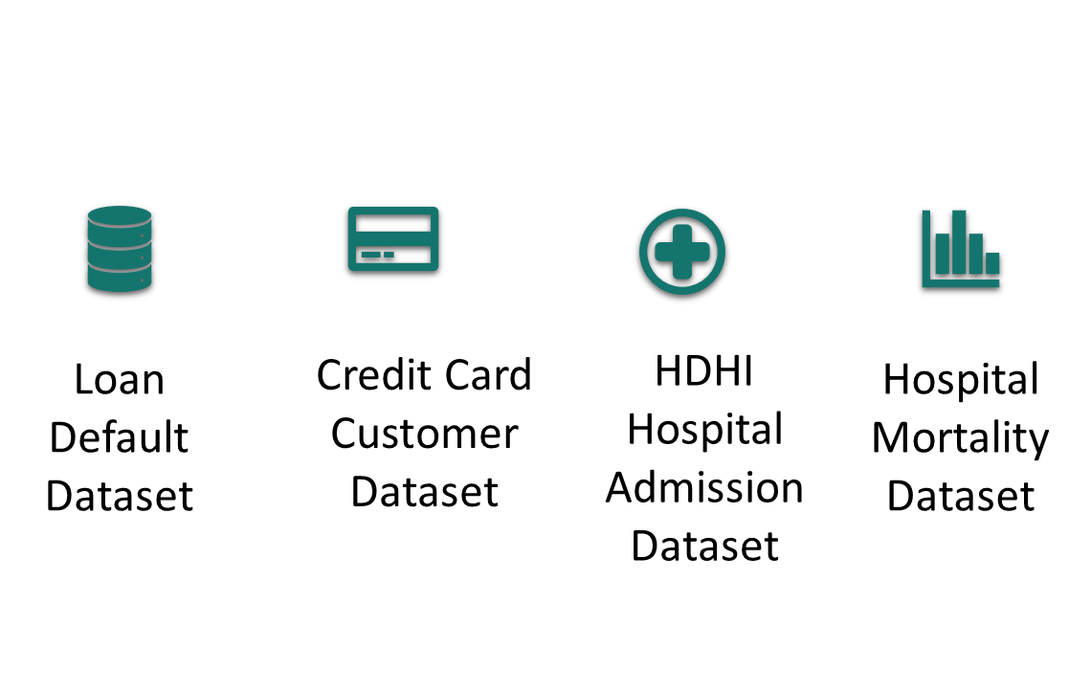

**Fig 4** – Datasets Used

## Overview

**Healthcare Domain:**

The healthcare domain represents a multifaceted sector dedicated to the well-being and health of individuals. Effective data management in healthcare is pivotal for patient care, research, and operational excellence. This section will delve into the various aspects of data management within this domain.

**Finance Domain:**

In the finance domain, we encounter a dynamic ecosystem comprising diverse financial activities, institutions, and markets. Robust data management practices are essential for financial institutions to ensure regulatory compliance, manage investments, and deliver financial services efficiently. This section will explore the critical role of data management in finance.

## Field Descriptions

**Healthcare Domain:**

In healthcare, data fields encompass:

* Patient Data: This includes personal information, medical history, and treatment records.
* Clinical Data: It covers diagnostic reports, lab results, radiology images, and other clinical information.
* Pharmaceutical Data: This field encompasses drug information, prescriptions, medication histories, and pharmacy records.

**Finance Domain:**

Within the finance domain, data fields comprise:

* Customer Data: This includes personal and financial information of clients or customers.
* Market Data: It covers financial market conditions, including stock prices, commodities, and currency exchange rates.
* Transaction Data: This field encompasses records of various financial transactions, such as investments, loans, and payments.

## Data Context

**Healthcare Domain:**

Data context in healthcare revolves around patient-specific information used for diagnosis, treatment, and research. It includes data on medical procedures, prescriptions, patient outcomes, and the entire healthcare journey.

**Finance Domain:**

In the finance domain, data context is fundamental for understanding market conditions, customer profiles, and transactional data. It is critical for making informed investment decisions, managing financial risk, and delivering personalized financial services.

## Data Descriptions

* The Loan Default Dataset dataset is enormous & consists of multiple deterministic factors like borrower's income, gender, loan purpose etc.
* The Credit Card dataset consists of 10,000 customers mentioning their age, salary, marital status, credit card limit, credit card category, etc.
* The HDHI dataset primarily consisted of patient-related information, encompassing admission and discharge dates, patient demographics, and medical history, including factors such as smoking, alcohol consumption, and various health indicators.
* The Mortality Prediction data contains demographic characteristics, vital signs within the first 24 hours of admission, comorbidities identified by ICD-9 codes, and laboratory variables throughout the ICU stay.

## Data Conditioning

**Healthcare Domain:**

Data conditioning in healthcare often involves de-identification and anonymization processes to safeguard patient privacy. It also includes data normalization and standardization to ensure interoperability between different systems.

**Finance Domain:**

In the finance domain, data conditioning comprises data cleaning and validation of customer records. Additionally, it may involve data transformation to address anomalies and outliers in market data.

## Data Quality Assessment

**Healthcare Domain:**

Data quality in healthcare is paramount. It encompasses the accuracy, completeness, and timeliness of patient records. Rigorous data quality assessment ensures the reliability of clinical decision-making and patient care.

**Finance Domain:**

Data quality assessment in finance is critical for ensuring the accuracy of financial transactions and market data. It is fundamental for regulatory compliance, risk management, and delivering trustworthy financial services.

As part of the quality assessment, we mainly focused on Data Completeness, Data Consistency, Outlier Detection, Summary Statistics and Categorical Cardinality.

### Data Completeness & Data Consistency for Datasets

**Dataset 1:** Loan Default Dataset

**Dataset 2:** HDHI Admission Dataset

**Dataset 3:** Hospital Mortality Prediction

**Dataset 4:** Bank Churners

**Methodology**:

**Data Loading:**

The Loan Default dataset has been loaded into a Pandas DataFrame named df1 for in-depth analysis. This preliminary step is essential to make the data ready for quality assessment.

**Data Completeness - Missing Values:**

To ensure data completeness and to identify any significant gaps in the dataset, we calculated the percentage of missing values in each column. The results are as follows:

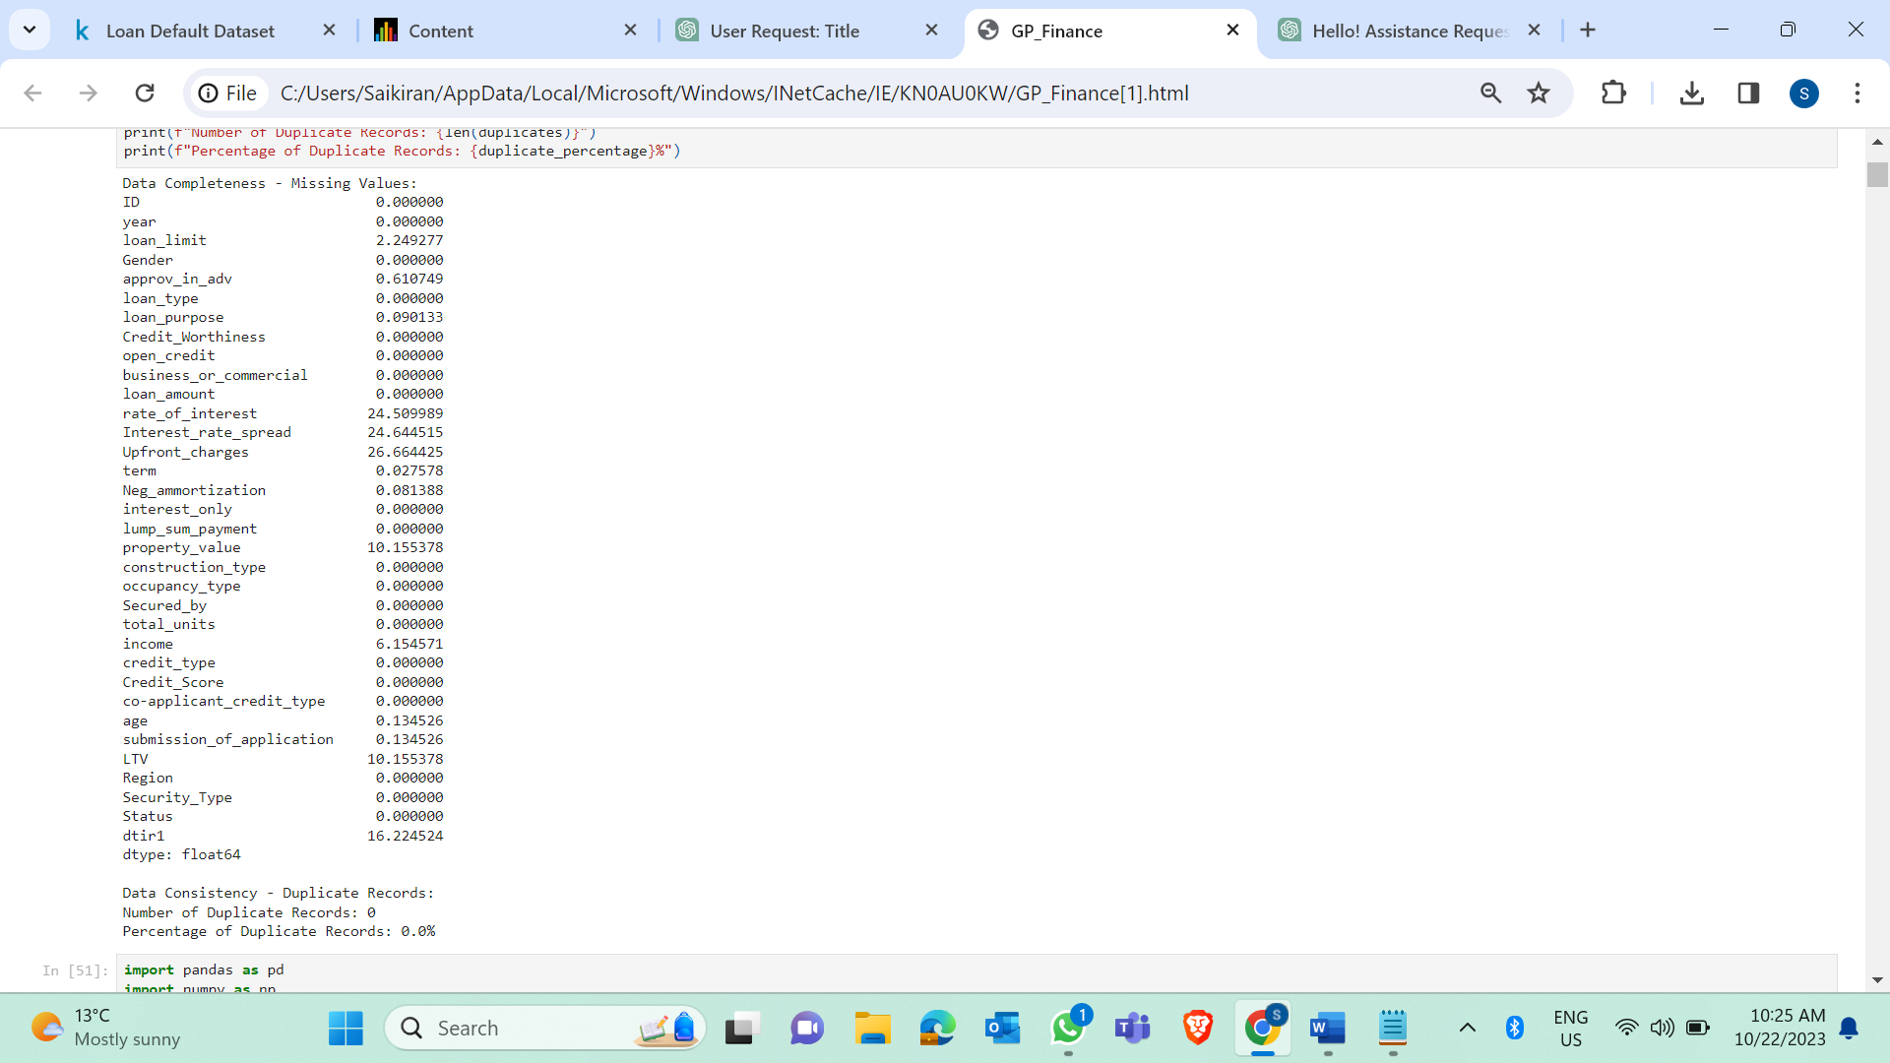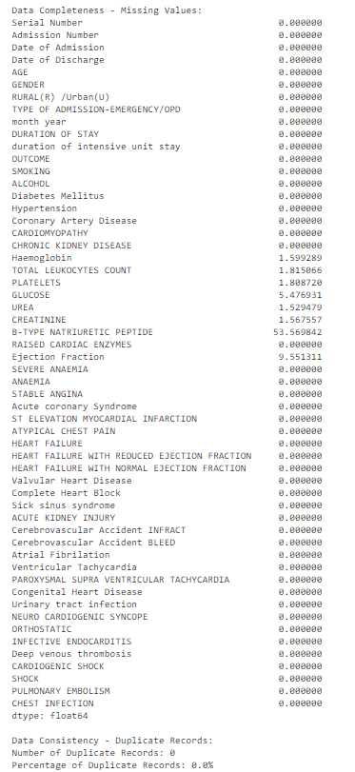

**Fig 5** - Missing Values: Dataset 1, Dataset 2

**Data Consistency - Duplicate Records:**

Duplicate records are identified within the dataset. The number and percentage of duplicate records are printed to assess data consistency. Duplicate records can lead to erroneous analysis results.

**Visual Presentation:**

i) Data completeness has been assessed by providing the percentage of missing values for each column.

ii) Data consistency has been assessed by identifying and presenting the number and percentage of duplicate records.

**Outcome**:

i) The evaluation of data completeness and consistency has provided insights into the overall quality of the Loan Default dataset.

ii) The identification of missing values and duplicate records is crucial, as addressing these issues is essential to maintain the reliability of the data for any future analyses.

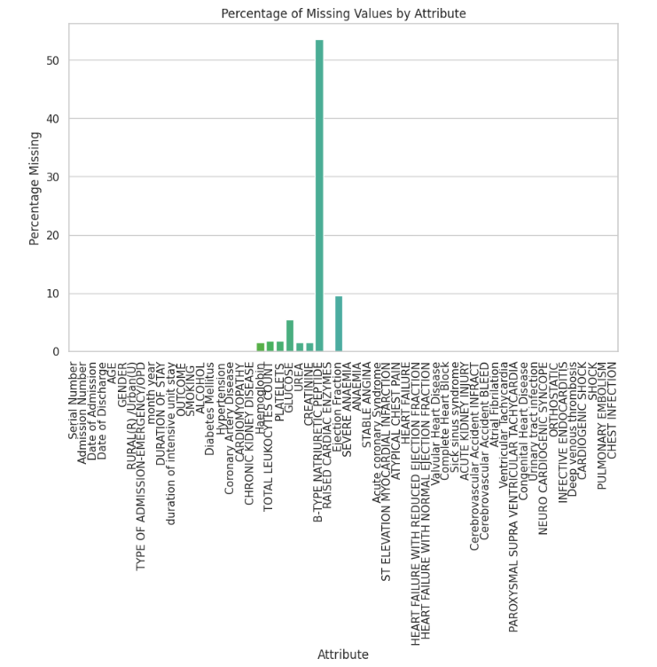

**Fig 6** - Missing Values By Attribute: Dataset 1

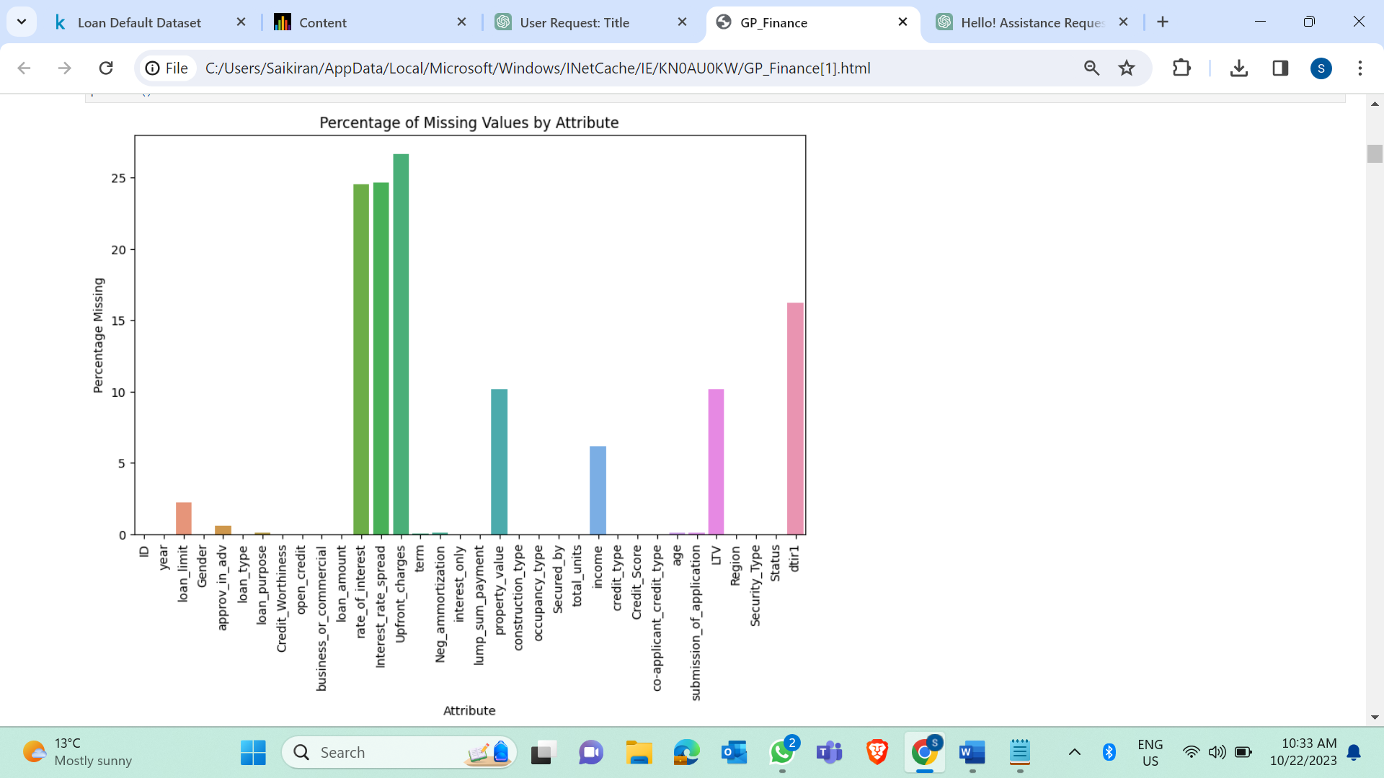

**Fig 7** - Missing Values By Attribute: Dataset 2

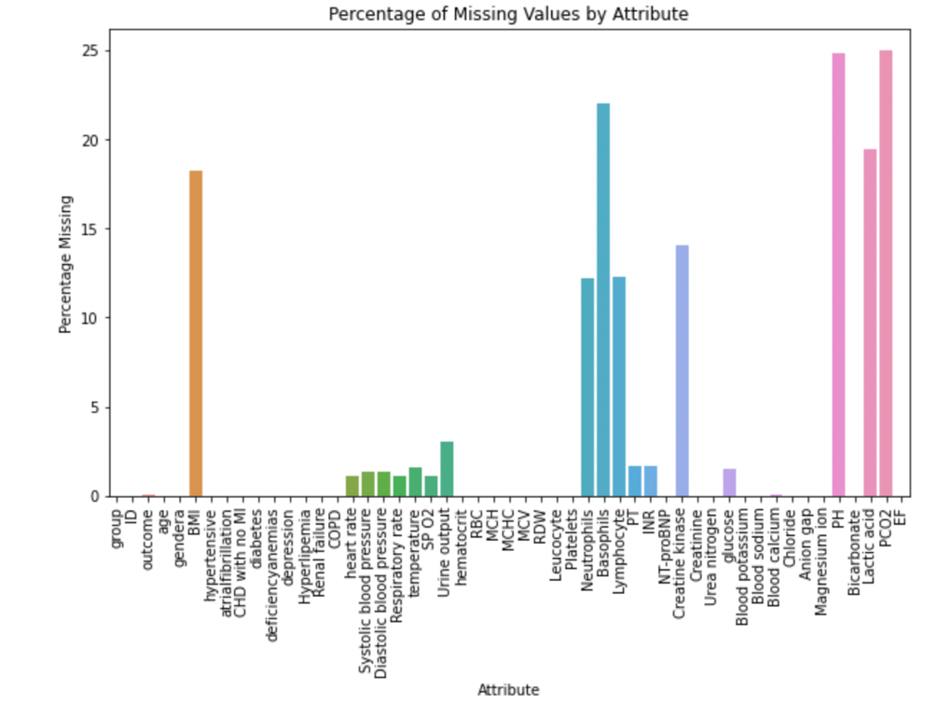

**Fig 8** - Missing Values By Attribute: Dataset 3

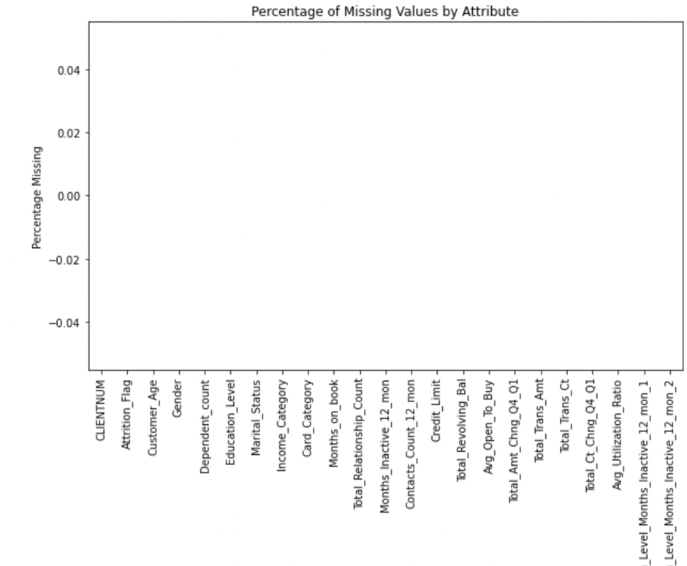

**Fig 9** - Missing Values by Attribute: Dataset 4

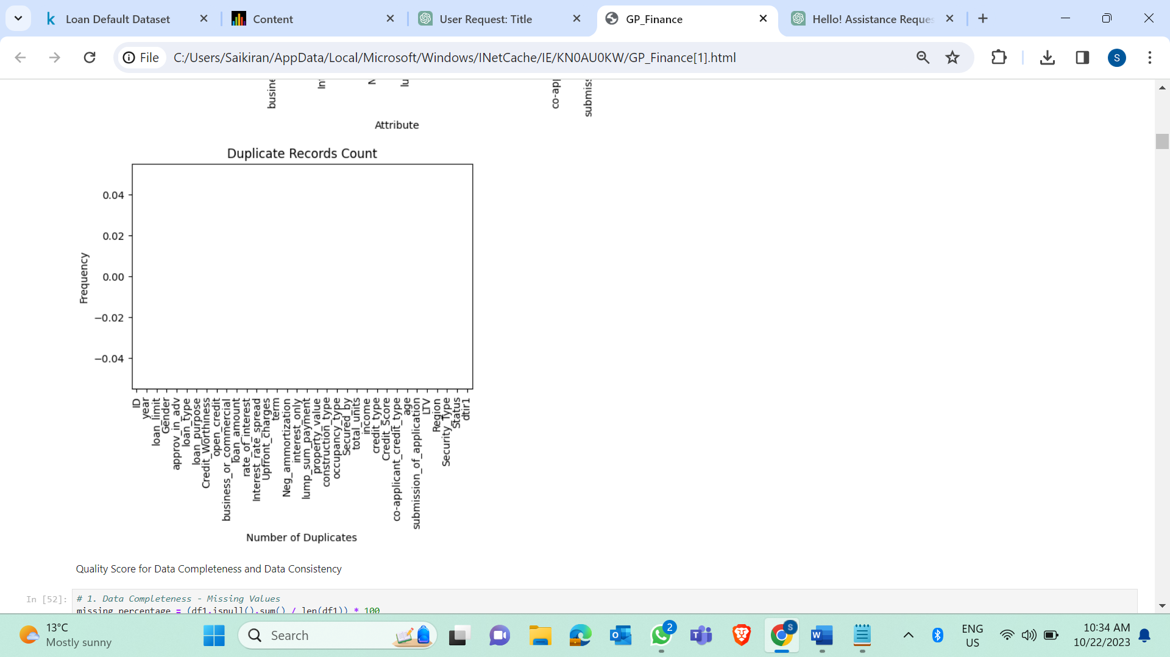

**Fig 10** – Duplicate Records for Dataset 1

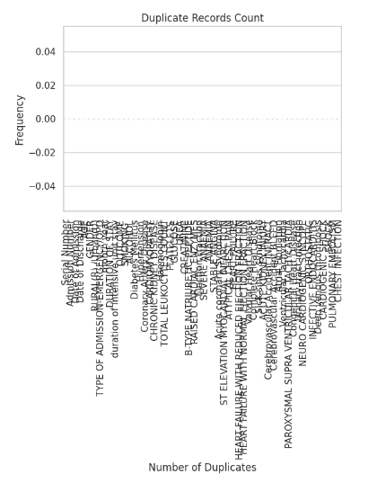

**Fig 11** – Duplicate Records for Dataset 2

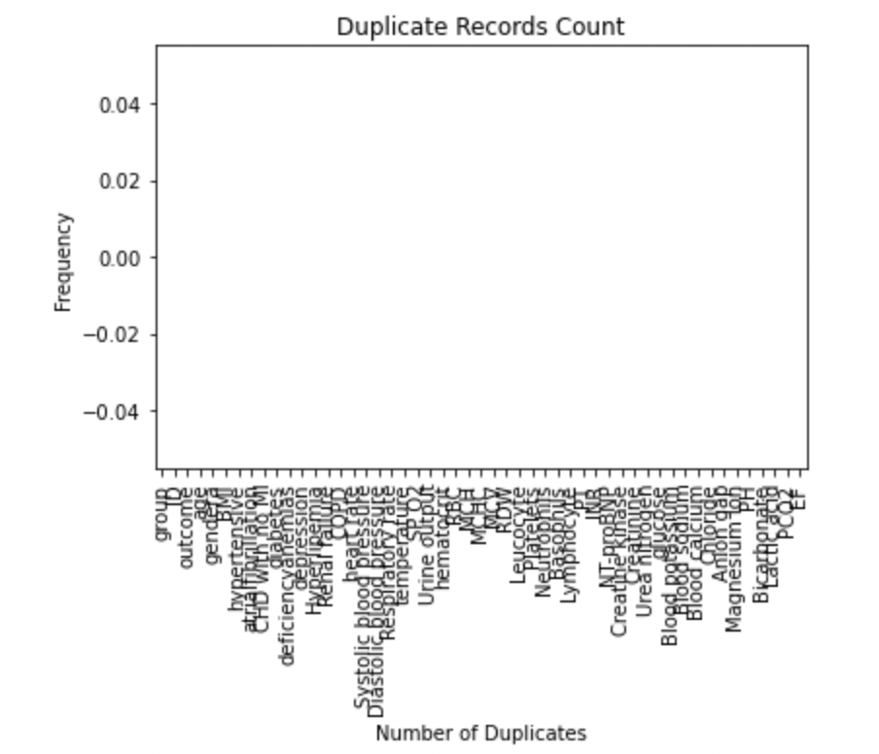

**Fig 12** – Duplicate Records for Dataset 3

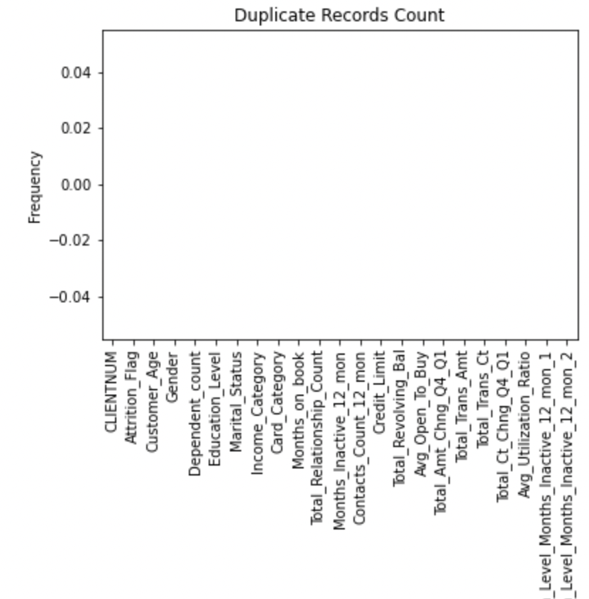

**Fig 13** – Duplicate Records for Dataset 4

### Outlier Detection and Analysis

**Methodology:**

Outlier detection is a critical step in data analysis to identify unusual or anomalous data points that might skew the results. In this analysis, we applied outlier detection techniques to the Loan Default dataset.

**Outlier Detection:**

We specified the columns to be analyzed for outliers. The selected columns are 'loan_limit', 'loan_amount', 'rate_of_interest', 'Upfront_charges', 'Interest_rate_spread', and 'LTV'.

**Visual Presentation:**

For each selected column, we performed the following steps:

Created a boxplot to visualize the distribution of the data.

Calculated the Interquartile Range (IQR) to define lower and upper bounds for identifying outliers.

Identified outliers as data points falling below the lower bound or above the upper bound.

The boxplots display the distribution of each attribute and highlight the outliers with red points, as seen in the figure below.

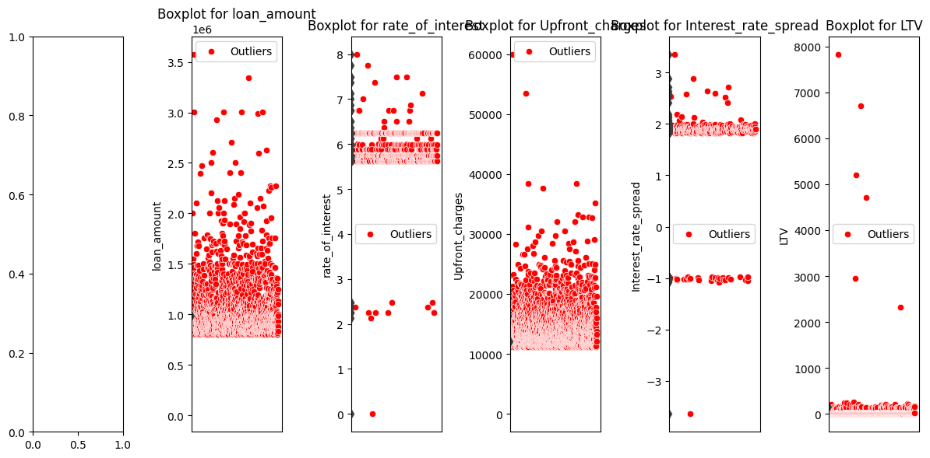

Fig 14 Outliers: Dataset 1

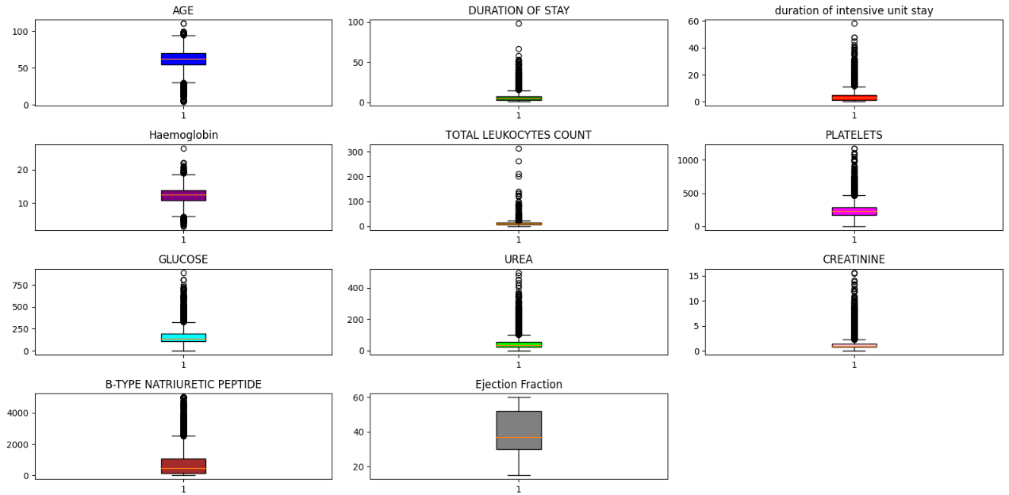

Fig 15 Outliers: Dataset 2

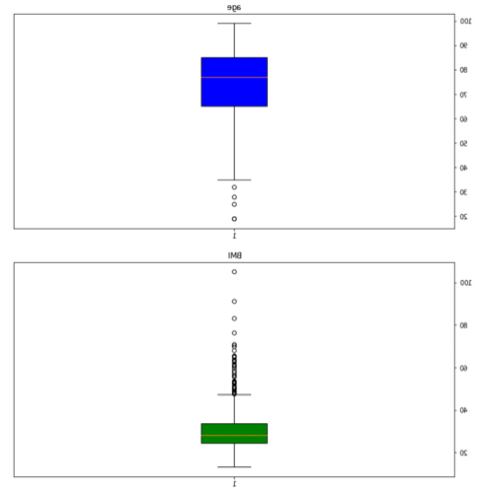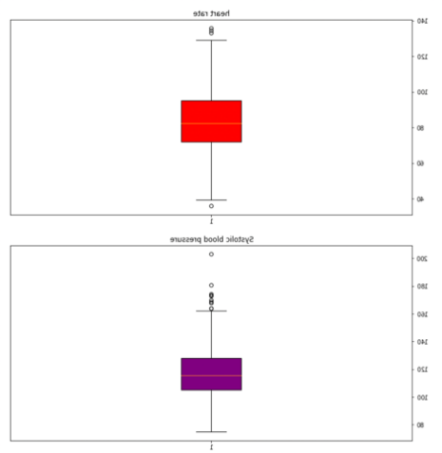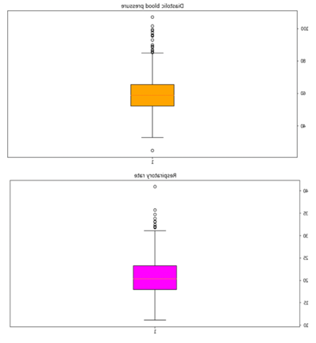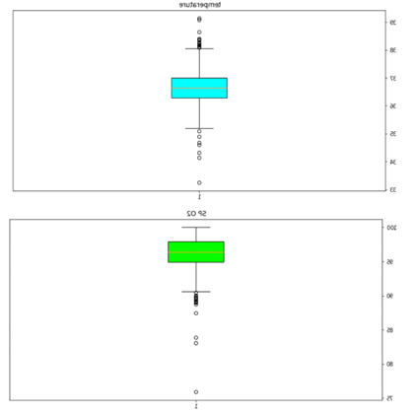

Fig 16 Outliers: Dataset 3

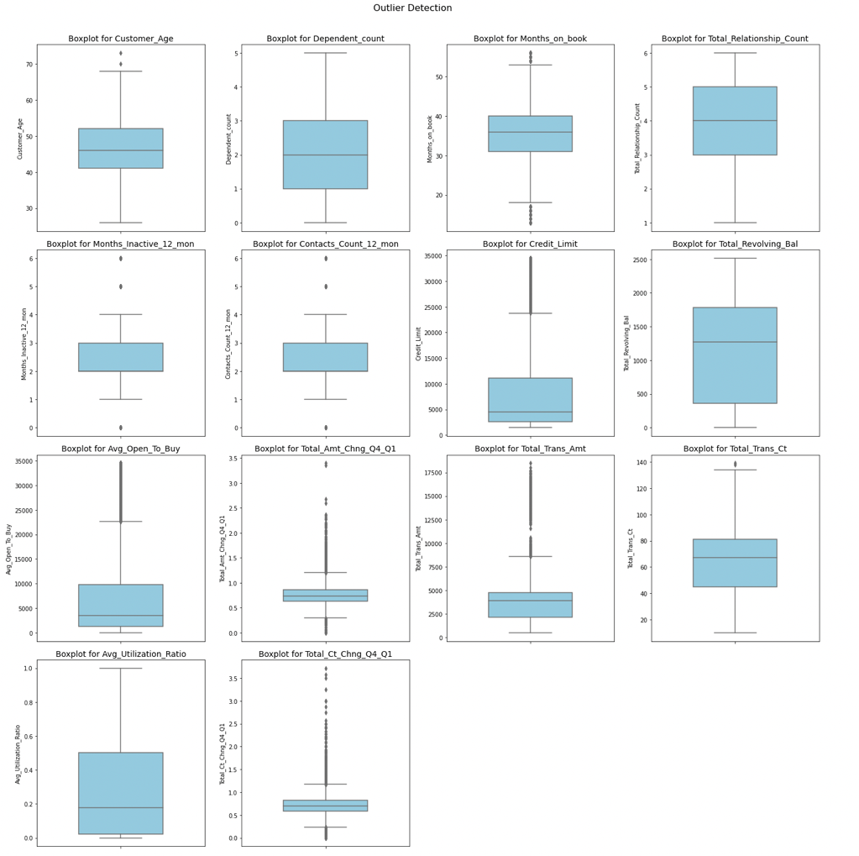

**Fig 17** – Outliers for 4 Datasets

### Statistics Summary

**Methodology:**

This report presents the results of summary statistics and custom percentiles for key numerical columns in the Loan Default dataset. These statistics and percentiles offer valuable insights into the distribution and characteristics of the data.

**Summary Statistics:**

We selected specific numerical columns for analysis, including 'loan_limit', 'loan_amount', 'rate_of_interest', 'Upfront_charges', 'Interest_rate_spread', and 'LTV'. These columns were chosen for their relevance to the dataset.

**Data Preprocessing:**

To ensure accurate analysis, we converted the selected columns to numeric data types. Any columns containing non-numeric data were excluded from the analysis. We handled errors gracefully to maintain data integrity.

**Analysis:**

We calculated both standard summary statistics and custom percentiles for each of the selected numerical columns.

Standard summary statistics, such as mean, standard deviation, minimum, 25th percentile (Q1), median (50th percentile), 75th percentile (Q3), and maximum, were computed and presented in the "Summary Statistics" section.

Custom percentiles (10th, 25th, 50th, 75th, and 90th percentiles) were calculated and are displayed in the "Custom Percentiles" section.

**Results:**

Below are the summary statistics and custom percentiles for the selected numerical columns:

**Summary Statistics:**

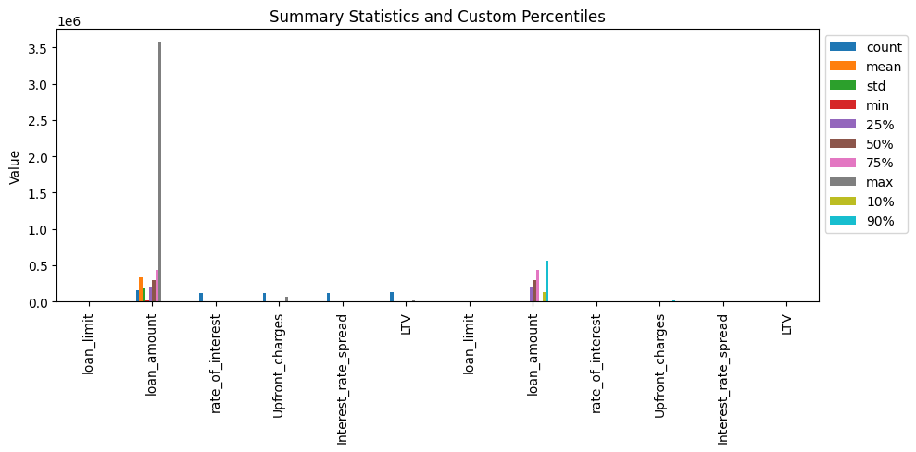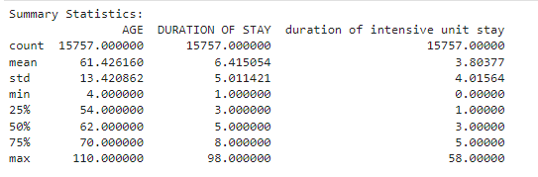

Fig 18 - Summary Statistics: Dataset 1

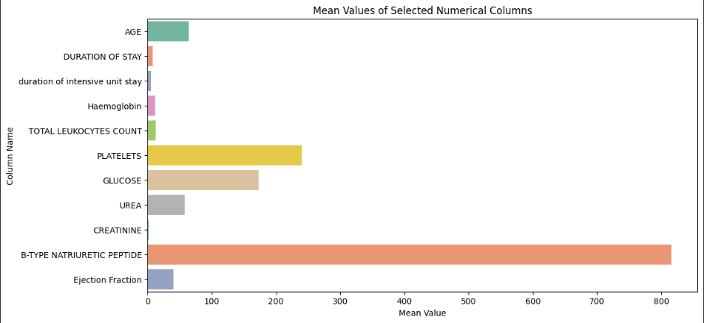

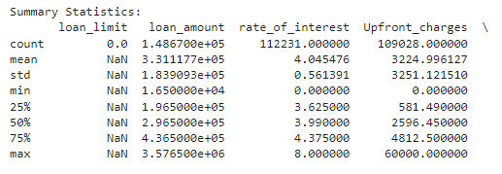 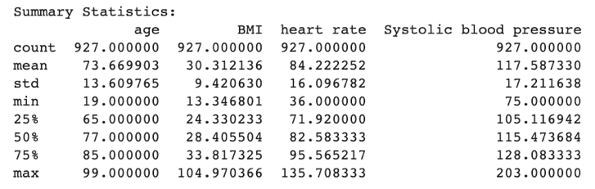

Fig 19-Summary Statistics: Dataset 2 & 3

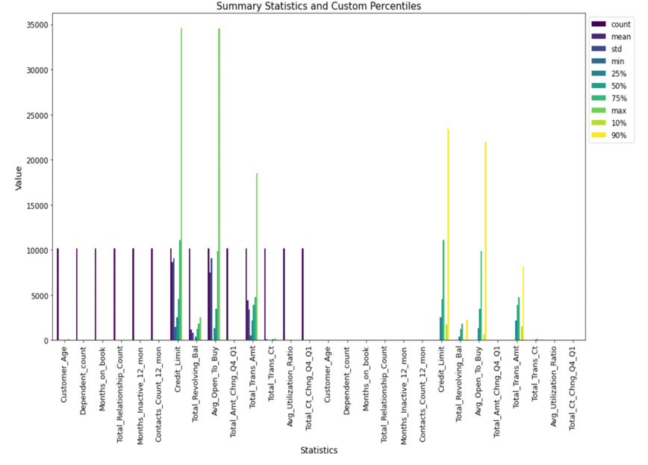

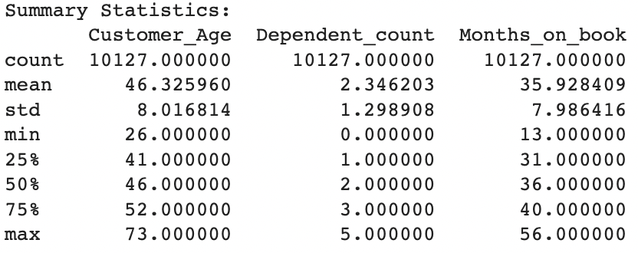

**Fig 20** - Summary Statistics for 4 Datasets

### Categorical Cardinality

**Methodology:**

This focuses on the analysis of categorical data within the Loan Default dataset. The cardinality of categorical columns is assessed, providing insights into the diversity and uniqueness of data within each category.

**Categorical Columns:**

We selected specific categorical columns for analysis, including 'ID', 'Gender', 'approv_in_adv', 'loan_type', 'loan_purpose', 'Credit_Worthiness', 'business_or_commercial', 'construction_type', 'occupancy_type', 'Secured_by', 'Region', 'Security_Type', 'Status', and 'dtir1'. These columns were chosen for their relevance to the dataset.

**Cardinality Assessment:**

We counted the number of unique values within each of the selected categorical columns, which is indicative of the diversity of data within those categories. Higher cardinality values suggest greater diversity.

**Results:**

Below are the counts of unique values for the selected categorical columns:

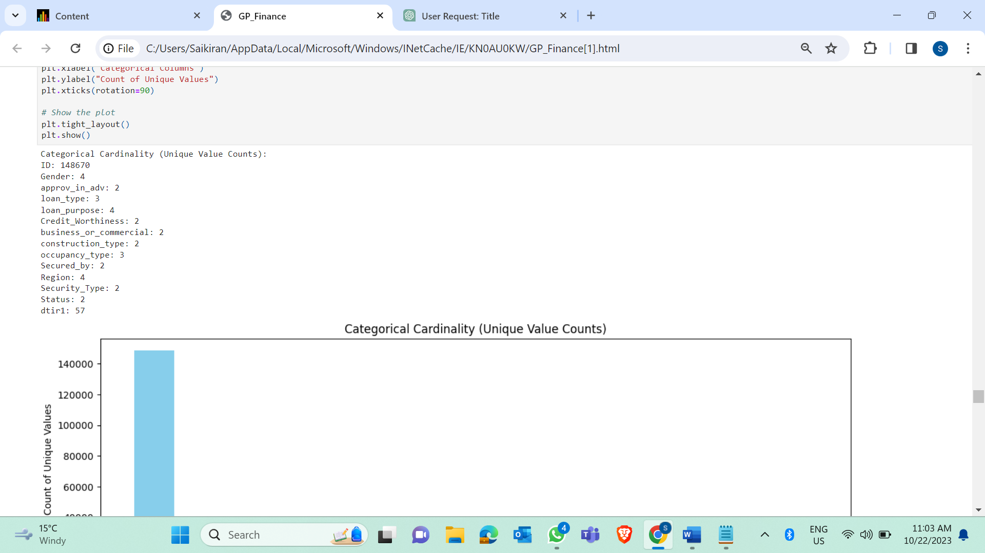

Fig 21- Unique Value Counts: Dataset 1 & 2

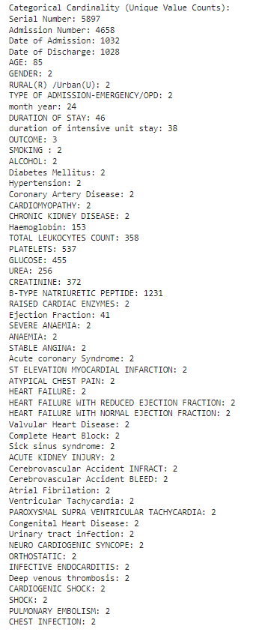

**Fig 22** - Unique Value Counts: Dataset 2

**Visualization:**

A visual representation of the counts of unique values in the categorical columns is provided through a bar plot, enabling a quick overview of the diversity and cardinality of each category.

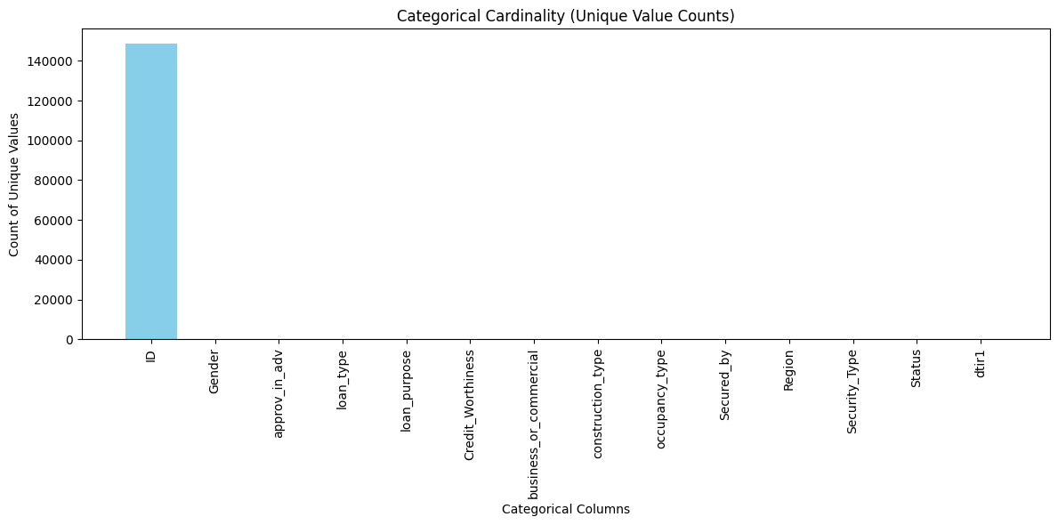

Fig 23- Categorical Cardinality: Dataset 1

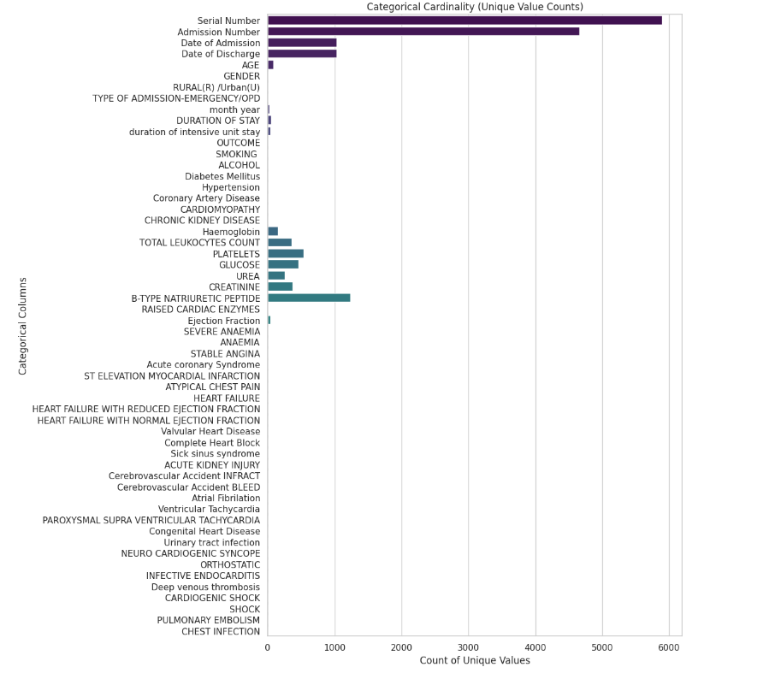

Fig 24- Categorical Cardinality: Dataset 2



**Fig 25** - Categorical Cardinality 4 Datasets

## Data Sources

**Healthcare Domain:**

Healthcare institutions are increasingly integrating data from diverse sources, including wearable devices, remote monitoring systems, and genetic testing, into patient records to enhance treatment and research capabilities.

**Finance Domain:**

In the finance domain, financial institutions often rely on external data sources such as credit bureaus, market feeds, economic indicators, and third-party financial data providers to enrich their data analytics and decision-making processes.

## Storage Medium

**Healthcare Domain:**

Patient data in healthcare is commonly stored in secure electronic health record (EHR) systems and data warehouses to ensure accessibility, security, and data integrity.

**Finance Domain:**

Financial data in the finance domain is typically stored in databases, data lakes, and cloud-based solutions, facilitating efficient data retrieval, analysis, and reporting.

## Storage Security

**Healthcare Domain:**

To protect patient data, healthcare organizations implement stringent security measures such as data encryption, access controls, and compliance with healthcare privacy regulations like HIPAA (Health Insurance Portability and Accountability Act).

**Finance Domain:**

In the finance domain, robust security protocols are essential to safeguard customer data and financial assets. Financial institutions adhere to strict compliance requirements and employ advanced cybersecurity measures to mitigate risks.

## Storage Costs

**Healthcare Domain:**

Managing storage costs in healthcare can be challenging due to the substantial volume of patient data. Healthcare institutions must strike a balance between data retention needs and budget constraints, often utilizing tiered storage solutions.

**Finance Domain:**

Financial institutions optimize storage costs by implementing data retention policies that align with regulatory requirements and industry best practices. They also leverage cost-effective cloud storage solutions to accommodate growing data volumes.

# Algorithms & Analysis / ML Model Exploration & Selection

## Solution Approach

### Data Flow Diagram (Schematic Flow)

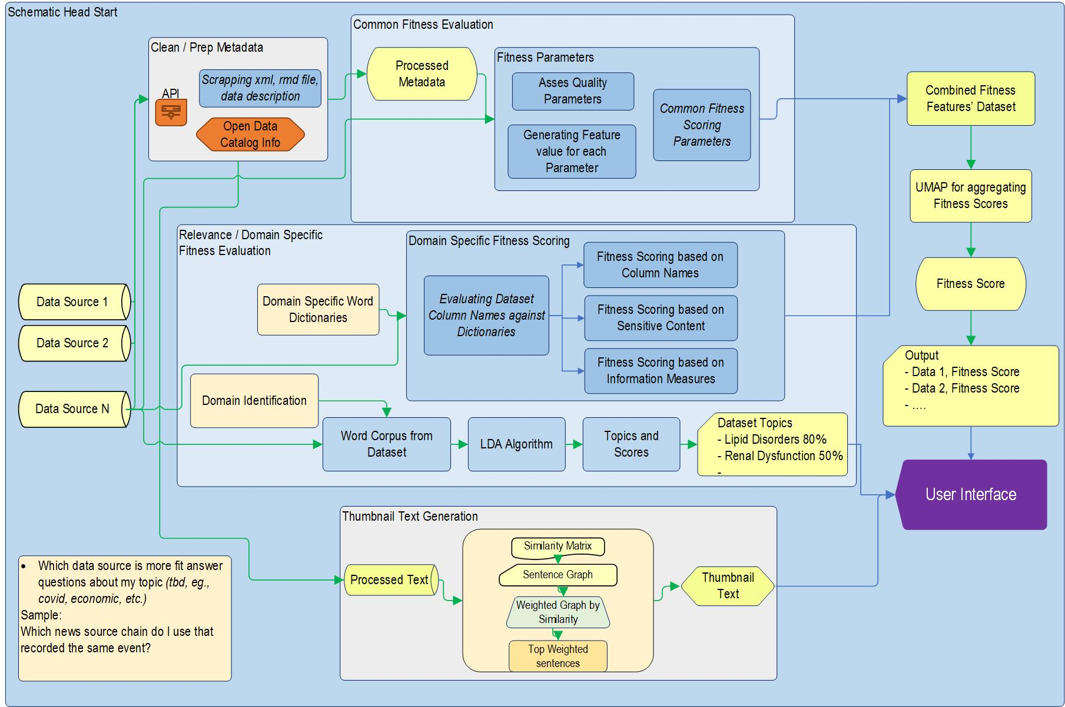

**Fig 26** – Schematic Flow

The data flow diagram above actually shows the three parallel workflows in progress at the same time for improving the Data Catalog according to data fitness,

1. The initial workflow, situated at the top of the data flow diagram, revolves around the comprehensive processing of data obtained from a multitude of designated sources. In this phase, the first step involves the identification of specific data quality and relevance rules that are tailored to the unique characteristics of the particular domain under consideration. These rules serve as crucial benchmarks against which each piece of data is meticulously evaluated, ensuring that it aligns with the predefined standards and objectives of the data catalog. As each dataset is subjected to evaluation against these domain-specific criteria, a distinct score is computed for every individual rule. This calculated score essentially represents the distinctive feature value associated with each dataset, signifying its performance and alignment with the identified rules. Consequently, datasets that achieve higher scores on these domain-specific features are deemed to be more suitable and competent in comparison to their counterparts, indicating their enhanced fitness and relevance within the context of the broader data catalog.
2. The second workflow, positioned in the middle of the data flow diagram, operates by effectively leveraging both metadata and data. Within this phase, the primary focus lies in the thorough analysis and processing of metadata and data in tandem. Through a systematic pipeline, the metadata, which provides essential information about the data, and the actual datasets themselves undergo a comprehensive evaluation aimed at identifying general data fitness parameters. These parameters serve as comprehensive benchmarks, guiding the evaluation process to determine the overall fitness of the datasets within the Data Catalog. Each dataset is rigorously assessed against these identified general data fitness parameters, thereby generating individual scores for each dataset based on their compliance with the predetermined parameters. These scores, when combined with the scores obtained from the first workflow, serve as key components in the determination of the final data fitness score for each dataset. By integrating the scores from both the domain-specific evaluation and the general data fitness parameters, a holistic assessment is made, providing a comprehensive understanding of the relative fitness of each dataset in comparison to others within the Data Catalog.
3. The final workflow, situated at the bottom of the data flow diagram, is designed to offer an informative introduction about each dataset to the viewer or user. This process involves a specific approach that utilizes the text rank algorithm to efficiently process the data description associated with each dataset. The primary aim is to distill the key aspects and essential information pertaining to the dataset into a concise and easily understandable format. The text rank algorithm, a method employed for natural language processing, plays a pivotal role in the process. It systematically analyzes the textual content and relevant descriptions linked to the datasets, identifying crucial elements and significant insights. Through this meticulous analysis, the algorithm generates a succinct and comprehensive summary, condensing the essential aspects of the dataset's content and features into a condensed and easily digestible form. The summarized thumbnail text, crafted through the utilization of the text rank algorithm, serves as a valuable tool in providing viewers with a quick and informative overview of the dataset's key attributes. By condensing the dataset's description into a concise format, it enables users to swiftly grasp the fundamental aspects and significance of the dataset, facilitating a more efficient and streamlined understanding of its contents.

### General Parameters

In order to find out whether our dataset is fit based on the general parameters which include Data Completeness, Data Consistency, Outliers, Summary Statistics and Categorical Cardinality, as discussed in the Quality Assessment of Section 2, we would like to calculate the scores based on their quality.

**Quality Score Calculation for Data Completeness and Data Consistency:**

To provide a comprehensive quality assessment, we calculate an overall quality score. This score is an average of the data completeness and data consistency scores:

The overall quality score reflects the combined quality of the dataset, considering both data completeness and data consistency.

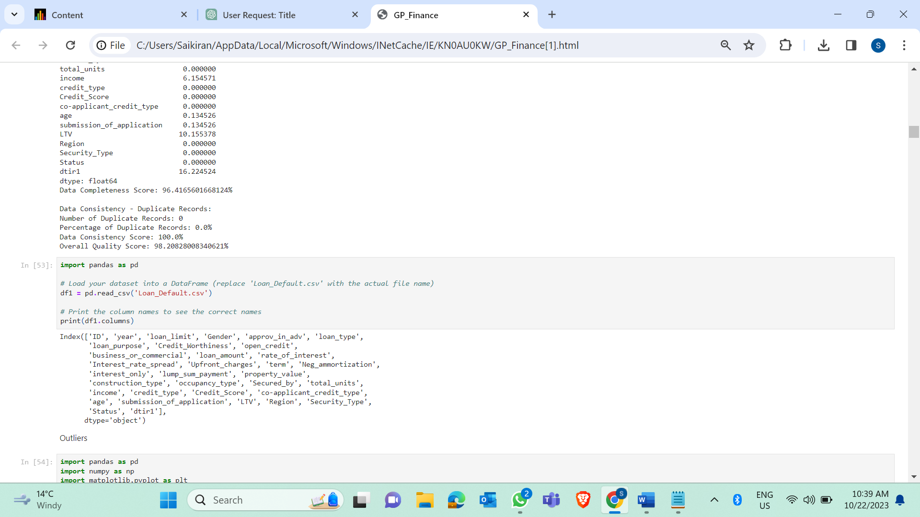

Fig Overall Quality Score : Dataset 1

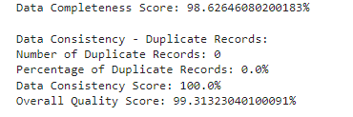

Fig Overall Quality Score : Dataset 2

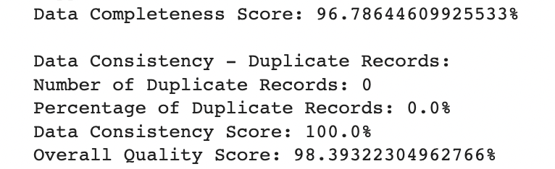

Fig Overall Quality Score : Dataset 3

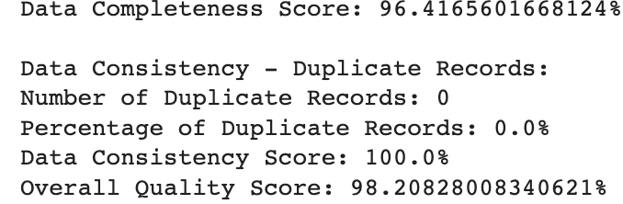

**Fig 27** - Overall Quality Score for 4 Datasets

**Outlier Identification:**

We identified and printed the outliers for each of the selected columns. Outliers are data points that fall outside the bounds defined by the IQR.

The identification of outliers is crucial for data analysis and modeling. Outliers can significantly impact the results and need to be handled carefully, whether by removal, transformation, or further analysis. In the context of the Loan Default dataset, understanding the outliers in attributes such as loan amount, interest rates, and LTV is important for making accurate predictions and decisions.

**Quality Score Calculation for Outliers:**

For each specified column, we performed the following steps:

1.Calculated the Interquartile Range (IQR) to define lower and upper bounds for identifying outliers.

2.Identified outliers as data points falling below the lower bound or above the upper bound.

3.Calculated the quality score for each column, where a lower score indicates a better quality. The quality score is calculated as 100 minus the percentage of outliers.

**Quality Score Results for Outliers:**

We have calculated and presented the quality scores for each of the specified columns. These scores help assess the data quality in terms of outliers:

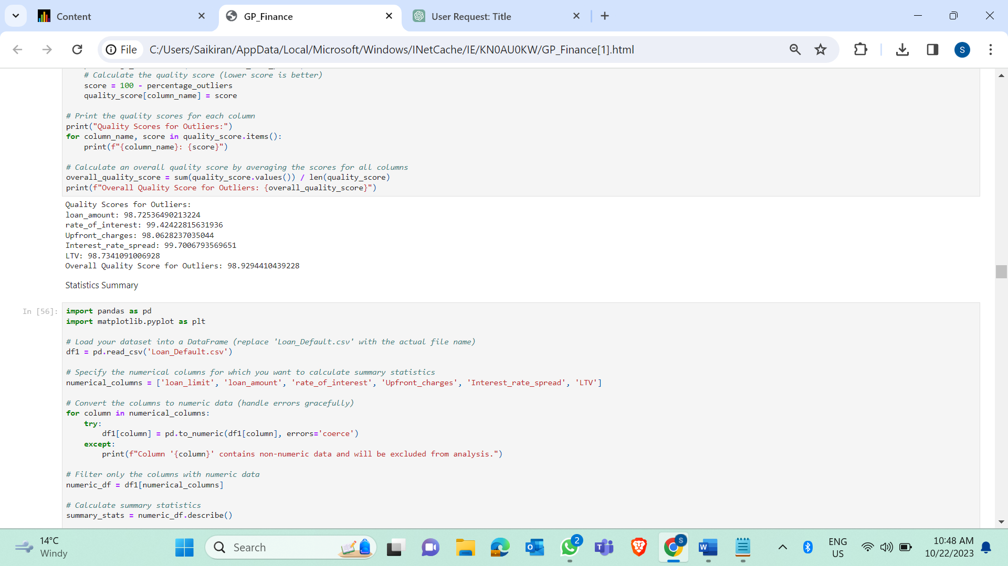

Fig Quality Score For Outliers : Dataset 1



Fig Quality Score For Outliers : Dataset 2



Fig Quality Score For Outliers : Dataset 3

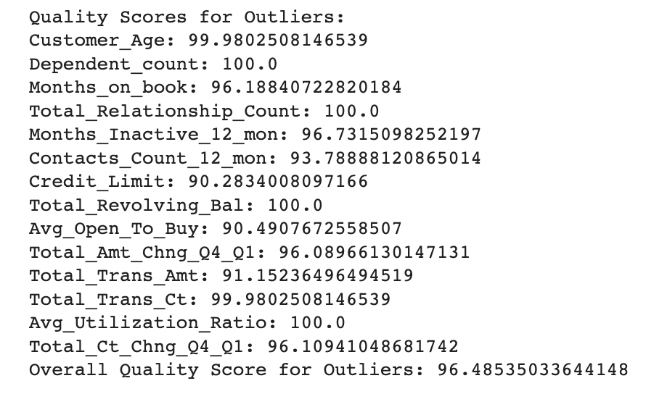

**Fig 28** - Quality Score for Outliers 4 Datasets

**Quality Score Calculation for Summary Statistics:**

We conducted a comprehensive quality assessment by considering multiple aspects:

1.Missing Values: We calculated the number of missing values for each column, as data completeness is crucial for accurate analysis.

2.Range: We computed the range (max - min) for each column to assess the spread of the data.

3.Standard Deviation: We calculated the standard deviation for each column, which measures the data's dispersion.

**Quality Scores:**

For each of the selected columns, we calculated quality scores based on the above assessments. We considered the following factors for quality scoring:

Missing values: A higher score indicates a lower percentage of missing data.

Range: A higher score indicates a broader data range.

Standard Deviation: A higher score indicates lower data dispersion.

The individual scores for missing values, range, and standard deviation were calculated and then averaged to obtain an overall quality score for each column.

**Results:**

Below are the quality scores for the selected numerical columns:

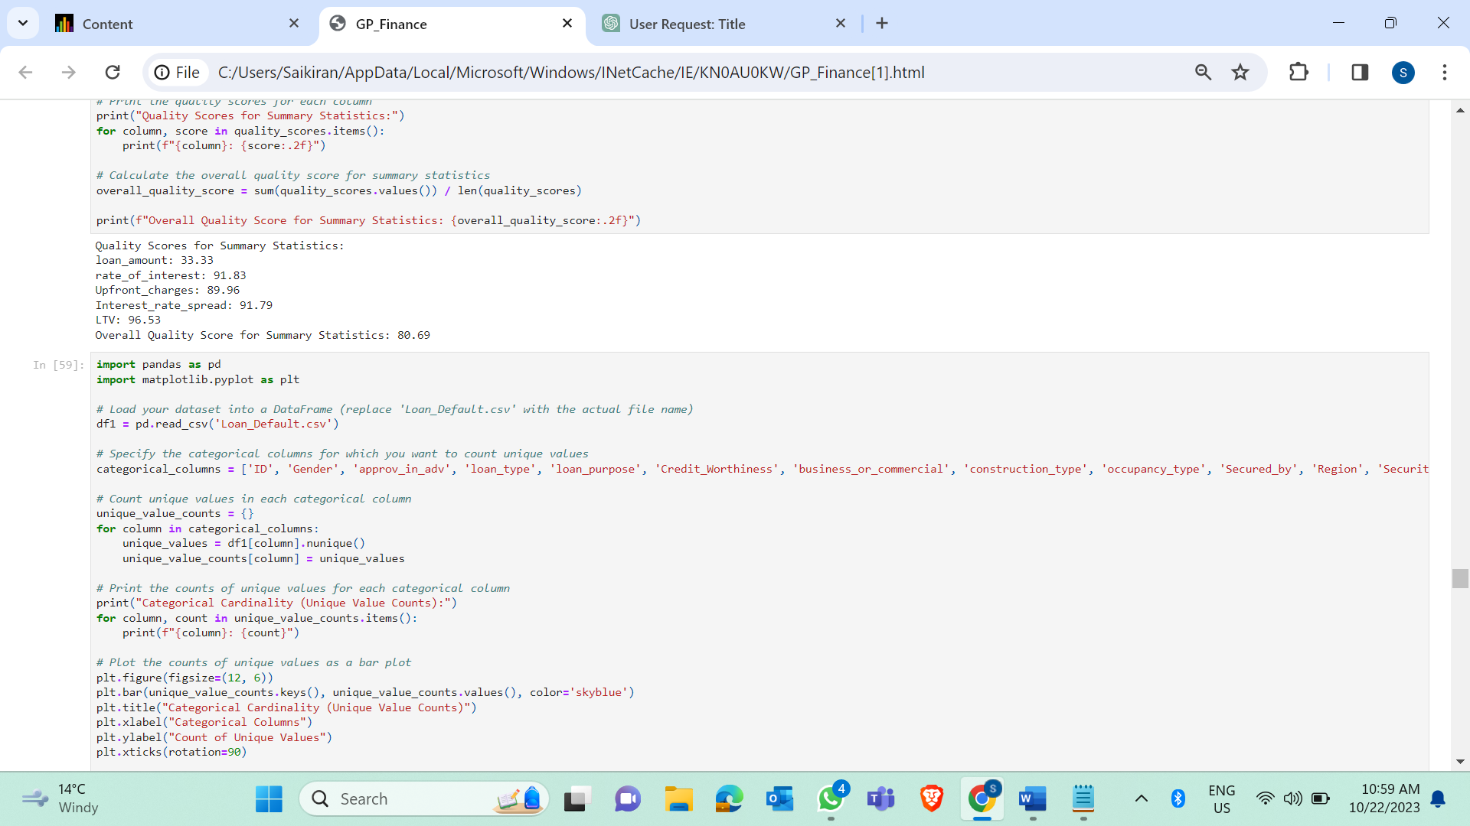

Fig Quality Score for Statistical Summary: Dataset 1



Fig Quality Score for Statistical Summary: Dataset 2



Fig Quality Score for Statistical Summary: Dataset 3

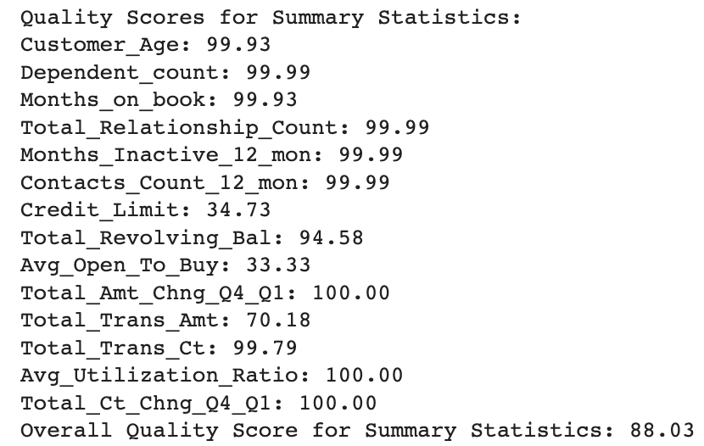

**Fig 29** - Quality Score for Statistical Summary: Dataset 4

**Quality Score Calculation for Categorical Cardinality:**

We calculated the counts of unique values within each of the selected categorical columns. These counts are indicative of the diversity of data within each category.

**Quality Scores:**

For each categorical column, we computed quality scores that indicate the diversity of data within each category, with scores ranging from 1 to 100. A higher score reflects greater diversity.

The overall quality score is determined by averaging the individual quality scores for all selected categorical columns.

**Results:**

Below are the quality scores for the selected categorical columns:

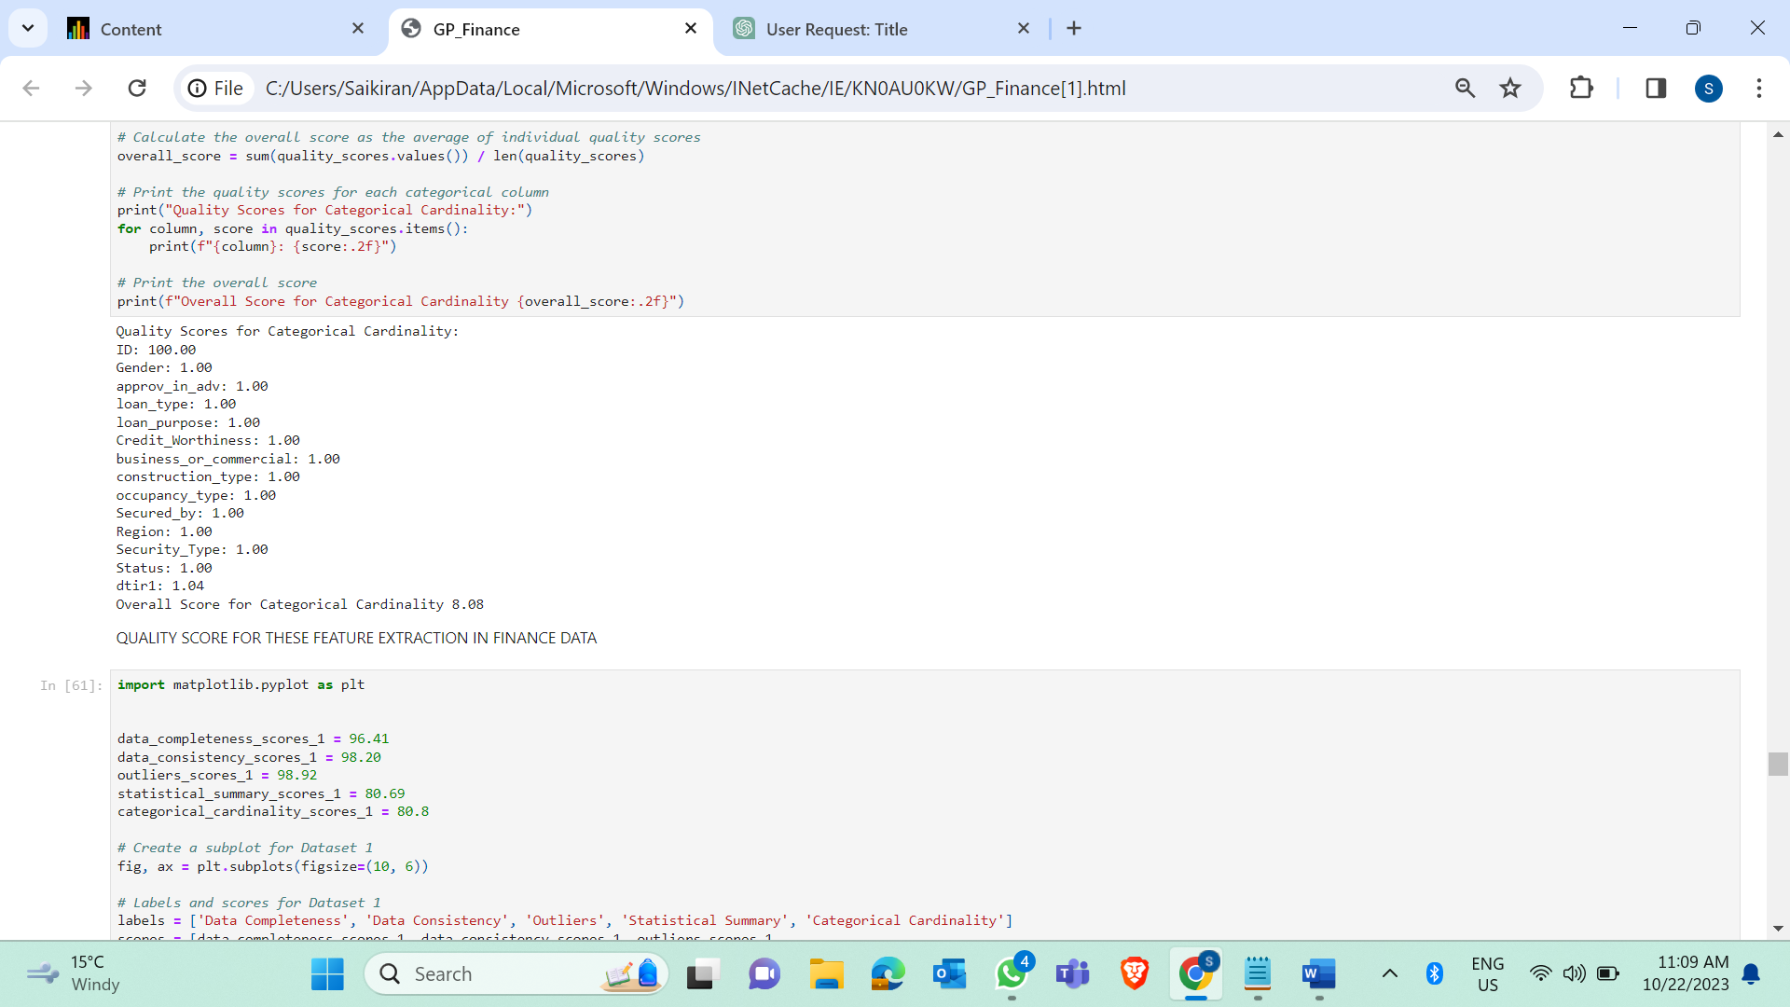

Fig Quality Score for Categorical Cardinality: Dataset 1



Fig Quality Score for Categorical Cardinality: Dataset 2



**Fig 30** – Quality Score for Categorical Cardinality: Dataset 4

### Fitness Scores based on General Parameters

The quality scores in the different datasets are visualized in the bar charts below:

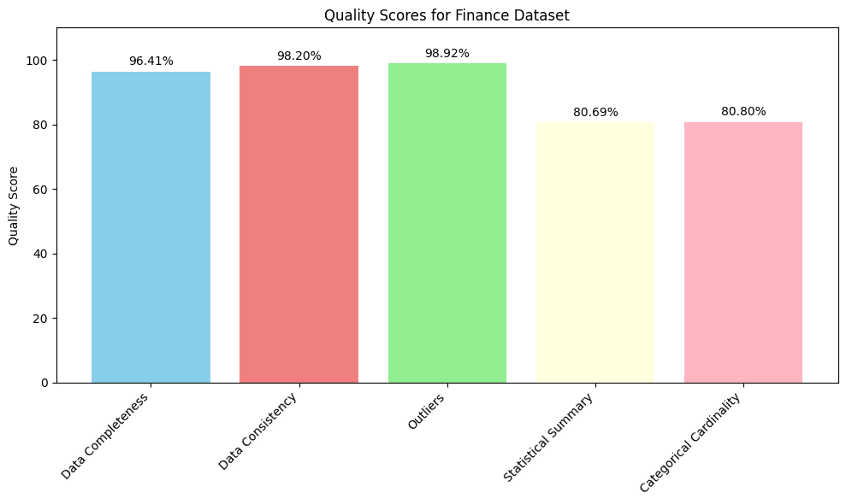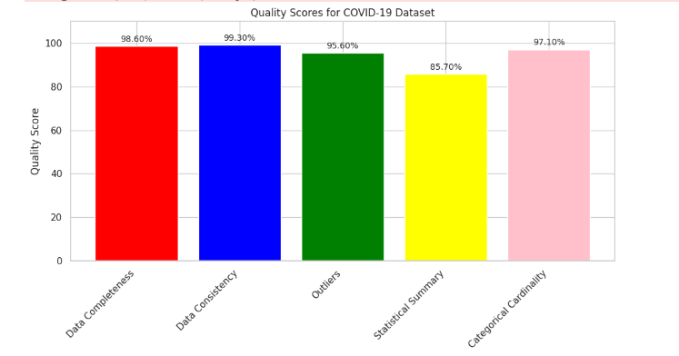

Fig 31- Overall Quality Scores: Dataset 1 & 2

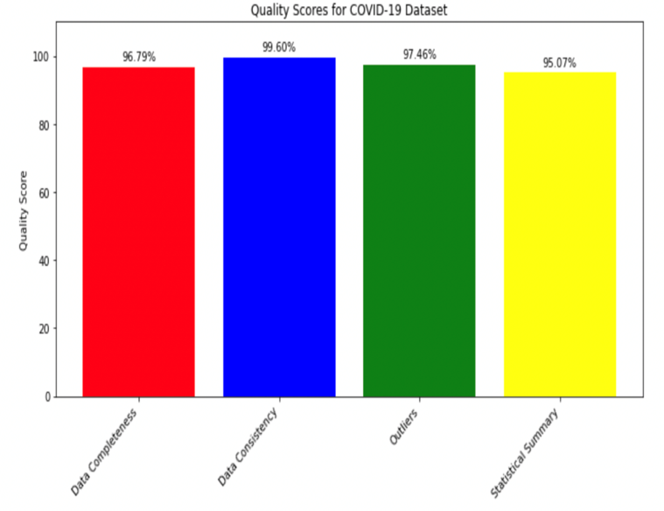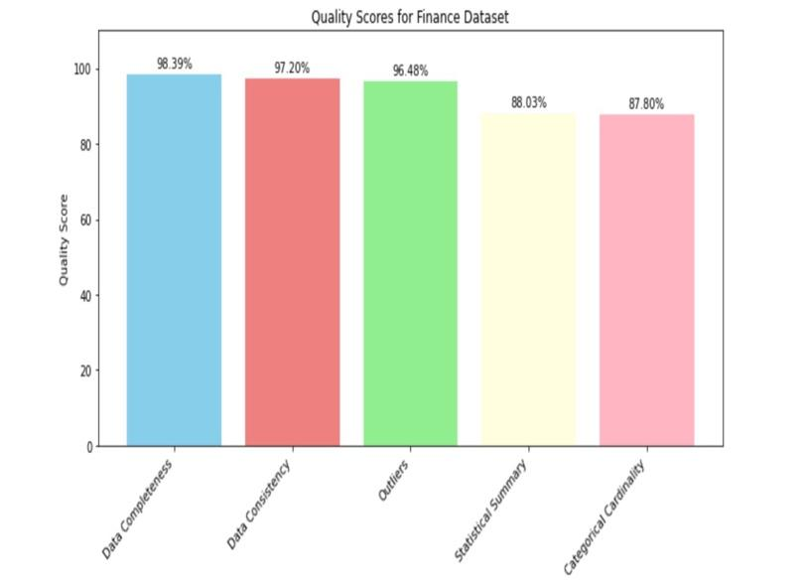

Fig 32-Overall Quality Scores: Dataset 3 & 4

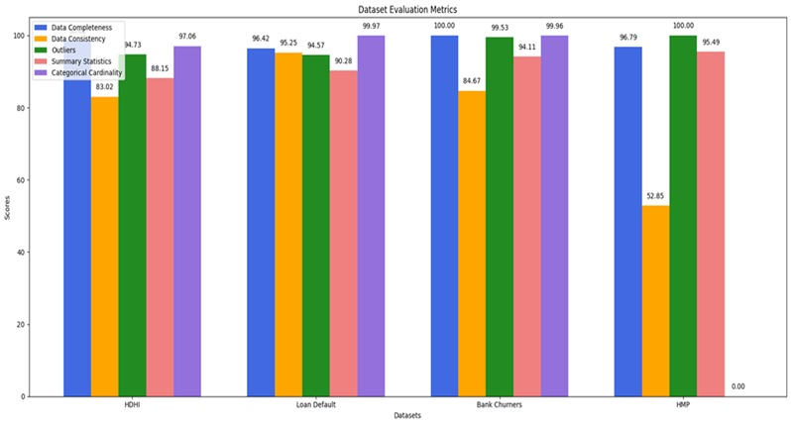

**Fig 33** Fitness Scores based on General Parameters for 4 Datasets

### Data Flow for Domain-based Feature Extraction

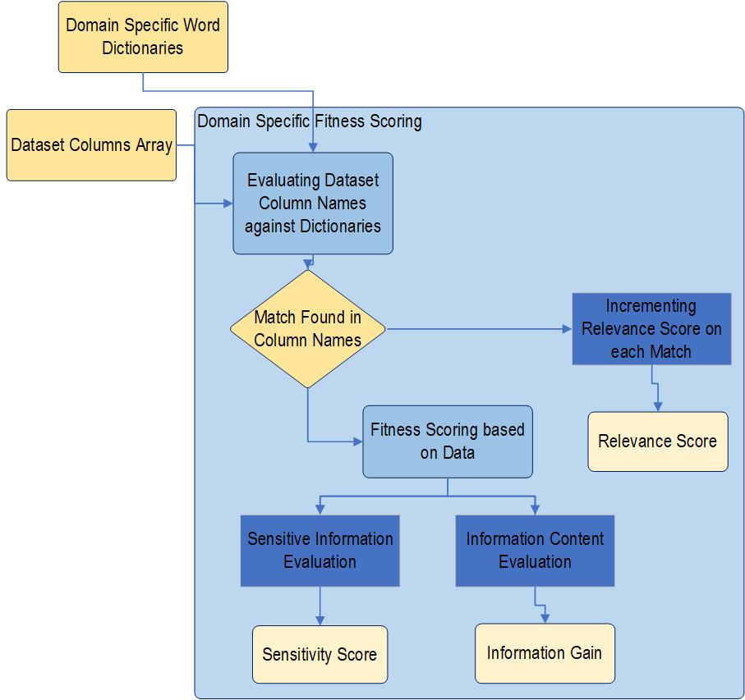

**Fig 34** – Schematic for Domain-Based Features Extraction

### Features Extraction for Domain (Relevance)

Scoring a dataset based on its importance to the domain involves a comprehensive assessment of the dataset's relevance and significance within its specific field and it is ultimately very significant for the users who are comparing multiple datasets. This process considers the dataset's ability to address critical research questions, contribute to domain knowledge, and impact decision-making or advancements within that domain. Factors such as the dataset's alignment with the core research objectives, its potential to facilitate breakthrough discoveries, its historical significance, and its ability to inform policy or practice are pivotal in assigning an importance score. Additionally, the dataset's recognition within the academic or professional community, as evidenced by citations and utilization in influential research, further substantiates its significance. In essence, scoring a dataset's importance to its domain requires a nuanced evaluation that considers both the immediate and long-term contributions it can make to advancing knowledge and improving outcomes within its specialized field of study.

* **Healthcare Domain**

When evaluating a healthcare dataset for comparison with other datasets, several critical features should be considered. These features encompass data quality, relevance, and usability. Firstly, the dataset's clinical accuracy and completeness are fundamental, ensuring that it provides reliable and comprehensive healthcare information. Second, the dataset's relevance to the specific research objectives or clinical applications at hand is essential, as it should align closely with the questions being addressed. Furthermore, aspects such as data timeliness, accessibility, and ethical compliance should be assessed, ensuring that the dataset is up-to-date, readily available, and complies with privacy regulations. Finally, the dataset's ease of integration, interoperability, and documentation quality also play significant roles in its evaluation. Evaluating a healthcare dataset against these features allows for informed comparisons, aiding researchers, and healthcare professionals in selecting the most suitable dataset for their specific needs and goals[[14](https://www.sages.org/publications/guidelines/is-per-oral-endoscopic-myotomy-poem-more-effective-than-pneumatic-dilation-and-heller-myotomy-a-systematic-review-and-meta-analysis/)].

Following are the specific features against which we will be evaluating the healthcare datasets,

1. **Relevance to Healthcare Research:**

Assess how closely the dataset aligns with the specific healthcare research questions or objectives you have. Relevance to healthcare is a primary usability factor.

1. **Granularity:**

Consider the level of detail and granularity in the dataset. Determine whether it provides data at the level of detail needed for your analysis, e.g., patient-level, facility-level, or population-level data.

1. **Consistency Across Time and Regions:**

Check if the dataset maintains consistency across different time periods, geographic regions, or subpopulations. Consistency is crucial for healthcare research.

1. **Timeliness:**

In healthcare, timely data is essential. Determine if the dataset is updated regularly to reflect current healthcare practices and trends.

1. **Privacy and Security:**

Given the sensitive nature of healthcare data, assess the dataset's compliance with privacy regulations such as HIPAA (for U.S. datasets) and its security measures to protect patient information.

1. **Interoperability:**

Evaluate whether the dataset is compatible with standard healthcare data formats (e.g., HL7, FHIR) and can be integrated with other healthcare systems or datasets.

1. **Clinical Significance:**

Assess the clinical significance of the dataset. Datasets that contain information about diseases, treatments, outcomes, or patient characteristics relevant to clinical practice may be of high importance.

1. **Epidemiological Value:**

Consider whether the dataset supports epidemiological studies, disease surveillance, or public health research. Datasets that contribute to understanding disease trends and prevention are important.

1. **Longitudinal Analysis Potential:**

Determine if the dataset allows for longitudinal analysis, which is essential for tracking patient outcomes over time and assessing the effectiveness of healthcare interventions.

1. **Healthcare Policy Relevance:**

Evaluate whether the dataset can inform healthcare policy decisions, healthcare resource allocation, or healthcare system improvements.

1. **Collaboration Opportunities:**

Consider whether the dataset encourages collaboration with healthcare institutions, researchers, or policymakers, which can enhance its importance and usability.

1. **Public Health Impact:**

Reflect on the potential public health impact of research conducted using the dataset. Datasets that can contribute to improving public health may be highly important.

1. **Ethical Considerations:**

Consider ethical considerations associated with the use of healthcare data, such as informed consent and ethical research practices.

#### Determining Granularity

Determining the granularity of data within a dataset involves assessing the level of detail or specificity contained in each column. By utilizing the concept of information entropy, it is possible to quantify the amount of uncertainty or randomness present in the data distribution of each column. Higher entropy suggests a greater diversity of values and potentially a finer level of granularity, indicating a more detailed or varied dataset. Conversely, lower entropy signifies a more uniform or restricted distribution of values, implying a coarser granularity with less variation or specificity in the dataset. By analyzing the information entropy across different columns, it becomes feasible to identify the varying degrees of granularity within the dataset, thereby enabling a comprehensive understanding of the data’s intricacies and levels of detail[[6](https://www.precisely.com/glossary/data-integration)].

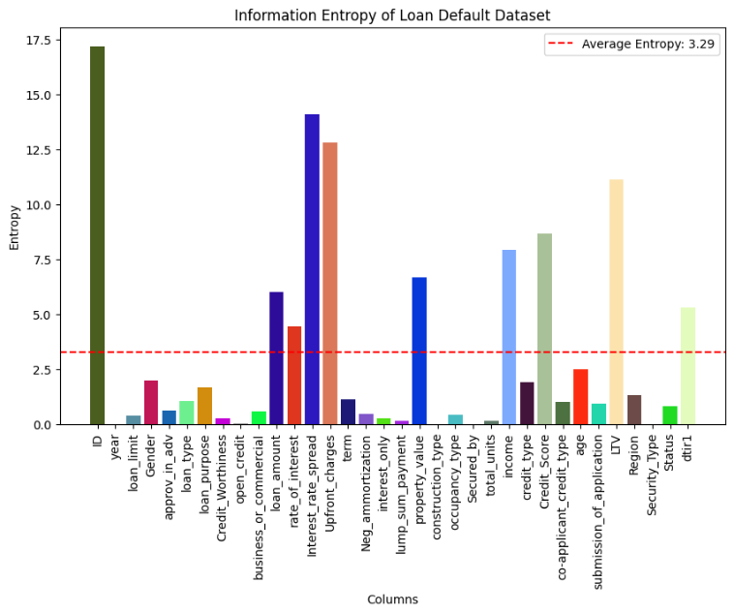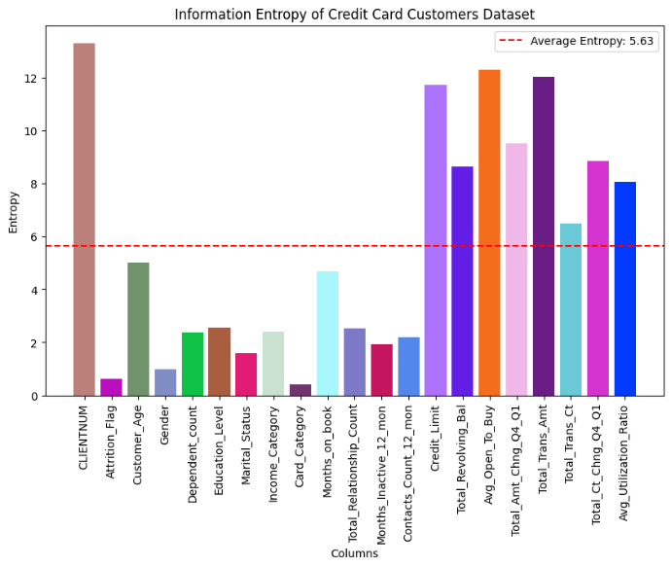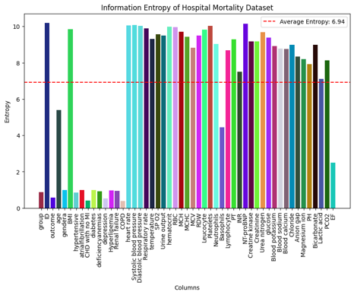

**Fig 35 –** Viz of Information Entropy for our datasets

#### Determining Epidemiological value

Determining the epidemiological value of a healthcare dataset involves assessing the broader population health implications, disease trends, risk factors, and the overall impact on public health. This assessment typically entails the analysis of disease prevalence, incidence rates, and distribution patterns within specific populations. By examining the dataset for key epidemiological indicators such as demographic information, geographic location, and temporal trends, researchers can identify high-risk populations, track disease outbreaks, and evaluate the effectiveness of public health interventions. Moreover, investigating the relationships between various health variables and exploring the impact of social determinants of health can provide valuable insights into the underlying factors contributing to disease burden and healthcare disparities. Through robust statistical analyses, trend identification, and predictive modeling, the epidemiological value of the dataset can be determined, enabling policymakers and healthcare professionals to implement targeted strategies for disease prevention, health promotion, and effective resource allocation.





**Fig 37** – Word Cloud for Epidemiological Corpus

#### Determining Economic Significance

**Fig 36** – Word Cloud for HDHI Data – Column Matches

To calculate the economic significance of a dataset, various financial parameters are considered. The Profitability Ratio, obtained by dividing Open Credit by Loan Limit, provides insights into the efficiency of credit utilization. A higher ratio suggests better utilization of available credit. The Interest Coverage Ratio, derived from Income divided by the Rate of Interest, signifies a borrower's ability to cover interest expenses with their income. A high ratio indicates a robust ability to manage interest payments. Additionally, the Credit Utilization Ratio, computed as Total Revolving Balance divided by Credit Limit, reflects how much of the available credit a borrower has used. A lower ratio typically indicates better financial health and prudent credit management. These metrics collectively offer a comprehensive evaluation of the economic significance of the dataset, enabling a nuanced understanding of financial dynamics within the analyzed context.

* Profitability Ratio = Open Credit / Loan Limit

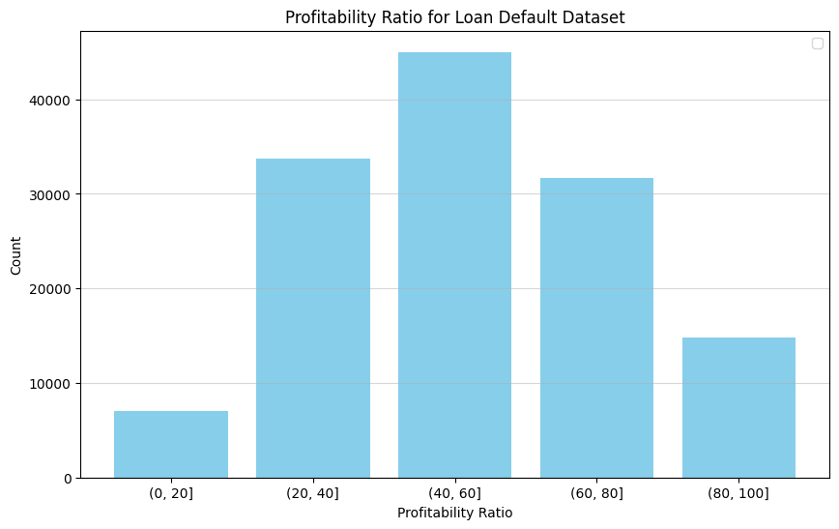

* Interest Coverage Ratio = Income / Rate of Interest

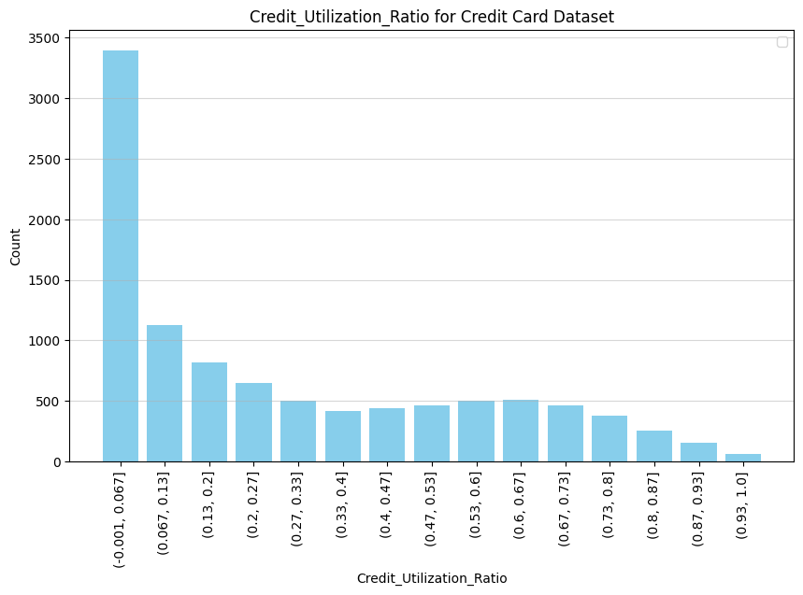

* Credit Utilization Ratio = Total Revolving Balance / Credit Limit

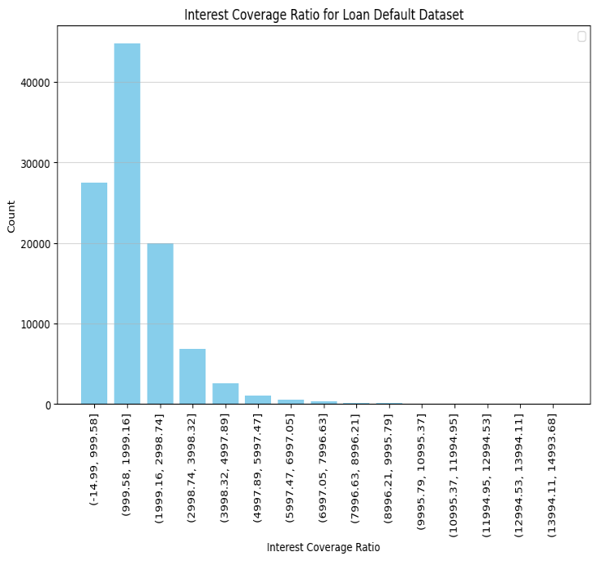

**Fig 38 –** Economic Significance Metrics

#### Dataset Sensitivity and Relationship Score Analysis Report

Understanding the sensitivity and relationships within a dataset is crucial for comprehensive data analysis. Sensitivity refers to the identification of critical data points that may significantly impact the overall analysis, while relationship score focuses on the interdependencies and correlations among different variables in the dataset[[8](https://mycalcu.com/blog/capm-calculator-for-stock-analysis)].

**1. Sensitivity Score Calculation:**

The sensitivity score is determined based on the impact of specific data points or features on the overall dataset. In this analysis, we followed these steps:

* Identify the key parameters or features that are of critical importance for the analysis.
* Evaluate the range and distribution of these parameters within the dataset.
* Assign a sensitivity score based on the significance of each parameter, considering factors such as data range, variability, and potential influence on the analysis outcomes.

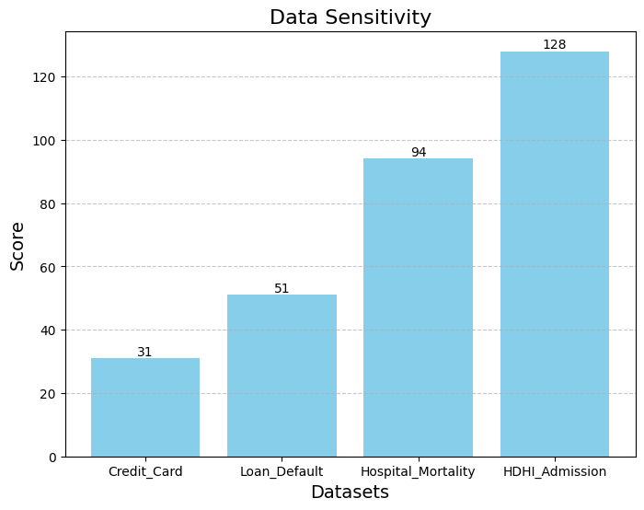

**Fig 39** – Viz for Data Sensitivity of 4 datasets

The sensitivity score analysis revealed that certain parameters, such as lab results, and account information, have a higher impact on the overall dataset. These parameters exhibited significant variability and influence, indicating their critical role in the data analysis process.

**2. Relationship Score Calculation:**

The relationship score measures the interdependence and correlations between different variables in the dataset. The process involved the following steps:

* Conduct a comprehensive correlation analysis to identify the strength and direction of relationships between variables.
* Calculate correlation coefficients, such as Pearson's correlation coefficient or Spearman's rank correlation coefficient, to quantify the relationship strength.
* Assign a relationship score based on the magnitude of the correlation coefficients, considering both positive and negative correlations.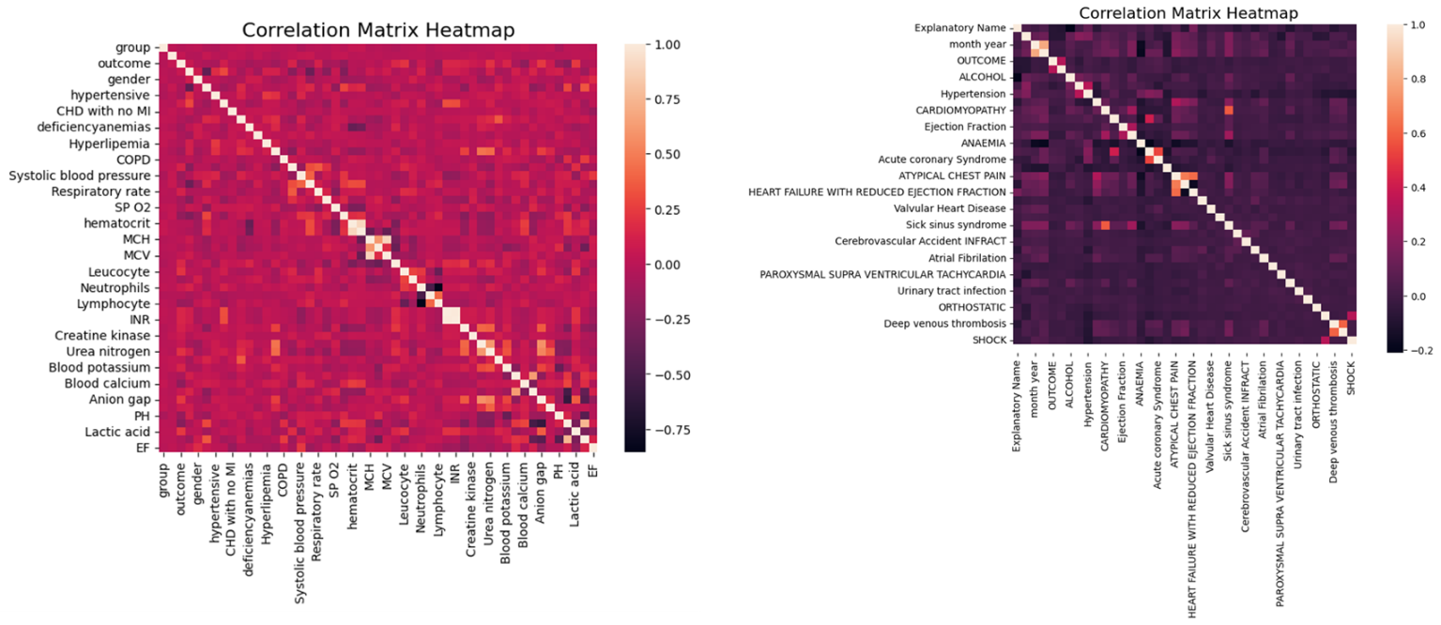

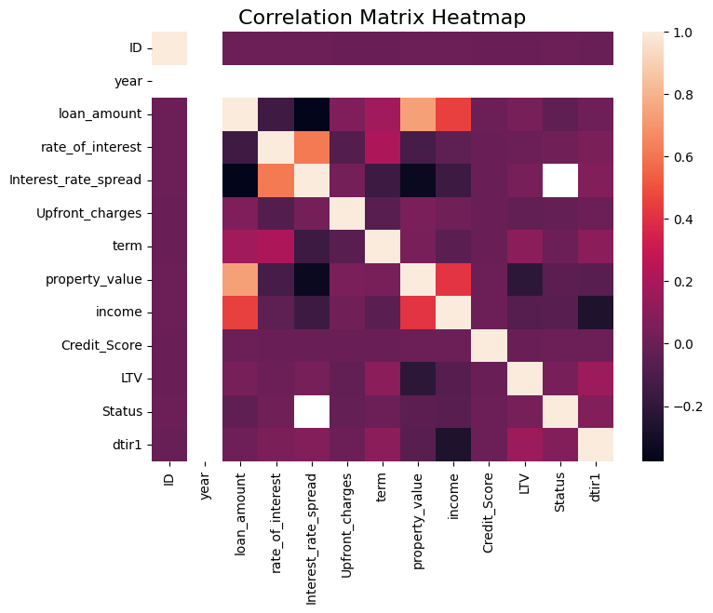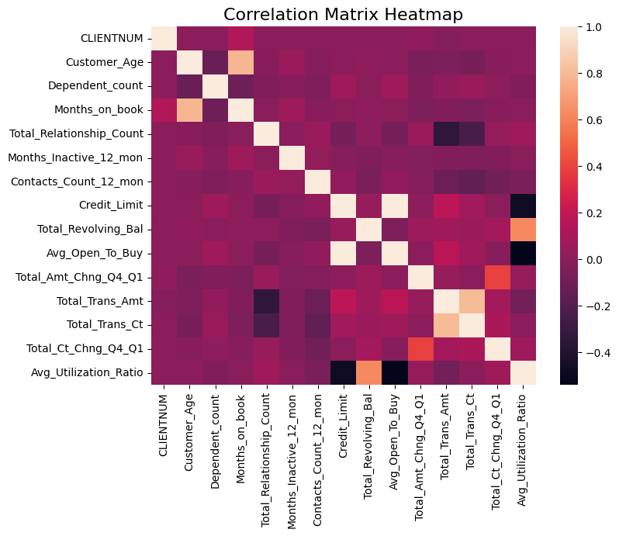

**Fig 40** – Comprehensive Correlation Analysis

The relationship score analysis demonstrated strong correlations between certain variables, as well as a negative correlation between others. These findings suggest a complex interdependence among specific variables, highlighting potential trends and patterns within the dataset.

The sensitivity and relationship score analysis provided valuable insights into the critical data points and interdependencies within the dataset. Understanding the sensitivity of key parameters helps prioritize data processing and analysis, while evaluating relationship scores aids in identifying significant associations and trends. These scores contribute to informed decision-making and enhance the overall quality and reliability of the data analysis process[[9](https://www.trustindex.io/behavioral-marketing-strategies/)].

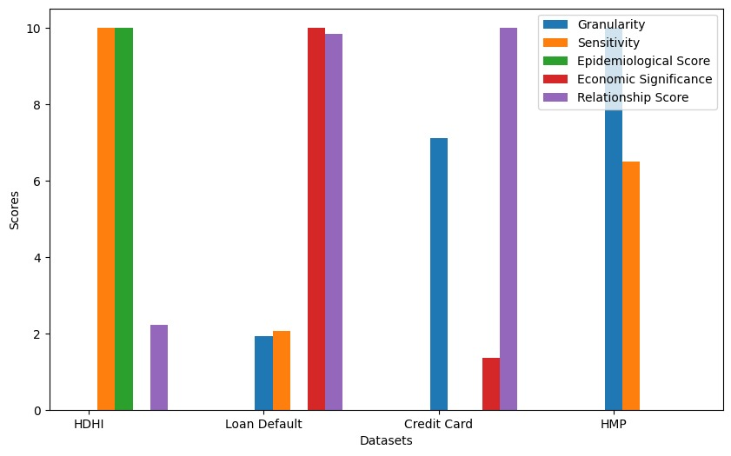

### Data frame with Overall Fitness Score

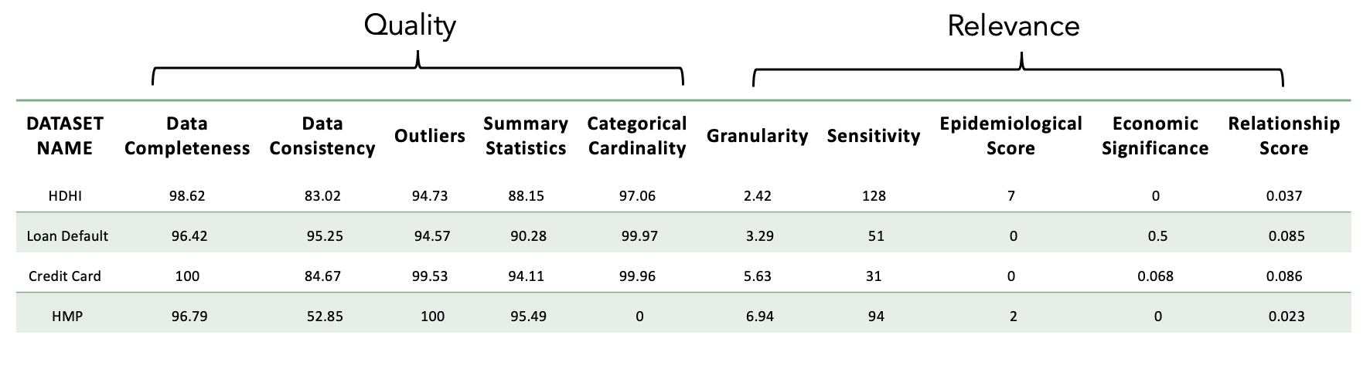

### Fig 41-Data frame with Overall Fitness Score

### Thumbnail Features

In order to make it appealing for the users, we have tried to include thumbnails into the catalog even after finding fitness scores based on quality and relevance. As part of these thumbnails, we have included Summarized Dataset Description, Key Descriptors, Key Topics.

#### Summarized Dataset Description using Text Summarization

We have used Text Summarization using NLP to generate a summary of the dataset description.

**Text Summarization using NLP:**

Extracting thumbnail text from metadata using the TextRank algorithm involves several steps, which are designed to identify the most informative and concise text snippet that represents the metadata.

TextRank is an extractive and unsupervised text summarization technique that helps to identify the most significant pieces of information in a text. It functions by building a graph for the text, with each node representing a sentence. The algorithm then iterates over the graph, assigning a score to each sentence based on the scores of the sentences linked to it. The links between sentences represent similarity scores, and the iterative process of score updating is similar to how Google's PageRank algorithm ranks web pages[[1](https://loremipsum.io/.)].

The core idea behind TextRank is that sentences that are similar to many other sentences in the text are likely to be more important. The similarity between two sentences is determined based on the overlap in their content — such as shared words or phrases. This is analogous to the concept of "voting" or "recommendation." When one sentence is similar to another, it is considered to be "voting" for that other sentence. The more votes a sentence has, the higher its score, and the more likely it is to be included in the summary.

TextRank is particularly useful because it doesn't require any training data; it can operate on any given piece of text without needing to learn from a corpus of annotated examples. This makes it a flexible algorithm that can be applied to diverse domains and languages. Additionally, being unsupervised, it reduces the need for costly and time-consuming manual annotation work[[11](https://community.dataiku.com/t5/General-Discussion/Natural-Language-Processing-How-It-Works-In-Plain-English/td-p/15176)].

In practical terms, TextRank can be employed for summarizing data sets, descriptions, abstracts, articles, or even larger documents where key sentences and phrases need to be highlighted. This algorithm is also used in keyword extraction, where it helps to find the terms that best represent the content of the text.

Here’s a detailed process:

1. **Metadata Extraction:**

Begin by extracting the metadata associated with a particular document, image, video, or web page. Metadata typically includes information such as titles, descriptions, and tags.

1. **Text Tokenization:**

Tokenize the extracted metadata into smaller units, such as sentences or phrases. This step breaks down the text into more manageable pieces for analysis.

1. **Building the TextRank Graph:**

Construct a graph where each node represents a tokenized unit of text (e.g., a sentence or phrase) from the metadata. Create edges between nodes to represent the relationships or similarities between these text units.

1. **Scoring Text Units:**
2. Assign initial scores to each text unit (node) within the graph. These scores serve as indicators of importance. TextRank relies on the similarity between text units to calculate scores. Common similarity measures include cosine similarity or Jaccard similarity.

Iterate through the graph and update the scores of text units based on their relationships with other text units. This iterative process refines the scores to identify the most relevant and significant text units.

1. **Iterative Refinement:**

Continue iterating through the graph until the algorithm reaches convergence or a predefined number of iterations. During each iteration, the scores of text units are updated, considering their relationships with other units.

1. **Selecting Thumbnail Text:**

Once the iterations are complete, select the text unit with the highest score. This text unit represents the most informative and significant portion of the metadata. This selected text unit will serve as the thumbnail text, providing a concise and meaningful representation of the metadata[[20](https://ideas.repec.org/a/gam/jsusta/v11y2019i14p3892-d249220.html)].

1. **Creating the Thumbnail:**

Use the chosen thumbnail text to create a thumbnail or preview of the document, image, video, or web page. The thumbnail can include the selected text along with other relevant visual elements, such as an image or a video frame, to provide context. The TextRank algorithm’s strength lies in its ability to identify the most essential and informative text units within metadata, making it a valuable tool for generating meaningful thumbnails and previews that enhance user engagement and content discovery[[2](https://en.wikipedia.org/wiki/Lorem_ipsum)].

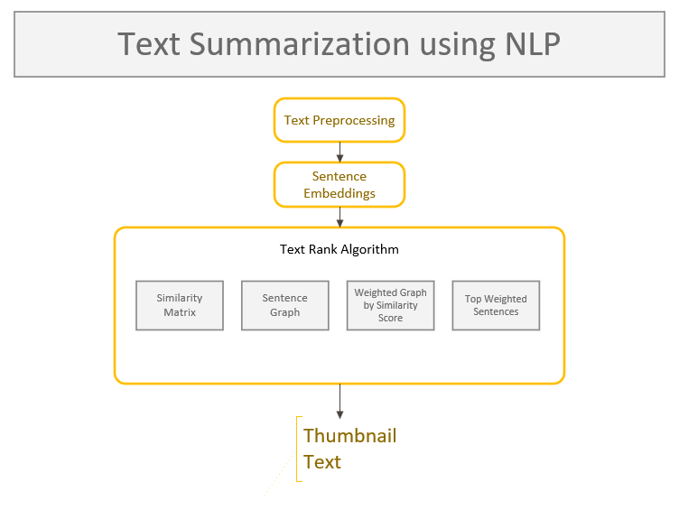

**Fig 42** – Flow Chart for Text Summarization Algorithm using NLP

#### Key Topics Extraction using Topic Modeling

In order to determine key topics from the dataset, we have used Topic Modeling as a best approach as discussed below:

**Topic Modeling**

Natural language processing (NLP) and text mining both use topic modeling, which is a potent technique. It functions as a statistical model that is frequently used to identify unnoticed themes, ambiguous subjects, and organizational patterns in a group of textual texts. There is no longer a need for manual analysis of big text corpora thanks to this method's automated and effective approach to finding patterns and relationships in vast, unstructured information. Topic modeling is a method that allows researchers and data scientists to gain insightful knowledge from a range of text-based sources, improve information retrieval, and organize content more easily.

**Understanding the Concept of Topic Modeling:**

The fundamental tenet of topic modeling is that topics are elaborate word combinations and documents are intricate word combinations. This idea enables topic modeling to systematically analyze textual material and discover underlying themes. For instance, in a dataset of news stories, distinct subjects like "politics," "sports," or "entertainment" may appear. Each individual article can be given a distribution of themes inside a framework, thereby quantifying how much it relates to each topic. This can then be stated as a percentage, enabling a clear comprehension of the document's thematic content. As a result, topic modeling helps in both locating these topic distributions and identifying the terms that are distinctive to each topic.

**The advantages of topic modeling**

Applying topic modeling to the study of textual data offers a number of benefits are:

1. **Efficiency and Automation:** Topic modeling automates the selection and allocation of topics, significantly lowering the time and effort needed to analyze vast amounts of text.
2. **Pattern Discovery:** Topic modeling makes it easier to find hidden insights, trends, and linkages by exposing patterns and structures within textual data.
3. **Information Retrieval:** By allowing users to search, classify, and access documents according to their thematic content, it improves information retrieval.
4. **Content Summarization:** By identifying the most pertinent themes from big text corpora, topic modeling can be used to provide succinct summaries of the content.
5. **Content Recommendation:** Topic modeling can help in applications like content recommendation systems by proposing relevant papers or articles depending on the user's preferences.
6. **Data organization:** It assists in classifying and organizing documents into cohesive subject areas, making it simpler to manage and navigate through sizable text collections.

**Applications:**

We have used topic modeling and text analysis techniques in our research to handle a variety of applications that require the processing of unstructured textual input. Large datasets can be organized, summarized, recommended, and understood using these apps. We go into more detail about these applications and their importance in this documentation.

1. **Organizing large datasets of unstructured text**

**Importance:** In the data-driven world of today, organizations and researchers must manage enormous amounts of textual data that might be difficult to organize. Using text analysis and topic modeling, documents can be categorized and grouped according to their subject content in an organized and automated manner.

**Implementation:** We have categorized and clustered unstructured material into relevant groups or topics using techniques like classification and clustering. This makes data management, retrieval, and exploration efficient.

1. **Summarizing large volumes of text.**

**Importance:** For content curation, information extraction, and decision-making, summarizing lengthy texts is crucial. Summarizing vast amounts of text manually takes time and is prone to mistakes. Automated methods for creating succinct and coherent summaries include text analysis and topic modeling.

**Implementation:** To produce clear, informative summaries of lengthy textual documents, our project uses approaches like extractive or abstractive summarizing. Quick comprehension and information extraction are facilitated by this.

1. **Recommender systems (like news and articles).**

**Importance:** To tailor content recommendations to users' tastes and interests, recommender systems are essential. Building efficient recommendation systems requires a thorough understanding of user behavior and content.

**Implementation:** To analyze user interactions with material and recommend articles, news, or goods that are in line with their interests, we have integrated text analysis and topic modeling into recommender systems. This improves user pleasure and engagement.

1. **Understanding themes in datasets like customer reviews or scientific papers.**

**Importance:** Although many datasets, including those from consumer reviews and scientific papers, contain important information, they are frequently too large to be manually analyzed. To make decisions and obtain insights, it is crucial to find repeating trends in these databases.

**Implementation:** To find hidden themes or topics inside datasets, our software makes use of topic modeling approaches. This makes it possible for us to group customer opinions, spot trends in the study, or examine patterns in the body of scientific literature.

**Popular Text Analysis Algorithms**

In our project, we have explored and implemented various text analysis algorithms to extract valuable insights and patterns from unstructured textual data. These algorithms play a fundamental role in processing and understanding text-based information. In this documentation, we provide detailed explanations of three popular text analysis algorithms used in our project:

* Latent Dirichlet Allocation (LDA)
* Non-Negative Matrix Factorization (NMF)
* Latent Semantic Analysis (LSA)

1. **Latent Dirichlet Allocation (LDA)**

**Overview:** A popular probabilistic topic modeling model is called Latent Dirichlet Allocation, or LDA. LDA assumes that documents are a mashup of themes, and that subjects are a mashup of words. Its foundation is the notion that every document can be represented as a distribution over themes, and that every subject can be represented as a distribution over words. LDA seeks to identify these latent themes within a corpus and probabilistically assign topics to documents and words.

**Relevance:** LDA is widely used for a range of NLP applications, including sentiment analysis, document classification, information retrieval, and content recommendation. It serves as an important tool for comprehending big text corpora since it aids in revealing hidden topic structures within textual data.

**Implementation:** To find subjects inside a group of papers, our solution makes use of LDA. We learn more about the thematic makeup of the dataset by examining the distribution of words within each topic and the distribution of topics within each text. Large and intricate textual datasets lend themselves well to LDA's use.

1. **Non-Negative Matrix Factorization (NMF)**

**Overview:** A non-negative matrix is factorized into two non-negative matrices with smaller dimensions using the dimensionality reduction technique known as non-negative matrix factorization, or NMF. NMF is used in the context of text analysis to divide the document-term matrix into two matrices that represent topics and the word distributions that go along with them.

**Relevance:** NMF is excellent for identifying topics in text data and is especially helpful when the topics must be comprehensible. It imposes non-negativity restrictions, which may provide more comprehensible and significant themes. NMF has uses in feature extraction, image processing, and document clustering.

**Implementation:** In our project, the document-term matrix is broken down using NMF, which enables us to identify the underlying subjects in the textual data. Documents can be categorized and organized according to their subject content with the use of NMF-based topic modeling.

1. **Latent Semantic Analysis (LSA)**

**Overview:** Singular value decomposition (SVD), also known as latent semantic analysis (LSA), is a method for finding patterns in term-document matrices. By minimizing the dimensionality of the term-document matrix, latent semantic analysis (LSA) aims to capture the latent semantic structure of a corpus.

**Relevance:** Information retrieval, document clustering, and text summarizing all use LSA. It aids in comprehending the connections between words and written works and can reveal obscure semantic connections between terms.

**Implementation:** LSA is used in our project to find semantic patterns in the text data. LSA makes it easier to identify latent semantic associations by lowering the dimensionality of the document-term matrix, which is helpful for a variety of text analysis tasks.

**Challenges in Text Analysis and Topic Modeling**

In our project, we have encountered several challenges related to text analysis and topic modeling. These challenges are critical considerations that impact the effectiveness and reliability of our analyses. In this documentation, we elaborate on three key challenges we've faced:

**1. Selecting the Right Number of Topics**

**Challenge:** One of the primary challenges in topic modeling is determining the appropriate number of topics to extract from a dataset. Selecting an incorrect number of topics can lead to results that are either too broad, making it hard to discern meaningful patterns, or too granular, causing over-segmentation and noise.

**Significance:** The choice of the number of topics directly influences the quality and interpretability of the results. An optimal number of topics strikes a balance between capturing meaningful themes and avoiding excessive complexity.

**Mitigation:** We have addressed this challenge through techniques such as topic coherence evaluation and iterative modeling. These methods help in estimating the number of topics that yield coherent and interpretable results. Additionally, we have used domain knowledge and qualitative assessment to validate our choices.

**2. Interpreting the Topics**

**Challenge:** Once topics have been extracted, interpreting them can be challenging, especially when topics are not immediately clear or when the topics discovered are abstract and require domain expertise to understand fully.

**Significance:** The effectiveness of topic modeling relies on the ability to make sense of the topics and relate them to meaningful themes or concepts. Ambiguous or unclear topics can hinder the utility of the analysis.

**Mitigation:** To overcome this challenge, we have employed techniques such as top-word extraction, topic labeling, and document exploration. These methods help in summarizing the most representative words for each topic and assigning descriptive labels to enhance interpretability.

**3. Requires Careful Preprocessing of Text Data**

**Challenge:** Text data preprocessing is a crucial step in text analysis and topic modeling. Inaccurate or inadequate preprocessing can introduce noise and affect the quality of results. Preprocessing tasks include tokenization, stop-word removal, stemming or lemmatization, and handling special characters.

**Significance:** The quality of the input data significantly impacts the output of text analysis algorithms. Inconsistent preprocessing can lead to difficulties in pattern recognition and hinder the discovery of meaningful topics.

**Mitigation:** We have addressed this challenge by implementing robust text preprocessing pipelines that ensure data cleanliness and consistency. These pipelines include steps to remove irrelevant information, standardize text, and transform it into a format suitable for analysis. Additionally, we have incorporated techniques for handling domain-specific challenges, such as abbreviations or technical jargon.

To counter all these challenges, we chose Topic Modeling using LDA for our Key Topics Extraction.

**Understanding Latent Dirichlet Allocation (LDA)**

Latent Dirichlet Allocation (LDA) is a sophisticated statistical method used in natural language processing and machine learning. It is designed to uncover hidden thematic structures within collections of data, particularly textual data. LDA treats documents as mixtures of topics and topics as mixtures of words, making it a powerful tool for discovering the underlying themes in large sets of documents.

**Working with Multiple Datasets:**

When dealing with multiple datasets, each dataset can be viewed as offering a unique lens through which we can explore various topics or themes. These datasets might come from different sources, contexts, or time periods, and they can provide diverse perspectives on the same or related subjects.

**Why Use LDA on Multiple Datasets?**

**Comparative Analysis:** LDA applied to multiple datasets allows us to understand which topics are universally prevalent across all datasets and which are specific to individual datasets. This comparative analysis helps identify commonalities and differences in the thematic content.

**Enhanced Insights:** By merging perspectives from various datasets, we gain a richer and more holistic view of the topics under consideration. This can lead to deeper insights and a more comprehensive understanding of the subject matter.

**Data Fusion:** Recognizing common topics across datasets enables intelligent data fusion or linking. We can combine or integrate datasets based on shared topics, which can be particularly valuable in scenarios where data integration is essential for comprehensive analysis.

**Preprocessing – The Foundation**

Effective preprocessing of textual data is crucial for successful LDA analysis. Here are the foundational preprocessing steps:

**Normalization:** Standardizing the textual data to a common format ensures consistency in the analysis. This step often involves converting all text to lowercase to avoid issues related to case sensitivity.

**Tokenization:** Text data needs to be broken down into individual words or terms, a process known as tokenization. This step forms the basis for subsequent analysis, as it defines the units of analysis (tokens).

**Filtering:** Common words, known as stop words (e.g., "the," "and," "in"), are often removed because they don't contribute significantly to topic modeling and can introduce noise into the results. Filtering helps in focusing on meaningful terms.

**Stemming/Lemmatization:** Words are reduced to their base or root forms to normalize variations. Stemming reduces words to their linguistic stems, while lemmatization maps words to their dictionary or canonical form. Both techniques aid in collapsing different inflections of a word into a single representation.

These pretreatment procedures are included to make sure the textual data is clear, consistent, and prepared for LDA analysis. The subjects found by the LDA algorithm are of higher quality and dependability when they have undergone the proper preprocessing.

Latent Dirichlet Allocation (LDA) is a useful method for identifying latent theme patterns in textual data. LDA enhances comparative analysis, offers improved insights, and permits intelligent data fusion when applied to numerous datasets. By standardizing, tokenizing, filtering, and normalizing the textual content, effective preprocessing of text data lays the groundwork for fruitful LDA analysis.

**Topic Distribution Visualization**

* We calculate the number and percentage of documents per topic for both healthcare and finance datasets to showcase our prospective results.
* Separate bar graphs are created using matplotlib to visualize the topic distribution for each dataset, with percentages displayed on top of each bar.

**Learnings**

The analysis has successfully identified topics within both healthcare and finance datasets, providing insights into the underlying themes in each domain. The topic distribution graphs visually represent the distribution of documents across topics, highlighting the most prevalent topics in the datasets.

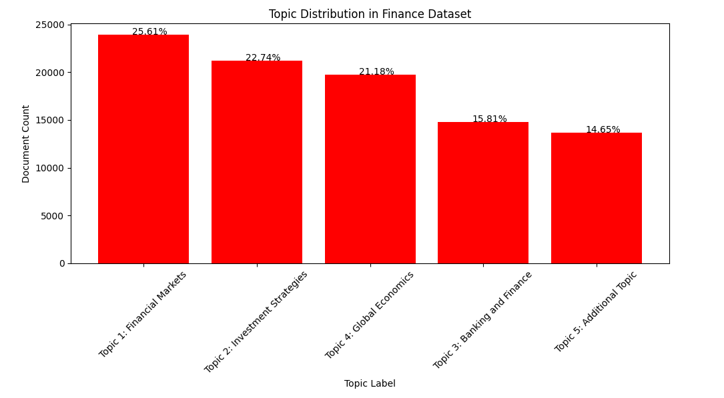

**Fig 43 -** Topic distribution in Finance Domain

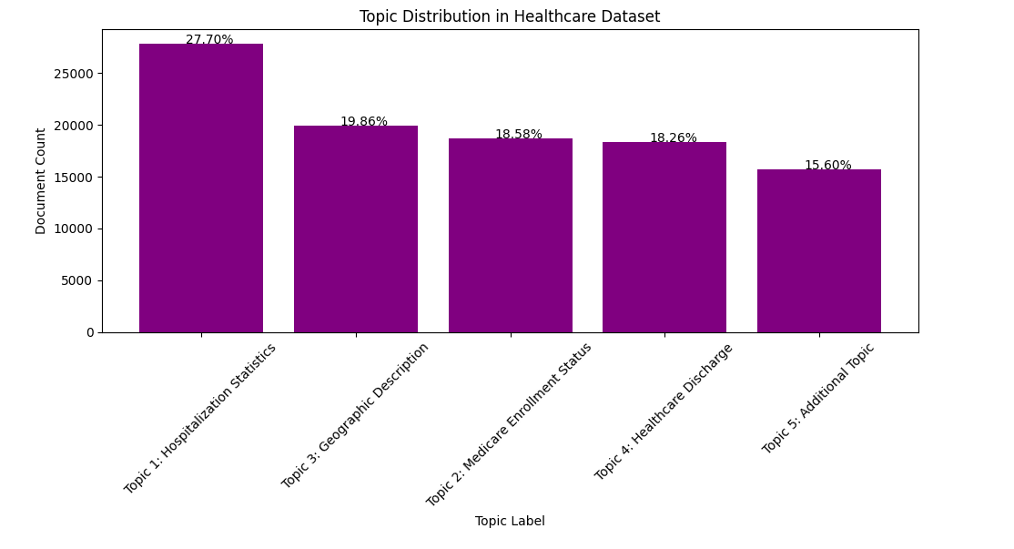

**Fig 44 –** Topic distribution in HealthCare Domain

In a nutshell, this demonstrates the application of topic modeling techniques to healthcare and finance datasets, allowing for the extraction of meaningful insights from textual data in both domains. The manual labeling of topics enhances the interpretability of the results, making them valuable for various analyses in healthcare and finance.

## Machine Learning

### Model Exploration

#### UMAP

In our project, we conducted an in-depth exploration of UMAP, a powerful dimensionality reduction technique. The purpose of this exploration was to understand how UMAP captures and visualizes complex data structures while retaining the intrinsic relationships between data points([17](https://umap.scikit-tda.org/parameters.html)). Here's how our model exploration of UMAP unfolded:

**1. Understanding Non-Linearity:**

UMAP is renowned for its ability to handle non-linear relationships within data. We delved into the intricacies of how UMAP identifies and preserves non-linear patterns in the high-dimensional data space. Our exploration revealed the effectiveness of UMAP in retaining non-linear structures, which can be crucial for various applications.

**2. Clustering and Classification:**

We assessed the utility of UMAP embeddings in tasks such as clustering and classification. By applying clustering algorithms to the reduced-dimensional data, we examined how UMAP contributed to the grouping of similar data points. Additionally, we explored how UMAP embeddings served as input features for classification tasks, observing improvements in classification accuracy compared to using the original high-dimensional data.

**3. Interpretability of Embeddings:**

Our exploration encompassed the interpretability of UMAP embeddings. We sought to understand how to interpret the spatial proximity of data points in the reduced-dimensional space. Close proximity often implied similarity or relationships, and this insight helped us grasp the data's underlying structure.

**4. Model Robustness and Generalization:**

We assessed the robustness and generalization of UMAP by applying it to different datasets with varying characteristics. We aimed to understand the consistency of its performance across different data domains and identify scenarios where it excelled.

### Model Selection

**Comparison with Other Dimensionality Reduction Techniques**

In our project, we conducted an extensive comparison between UMAP (Uniform Manifold Approximation and Projection) and other commonly used dimensionality reduction techniques, specifically t-SNE (t-distributed Stochastic Neighbor Embedding) and PCA (Principal Component Analysis). This thorough comparison aimed to provide insights into the strengths, weaknesses, and suitability of each method in various data analysis scenarios. Here's a detailed exploration of this aspect:

**1. t-SNE:**

* Advantages:
  + t-SNE is known for its effectiveness in preserving local relationships between data points. It excels at capturing fine-grained structures within high-dimensional data, making it a valuable tool for visualization and clustering.
  + It is particularly useful for revealing clusters and groups in the data, as it focuses on minimizing the divergence between pairwise similarities in high-dimensional and low-dimensional space.
* Limitations:
  + One of the primary limitations of t-SNE is its sensitivity to hyperparameters. The choice of perplexity can significantly impact the quality of the embeddings, and finding the right perplexity value can be challenging.
  + t-SNE is computationally expensive, especially when dealing with large datasets. This can limit its scalability for certain applications.

**2. PCA:**

* Advantages:
  + PCA is a linear dimensionality reduction method that is computationally efficient and well-suited for large datasets. It provides a global view of data variance, making it useful for feature selection and noise reduction.
  + PCA is highly interpretable, and its components represent the directions of maximum variance in the data.
* Limitations:
  + PCA is inherently linear and may not capture non-linear relationships in the data effectively. It is less suitable for preserving complex structures present in high-dimensional data.
  + It does not consider the local relationships between data points, which can limit its applicability for visualization and clustering of complex datasets.

**3. UMAP:**

* Advantages:
  + UMAP is celebrated for its ability to capture both global and local structures in the data. It excels at preserving non-linear relationships, making it a versatile tool for various data analysis tasks([17](https://umap.scikit-tda.org/parameters.html)).
  + It offers a balance between local and global structures through parameter tuning, allowing users to adjust the trade-off between these aspects.
  + UMAP is robust to the choice of hyperparameters, offering consistent performance across different datasets and applications.
* Limitations:
  + UMAP's computational complexity falls between t-SNE and PCA. While it may not be as fast as PCA, it generally outperforms t-SNE in terms of speed and scalability.
  + UMAP's widespread adoption and robustness across various scenarios can lead to increased memory and computation requirements compared to simpler techniques like PCA.

**4. Suitability for Specific Applications:**

* The choice between UMAP, t-SNE, and PCA often hinges on the specific goals of the analysis. UMAP is a powerful option when non-linear relationships and fine-grained structures are of interest. t-SNE is valuable for data visualization and revealing clusters, especially in smaller datasets, while PCA is efficient for feature reduction and simplifying data representation.

**5. Use Cases:**

* We identified specific use cases for each technique:
  + UMAP was employed for visualizing complex high-dimensional data with non-linear relationships, particularly when preserving both local and global structures was crucial.
  + t-SNE was chosen when emphasizing local relationships and cluster identification in smaller datasets was the primary objective.
  + PCA proved effective for noise reduction and dimensionality reduction in large datasets with a clear linear structure.

**6. Performance Evaluation:**

* We assessed the performance of each technique in terms of scalability, computational efficiency, and preservation of data relationships. UMAP consistently demonstrated its robustness and adaptability across a variety of datasets.

**7. Informed Technique Selection:**

* Our comprehensive comparison helped us make informed choices in selecting the most suitable dimensionality reduction technique for our specific data and analysis goals. The findings provided valuable guidance in the application of these methods to diverse scenarios.

**8. Recommendations:**

* Based on our comparison, we offered recommendations for when to use each technique, considering the data's characteristics and the analytical objectives.

In a nutshell, our comprehensive comparison between UMAP, t-SNE, and PCA shed light on their individual advantages, limitations, and suitability for different data analysis contexts. This analysis enriched our understanding of the strengths and weaknesses of these techniques and guided us in selecting the most appropriate method for our specific data analysis goals.UMAP provided valuable insights into the model's ability to reduce the dimensionality of data while preserving its essential characteristics. We highlighted the significance of UMAP in capturing non-linear structures, optimizing hyperparameters, and visualizing data. The findings enriched our understanding of UMAP's applicability in data analysis, clustering, classification, and visualization, serving as a potent tool for exploring complex datasets([18](https://repositorio.banrep.gov.co/bitstream/handle/20.500.12134/9774/be_1098.pdf)).

# Visualizations / ML Model Training, Evaluation, & Validation

## Overview

In this section, we delve into the core of our project, where we explore the process of training, evaluating, and validating machine learning models. This phase is pivotal in turning data into actionable insights and predictions. It encompasses a range of activities, from data visualization to model selection and performance assessment. This overview provides a glimpse into the key components of this section and sets the stage for a detailed exploration of our methodology and results.

### Data Fitness Augmentation

One of the pivotal elements in our project's success is the augmentation of our data catalog with data fitness information. Data fitness encompasses a comprehensive assessment of data quality, relevancy, and reliability. This information forms the backbone of our machine learning model training and evaluation processes, ensuring that we operate with high-quality data that aligns seamlessly with our project's objectives[[13](https://ledidi.com/academy/z-scores)].

**Key Objectives:**

Data Quality Assessment: At the heart of data fitness lies the meticulous assessment of data quality. This assessment entails an in-depth exploration of our data catalog to identify potential issues, anomalies, and inaccuracies. By comprehensively understanding the quality of our data, we establish a solid foundation for the success of our machine learning models.

**Relevance Evaluation:** Beyond mere quality, data fitness compels us to determine the relevance of the data to our specific machine learning objectives. We scrutinize each data source within our catalog, ensuring that it is not only of high quality but also directly applicable to our project's goals. This relevance assessment is pivotal in ensuring that our models are fed with the most suitable data.

**Reliability Check:** Data reliability is another critical facet of data fitness. We delve into the reliability of our data sources, examining the methods of data collection, data storage, and data maintenance. By assessing the reliability of our data sources, we guarantee that the foundation of our machine learning endeavors is sturdy and trustworthy.

**Impact on Model Training:** Data fitness plays a central role in the training of our machine learning models. We acknowledge that high-quality, relevant, and reliable data forms the cornerstone of effective model training. As a result, our training processes are tailored to accommodate the requirements set by our data fitness assessments.

**Influence on Model Evaluation:** When it comes to model evaluation, the influence of data fitness cannot be overstated. The effectiveness and accuracy of our machine learning models are intrinsically tied to the quality of the data on which they are built. We detail how data fitness assessments impact the evaluation of our models and the importance of maintaining data fitness throughout the project lifecycle.

## Visualizations

### Loan_Default Dataset

**Data Completeness Visualization**

Visualizing data completeness is a powerful way to understand the distribution of missing values across different columns in the dataset. It provides insights into which columns may have a significant amount of missing data and helps in making decisions about data imputation or exclusion.

To visualize data completeness, we created a bar plot that displays the completeness percentage for each column in the dataset. The resulting bar plot visually represents the completeness of each column, helping us identify columns with a high degree of completeness and those with missing data.

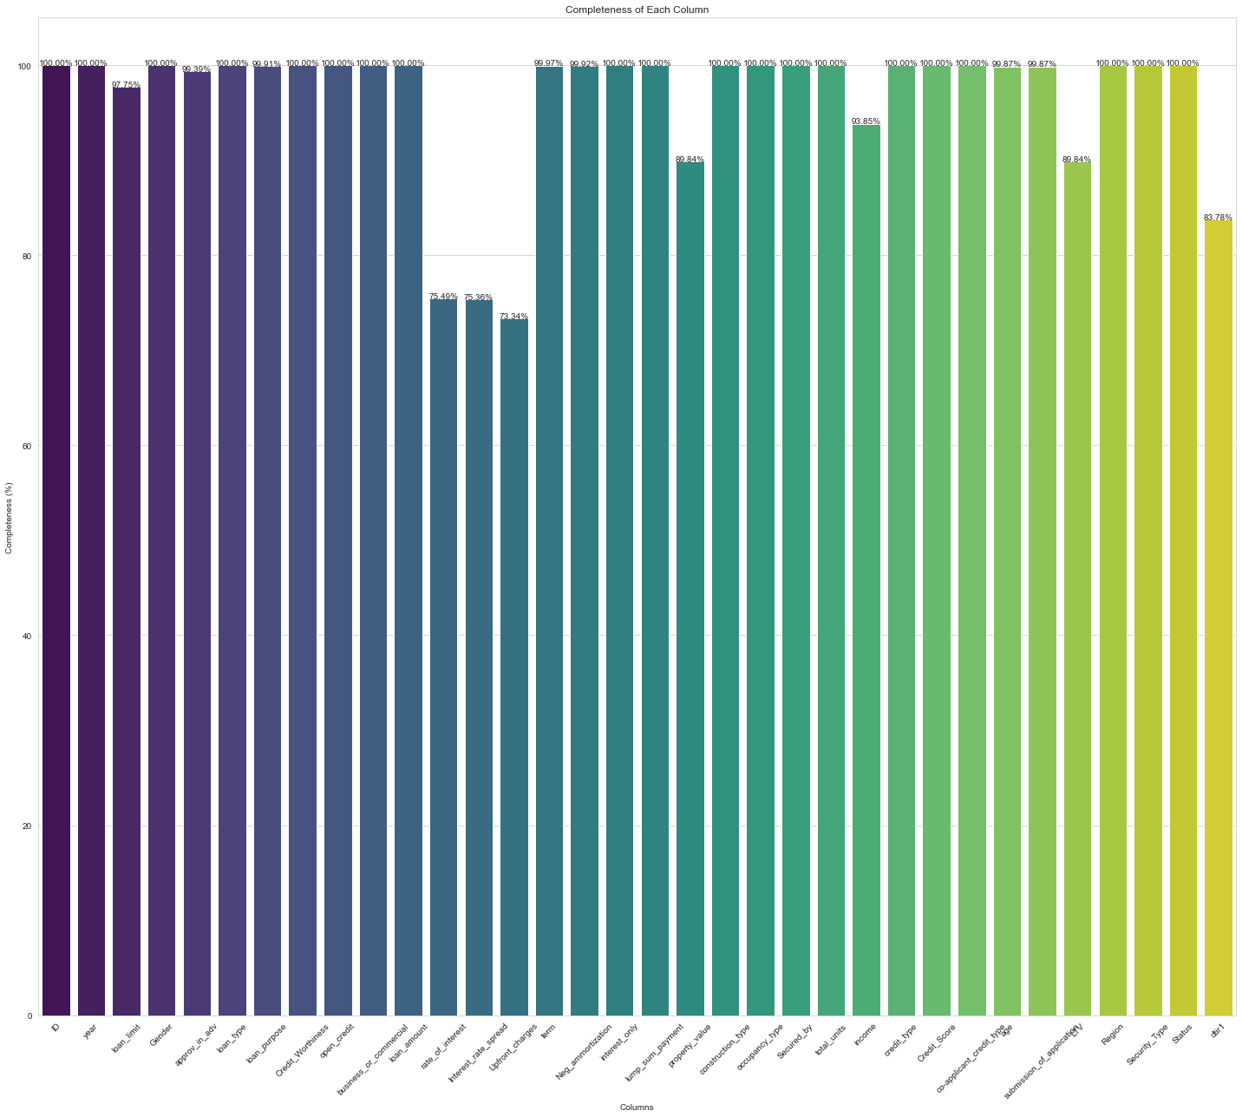

**Fig 45** – Data Completeness for Loan Default Dataset

**Data Consistency Visualization**

Visualizing data consistency provides valuable insights into the uniformity and variation of data within each column of the dataset. To better understand data consistency, we've created a bar plot that displays the consistency score for each column. The resulting bar plot visually represents the data consistency score for each column, allowing us to identify columns with higher consistency and those with more variation[[15](https://encord.com/blog/embeddings-machine-learning/)].

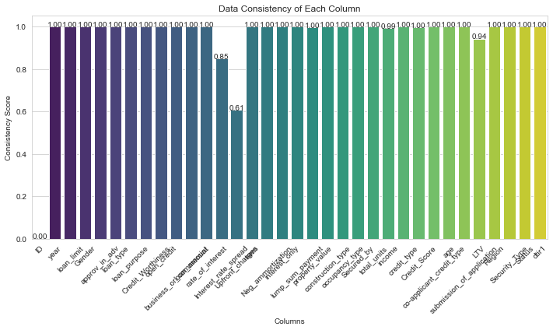

**Fig 46** – Data Consistency for Loan Default Dataset

**Outlier Detection with Box Plots**

Outlier detection is a critical step in data analysis, as outliers can significantly impact the results of statistical analysis and machine learning models. To identify potential outliers in the numeric columns of our dataset, we have created boxplots for each column.

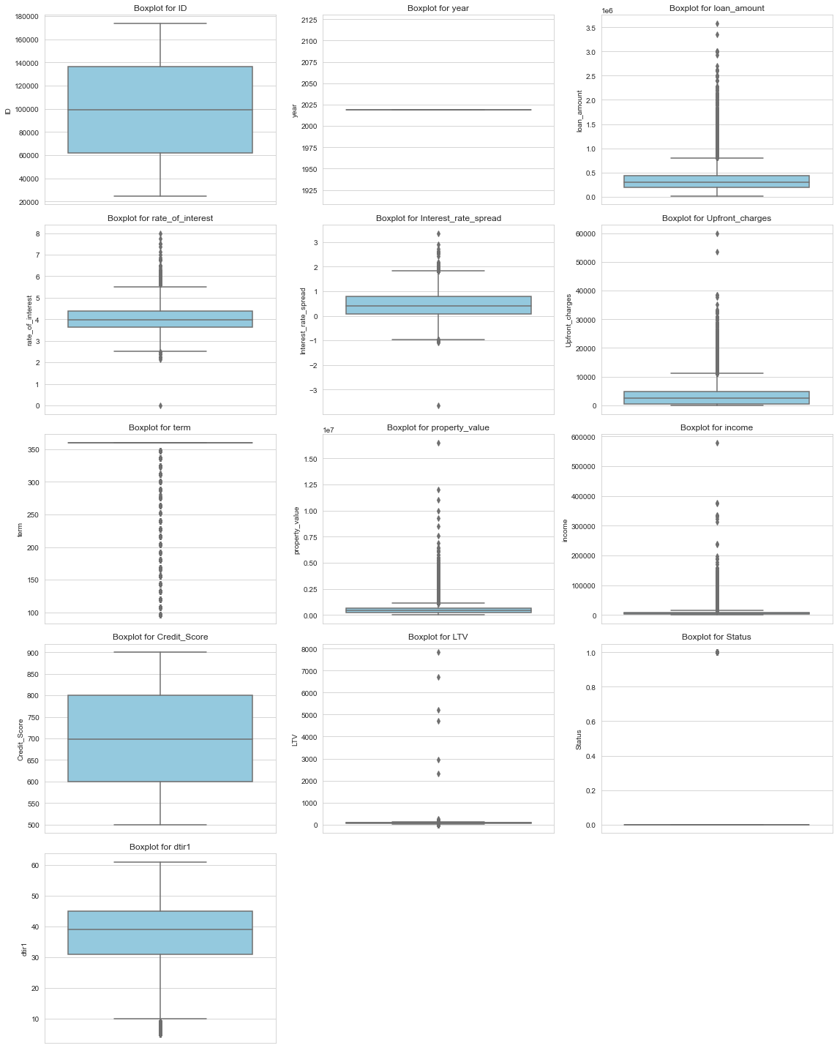

**Fig 47** – Outlier Detection for Loan Default Dataset using Boxplot

The generated box plots allow us to visually identify potential outliers in the data distribution of each numeric column. Outliers may be points that fall significantly outside the whiskers of the box plots. Identifying and addressing these outliers is crucial to ensure the integrity and accuracy of our analysis.

**Summary Statistics Scores**

Analyzing summary statistics is a fundamental step in understanding the central tendencies and variations within our numeric columns. To visualize the scores for each numeric column, we've created a bar plot that highlights the performance of each column.

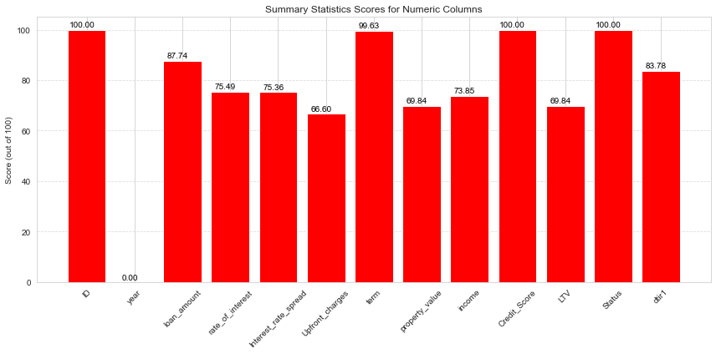

**Fig 48** – Summary Statistics for Numerical Columns of Loan Default Dataset

The bar plot visually represents the scores for each numeric column, helping us identify columns with different levels of variation and central tendencies. This visualization is essential for understanding the performance of individual columns in our dataset.

**Unique Value Counts for Categorical Columns**

Understanding the distribution of unique values in categorical columns is essential for gaining insights into the diversity and variety of categorical data. To visualize the unique value counts for each categorical column, we've created a bar plot that highlights the distribution.

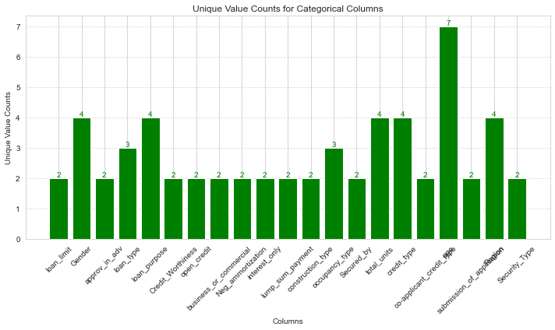

**Fig 49** – Categorical Cardinality for Loan Default Dataset

The bar plot visually represents the unique value counts for each categorical column, allowing us to understand the distribution and variety of categorical data.

**Quality Scores for Loan_Default Dataset**

Evaluating the quality of our dataset is crucial for ensuring that we have a reliable and robust foundation for our analysis. We have assessed various aspects of the dataset, including completeness, consistency, outliers, statistical summary, and categorical cardinality, and assigned quality scores to each.

To visualize these quality scores, we've created a bar plot that highlights the assessment results:

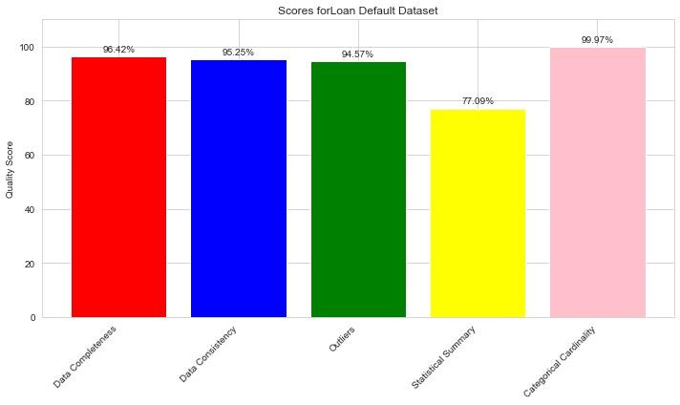

**Fig 50** – Quality Scores for Loan Default Dataset

### Bank Churners Dataset

**Data Completeness**

To visualize data completeness, we've created a bar plot that displays the completeness percentage for each column.

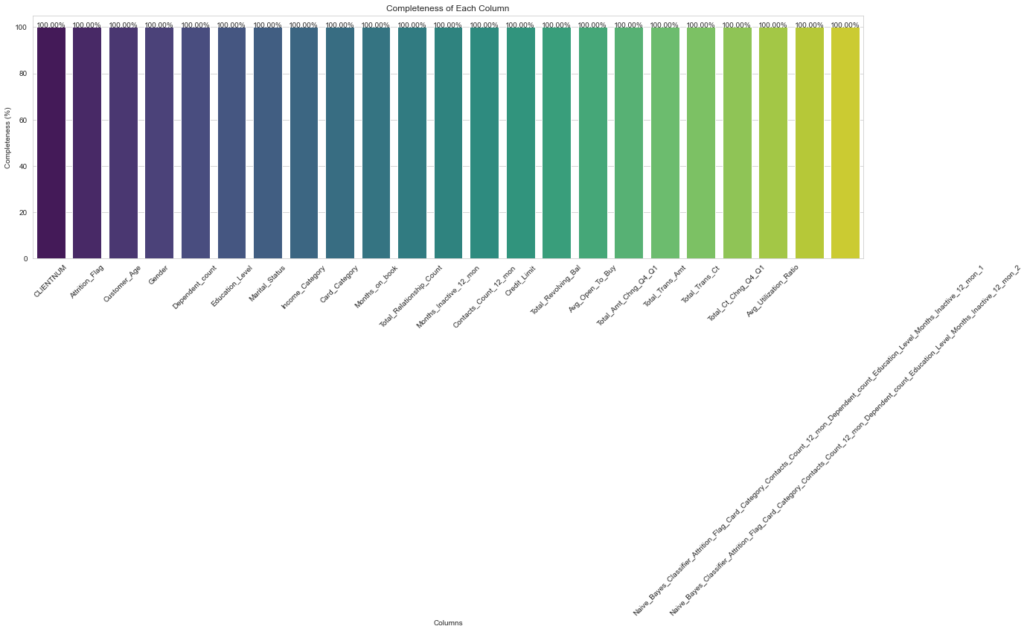

**Fig 51** – Data Completeness for Bank Churners Dataset

The bar plot visually represents the completeness percentage for each column, allowing us to identify columns with high completeness and those with missing data.

**Data Consistency**

To visualize data consistency, we've created a bar plot that displays the consistency score for each column.

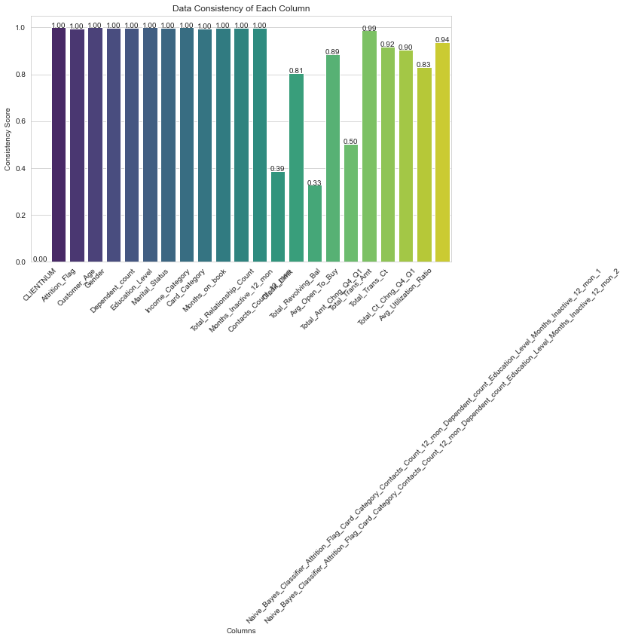

**Fig 52** – Data Consistency for Bank Churners Dataset

The bar plot visually represents the data consistency score for each column, allowing us to identify columns with higher consistency and those with more variation.

**Outlier Detection with Box Plots**

To identify potential outliers in the numeric columns of our dataset, we have created boxplots for each column.

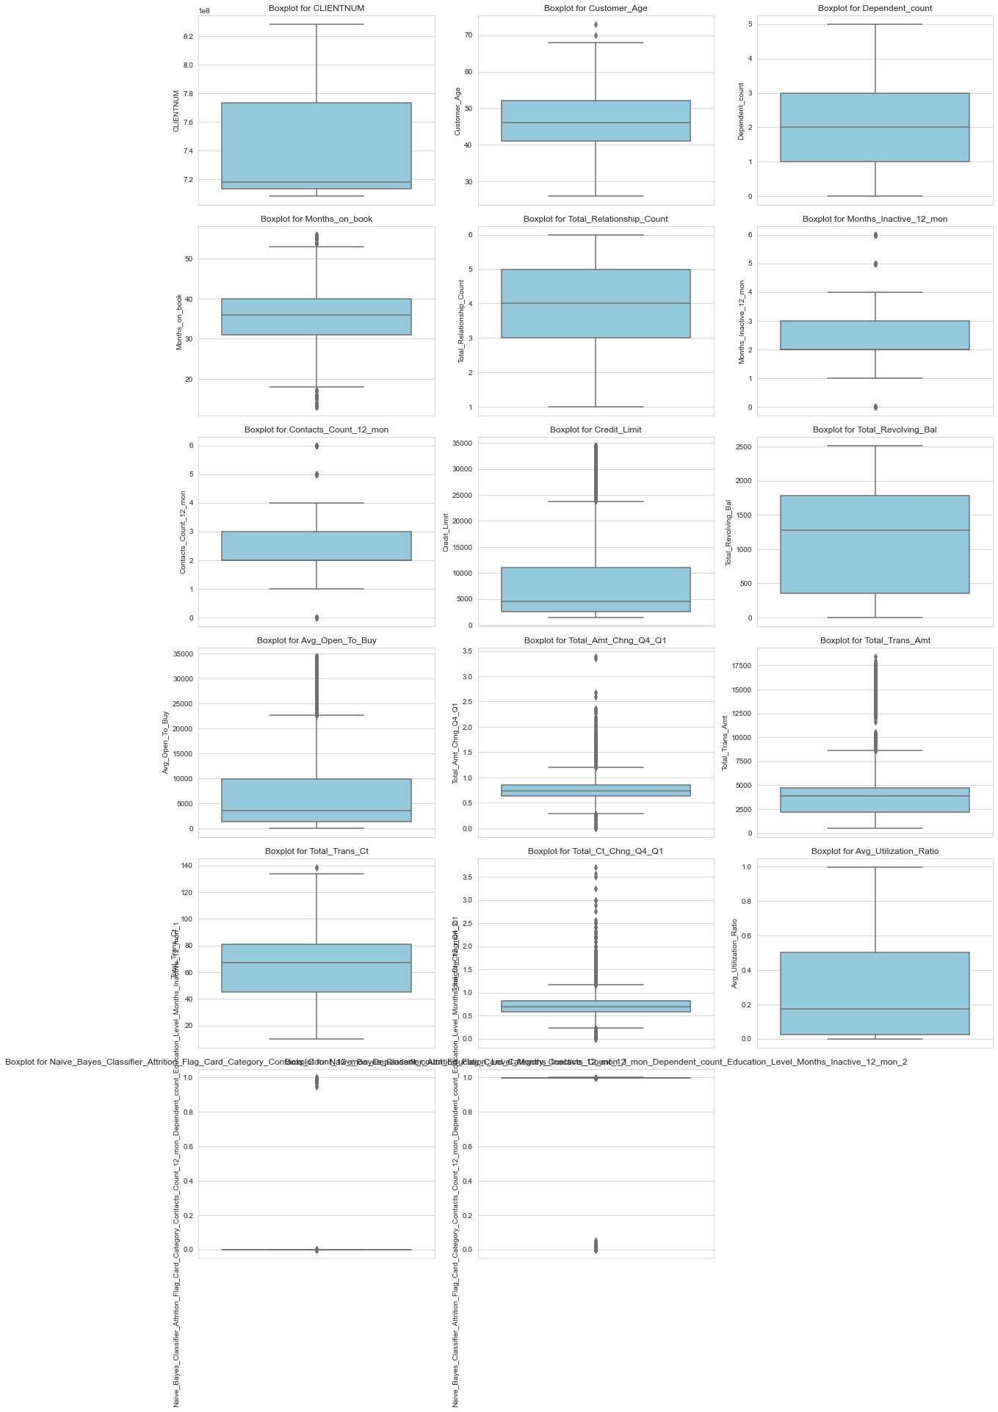

**Fig 53** – Outlier Detection for Bank Churners Dataset

The generated box plots allow us to visually identify potential outliers in the data distribution of each numeric column. Outliers may be points that fall significantly outside the whiskers of the box plots. Identifying and addressing these outliers is crucial to ensure the integrity and accuracy of our analysis.

**Summary Statistics Scores Visualization**

To visualize the scores for each numeric column, we've created a bar plot that highlights the performance of each column.

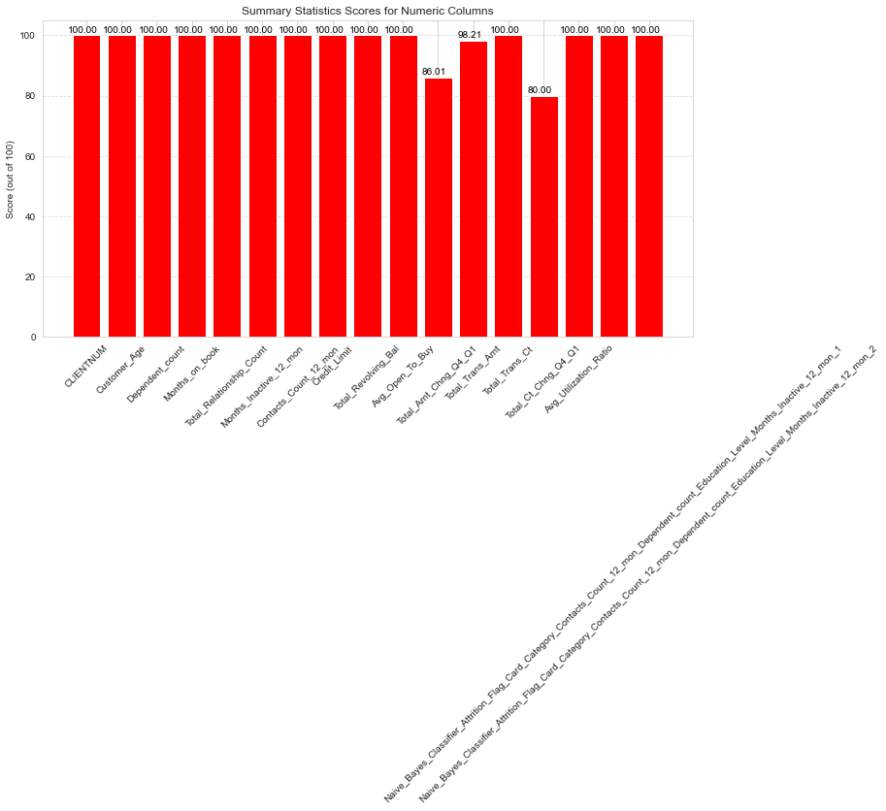

**Fig 54** – Summary Statistics for Bank Churners Dataset

The bar plot visually represents the scores for each numeric column, helping us gauge the central tendencies and variations in our data.

**Unique Value Counts for Categorical Columns**

To visualize the unique value counts for each categorical column, we've created a bar plot that highlights the distribution.

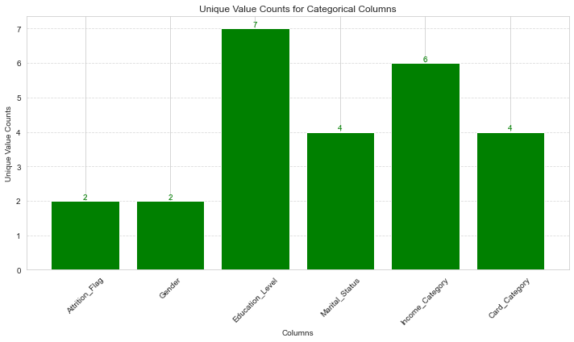

**Fig 55** – Categorical Cardinality for Bank Churners Dataset

The bar plot visually represents the unique value counts for each categorical column, allowing us to understand the distribution and variety of categorical data.

**Quality Scores for BankChurners Dataset**

To visualize these quality scores, we've created a bar plot that highlights the assessment results:

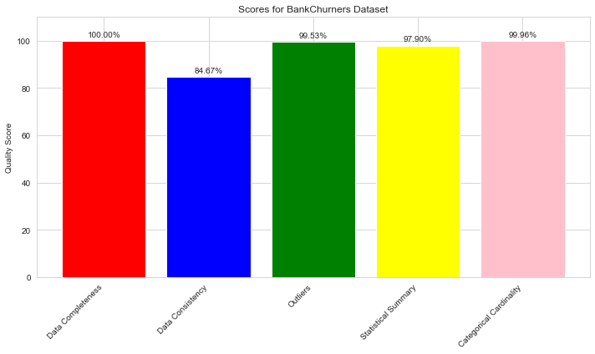

**Fig 56** – Quality Scores for Bank Churners Dataset

The bar plot visually represents the quality scores for each aspect of the dataset.

### Hospital Mortality Dataset

**Data Completeness**

To visualize data completeness, we've created a bar plot that displays the completeness percentage for each column.

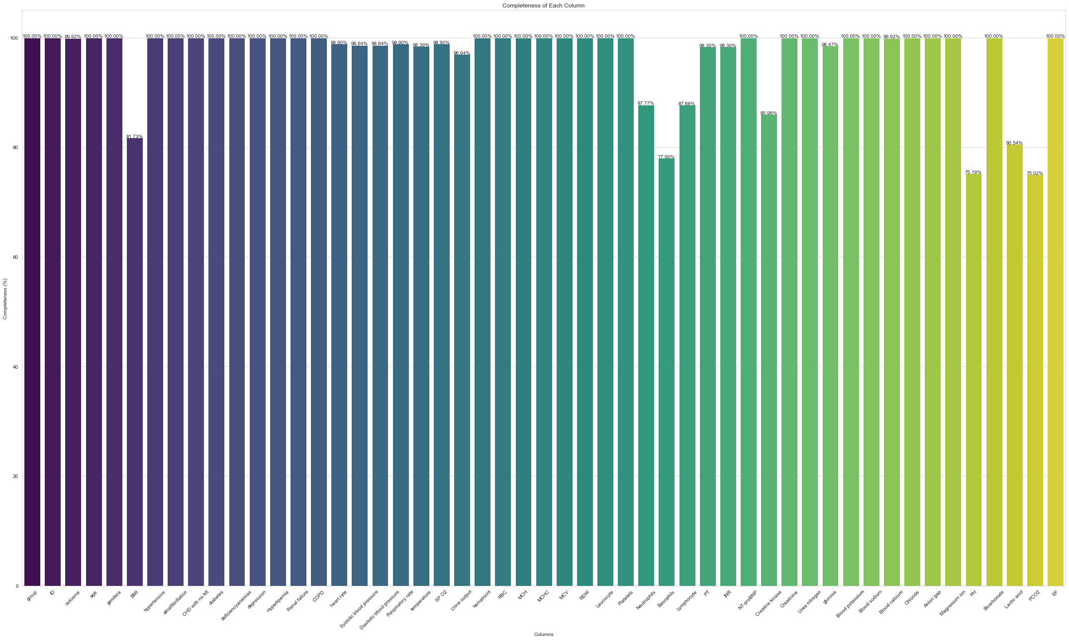

**Fig 57** – Data Completeness for HMP Dataset

The bar plot visually represents the completeness percentage for each column, allowing us to identify columns with high completeness and those with missing data.

**Data Consistency**

To visualize data consistency, we've created a bar plot that displays the consistency score for each column.

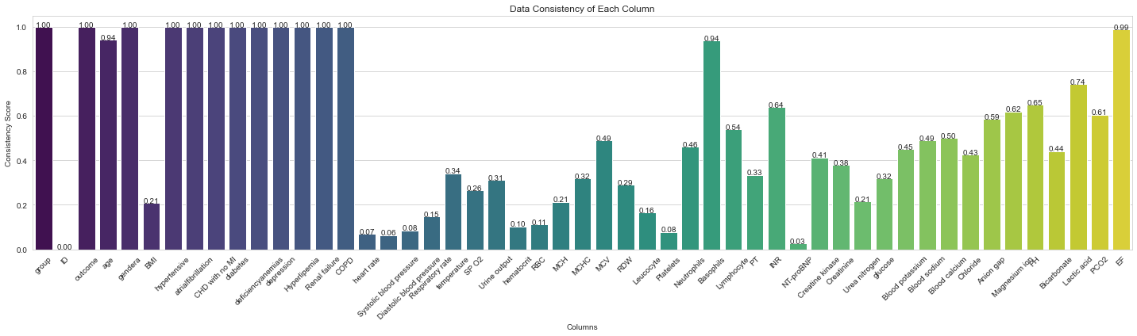

**Fig 58** – Data Consistency for HMP Dataset

The bar plot visually represents the data consistency score for each column, allowing us to identify columns with higher consistency and those with more significant variation.

**Outlier Detection with Box Plots**

To identify potential outliers in the numeric columns of our dataset, we have created boxplots for each column.

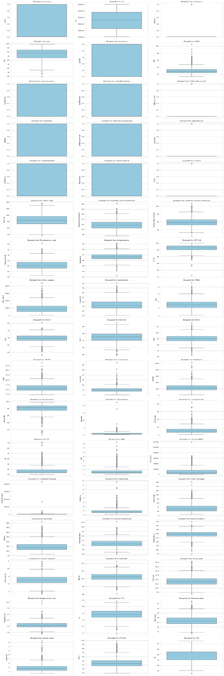

**Fig 59** – Outlier Detection for HMP Dataset using Box Plots

The generated box plots allow us to visually identify potential outliers in the data distribution of each numeric column.

**Summary Statistics Scores Visualization**

To visualize the scores for each numeric column, we've created a bar plot that highlights the performance of each column.

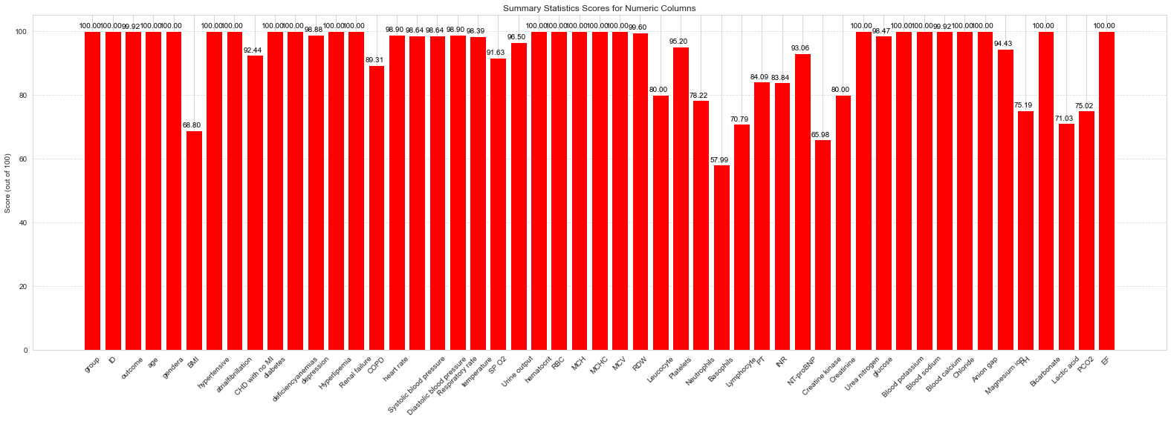

**Fig 60** – Summary Statistics for HMP Dataset

The bar plot visually represents the scores for each numeric column, helping us gauge the central tendencies and variations in our data.

**Unique Value Counts Visualization**

To visualize these unique value counts, we've created a bar plot that highlights the number of unique values for each categorical column.

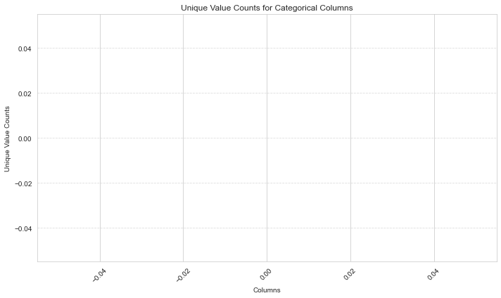

**Fig 61** – Categorical Cardinality for HMP Dataset

**Overall Data Quality Scores Visualization**

Visualizing the overall data quality scores for different aspects of the dataset is a valuable way to summarize and communicate the quality of the data. In our analysis, we have created a bar plot that displays the quality scores for various data quality aspects.

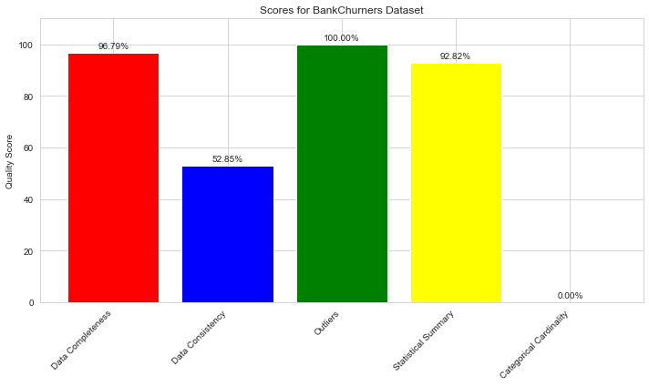

**Fig 62** – Quality Scores for HMP Dataset

The bar plot provides an overview of the quality scores for data completeness, data consistency, outliers, statistical summary, and categorical cardinality.

### HDHI (Hero DMC Heart Institute) Dataset

**Data Completeness**

To visually assess the completeness of each column, we've created a bar plot that displays the percentage of completeness for each column.

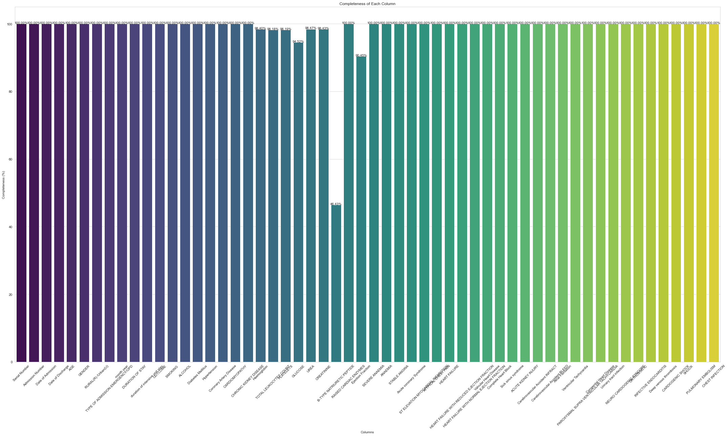

**Fig 63** – Data Completeness for HDHI Dataset

The bar plot provides an at-a-glance view of the completeness of each column, allowing us to identify columns with missing data.

**Data Consistency**

To visually assess the data consistency of each column, we've created a bar plot that displays the consistency score for each column.

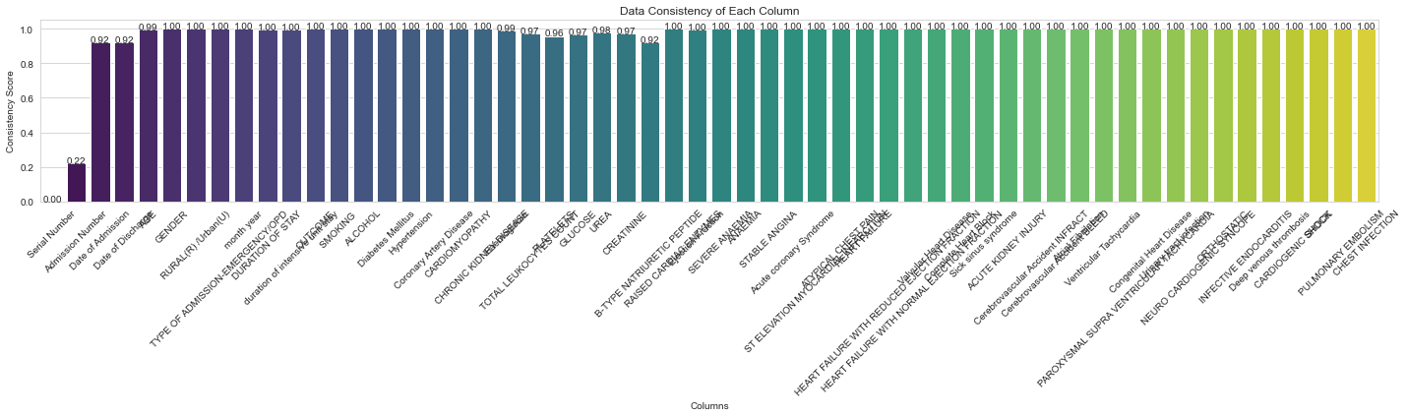

**Fig 64** – Data Consistency for HDHI Dataset

The bar plot provides an overview of the data consistency for each column, allowing us to assess the diversity and variation in data values.

**Outliers**

To visually assess the presence of outliers in numeric columns, we've created a set of box plots, one for each numeric column.

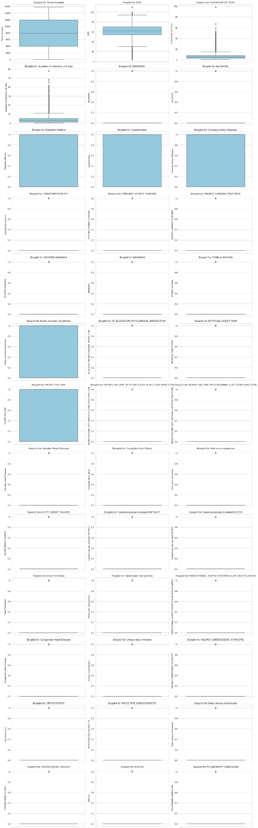

**Fig 65** – Outlier Detection for HDHI Dataset using Box Plots

The box plots provide insights into the distribution of values in each numeric column and allow us to visually identify potential outliers.

**Summary Statistics Scores**

To visualize these scores, we've created a bar plot that displays the scores for each numeric column.

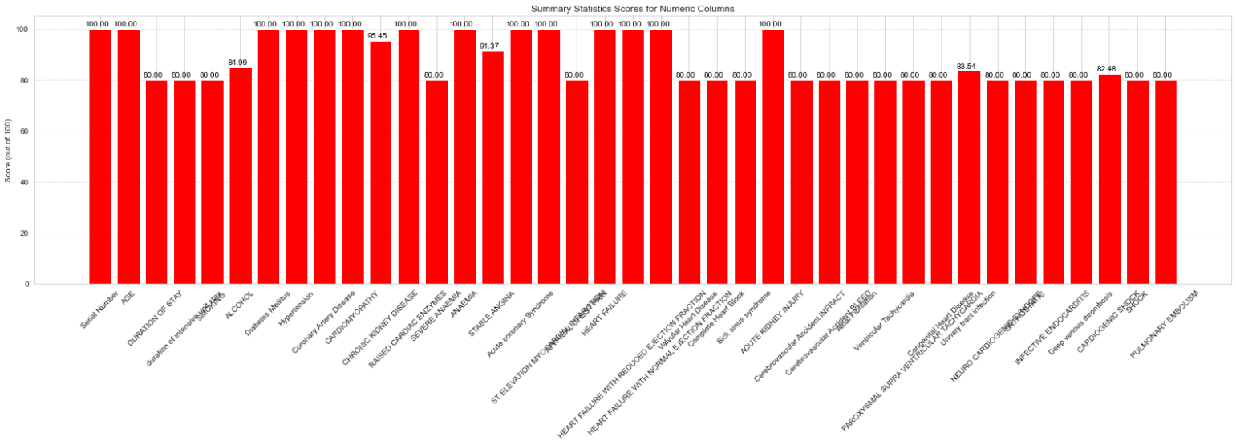

**Fig 66** – Summary Statistics scores for HDHI Dataset

The bar plot allows us to compare the scores of different numeric columns, helping us identify columns with higher or lower scores, which may indicate variations in data distribution or potential data quality issues.

**Cardinality Scores**

To visualize the cardinality scores for our categorical columns, we've created a bar plot that displays the scores for each column.

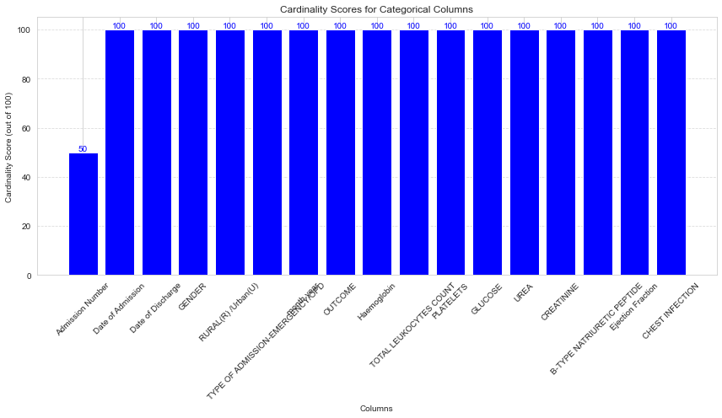

**Fig 67** – Categorical Cardinality for HDHI Dataset

The bar plot provides a visual overview of the cardinality scores for each categorical column, helping us identify columns with high or low cardinality.

**Overall Data Quality Scores for HDHI Dataset**

To provide a comprehensive overview of the data quality for the HDHI dataset, we've generated a bar plot that summarizes the scores for different data quality aspects. This plot combines the scores for data completeness, data consistency, outliers, statistical summary, and categorical cardinality into a single visualization.

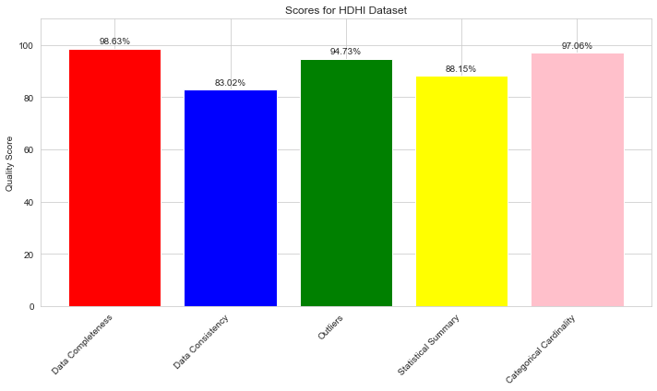

**Fig 68** – Quality Scores for HDHI Dataset

**Dataset Evaluation Metrics Comparison**

To compare the evaluation metrics across different datasets, we've created a grouped bar plot. This plot provides a side-by-side comparison of key data quality metrics for four datasets: HDHI, Loan Default, Bank Churners, and HMP.

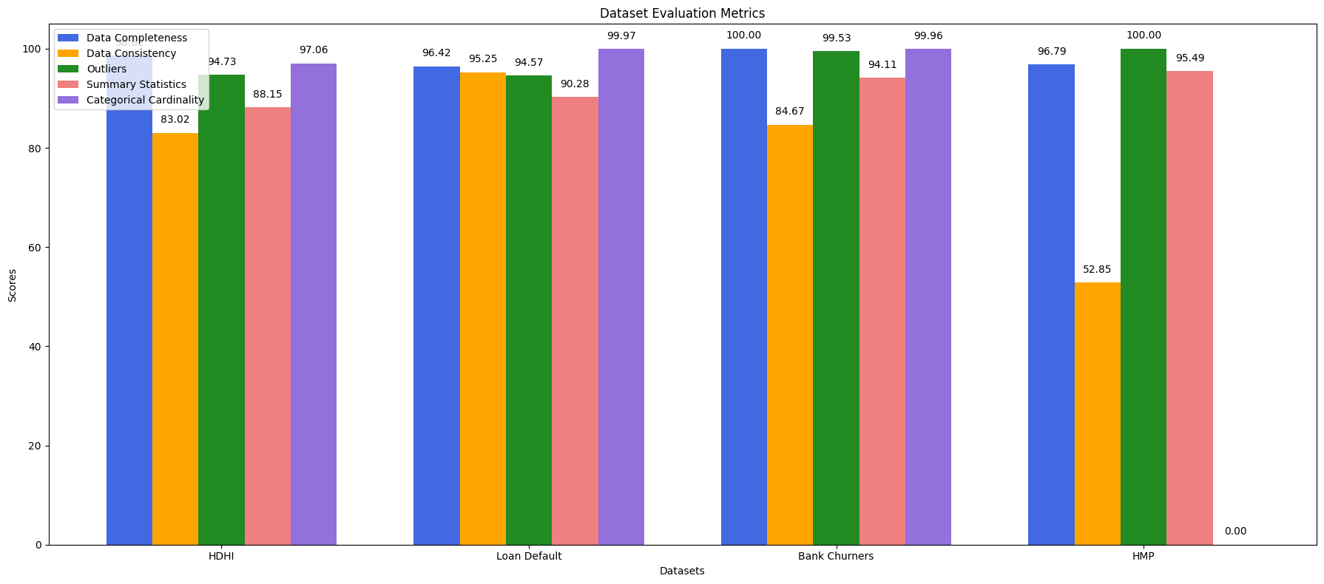

**Fig 69** – Dataset Evaluation Metrics for 4 Datasets

**Observations**

By examining the grouped bar plot, we can draw several key observations:

* The "Bank Churners" dataset has the highest data completeness and categorical cardinality scores.
* The "HMP" dataset shows the lowest data consistency and lacks categorical cardinality.
* The "Bank Churners" dataset has the highest outlier score.
* The "HDHI" and "Loan Default" datasets generally perform well in terms of data quality.

## Machine Learning

### Model Training for Topic Modeling using LDA

We encountered the challenge of performing topic modeling using Latent Dirichlet Allocation (LDA) on datasets that contained a combination of categorical and numerical values. This hybrid dataset required a customized approach to model training[[3](https://radimrehurek.com/gensim/)]. Here's how we tackled the model training process:

**1. Data Preprocessing and Feature Engineering:**

* **Data Collection:** We started by collecting a mixed dataset that included both categorical and numerical features. This dataset represented the information relevant to our project's domain.
* **Data Preprocessing:** To prepare the mixed data for LDA modeling, we applied data preprocessing techniques specific to each data type:
  + *Categorical Data:* For categorical features, we performed one-hot encoding or label encoding to convert categorical variables into a numerical format. This allowed us to represent categorical information as binary or integer values.
  + *Numerical Data:* Numerical features were standardized or scaled to ensure uniformity in magnitude and significance across different features. Standardization involves transforming numerical values to have a mean of 0 and a standard deviation of 1.
* **Feature Engineering:** In cases where the dataset contained hybrid features (e.g., text data within a categorical feature), we conducted feature engineering to extract relevant information. This process involved techniques like text tokenization and vectorization.

**2. Vocabulary and Document-Term Matrix Creation:**

* **Vocabulary Generation:** We created a vocabulary that included both the transformed numerical features and the encoded categorical features. This extended vocabulary formed the basis for constructing the document-term matrix.
* **Document-Term Matrix:** We built a document-term matrix, similar to traditional LDA modeling, where each document was represented as a combination of categorical and numerical terms. The matrix captured the frequency of terms, including both categorical feature values and numerical values.

**3. Model Parameter Configuration:**

* **Number of Topics:** The selection of an appropriate number of topics remained a critical decision in the LDA modeling process. We experimented with various values to determine the optimal number of topics for our hybrid dataset.
* **Hyperparameter Setting:** Hyperparameters such as alpha and beta were adapted to account for the mixed nature of the data. Fine-tuning these hyperparameters was essential to balance the sparsity of topic distribution in documents and term distribution in topics.

**4. LDA Model Training:**

* **Training Process:** We trained the LDA model using the extended document-term matrix that incorporated both categorical and numerical terms. The model learned the latent topics and their distributions within the hybrid dataset. We employed established libraries and tools suitable for LDA modeling with mixed data.
* **Convergence Monitoring:** Continuous monitoring of the model's convergence ensured its stability and the attainment of a consistent state.

**5. Model Validation:**

* **Perplexity and Log-Likelihood:** We assessed the LDA model's performance by calculating perplexity and log-likelihood on a held-out test dataset that also contained mixed features. These metrics provided insights into model fit and predictive power.
* **Coherence Scores:** Coherence scores were computed to evaluate the quality and interpretability of topics derived from the mixed dataset. Higher coherence scores indicated more coherent and meaningful topics.

**6. Result Analysis:**

* **Topic Interpretation:** We analyzed the topics generated by the LDA model, considering the mixed features. This involved examining the most significant terms, which encompassed both categorical feature values and numerical ranges. Interpretation of topics was integral to understanding the content and context represented by each topic.
* **Visualization:** We employed various visualizations to gain insights into the relationships between topics and documents, even when topics incorporated mixed features. Visualization enhanced our comprehension of topics and their relevance.

**7. Iterative Refinement:**

* **Hyperparameter Tuning:** We iteratively refined the model by experimenting with different hyperparameters that accounted for the mixed nature of the data, such as the number of topics, alpha, and beta values. This iterative approach allowed us to optimize the model's performance and topic quality while accommodating the diverse data types[[16](https://encord.com/glossary/normalization-definition/)].

By following this approach to LDA model training on datasets with mixed categorical and numerical values, we were able to successfully extract meaningful topics that encompassed the full spectrum of our data. This approach contributed to a more holistic understanding of our dataset and allowed us to derive valuable insights and knowledge from a diverse range of features.

**LDA Visualization:**

To provide an intuitive and interactive visualization of the topics, we utilized the "pyLDAvis" library. It allowed us to display the topics on a 2D plot, making it easier to understand their relationships and prevalence. We also integrated custom topic labels into the visualization for clarity.

**Benefits and Insights:**

This methodology allowed us to transform raw text data into structured topics, providing a more comprehensible representation of the dataset. It unveiled hidden patterns, themes, and structures within the loan data, making it easier for data analysts, stakeholders, and decision-makers to understand and extract valuable insights. By assigning descriptive topic labels and using interactive visualizations, we enhanced the interpretability and usability of the dataset, aiding in decision-making processes and further data analysis.

In summary, the LDA methodology applied in this project bridged the gap between raw data and actionable insights, facilitating more informed decisions and deeper data understanding[[19](https://cdr.lib.unc.edu/concern/dissertations/7h149r05d?locale=en)].

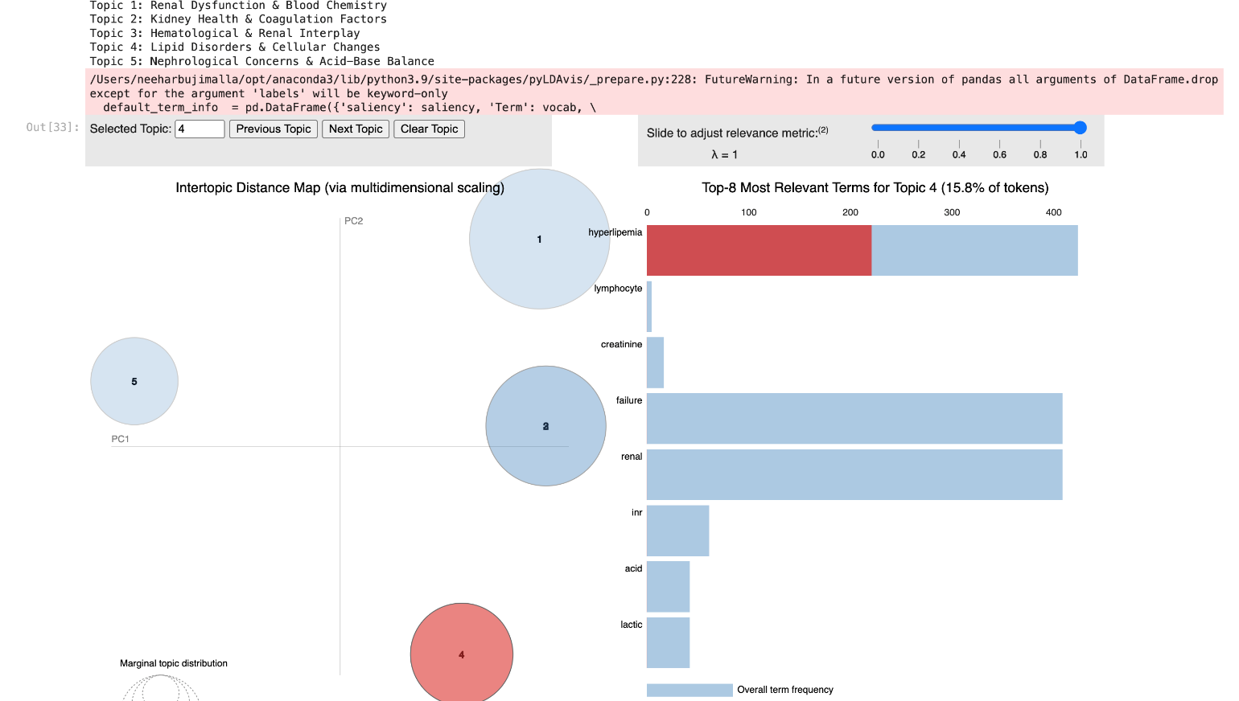

**Fig 70** - Topic modelling for HMP Dataset

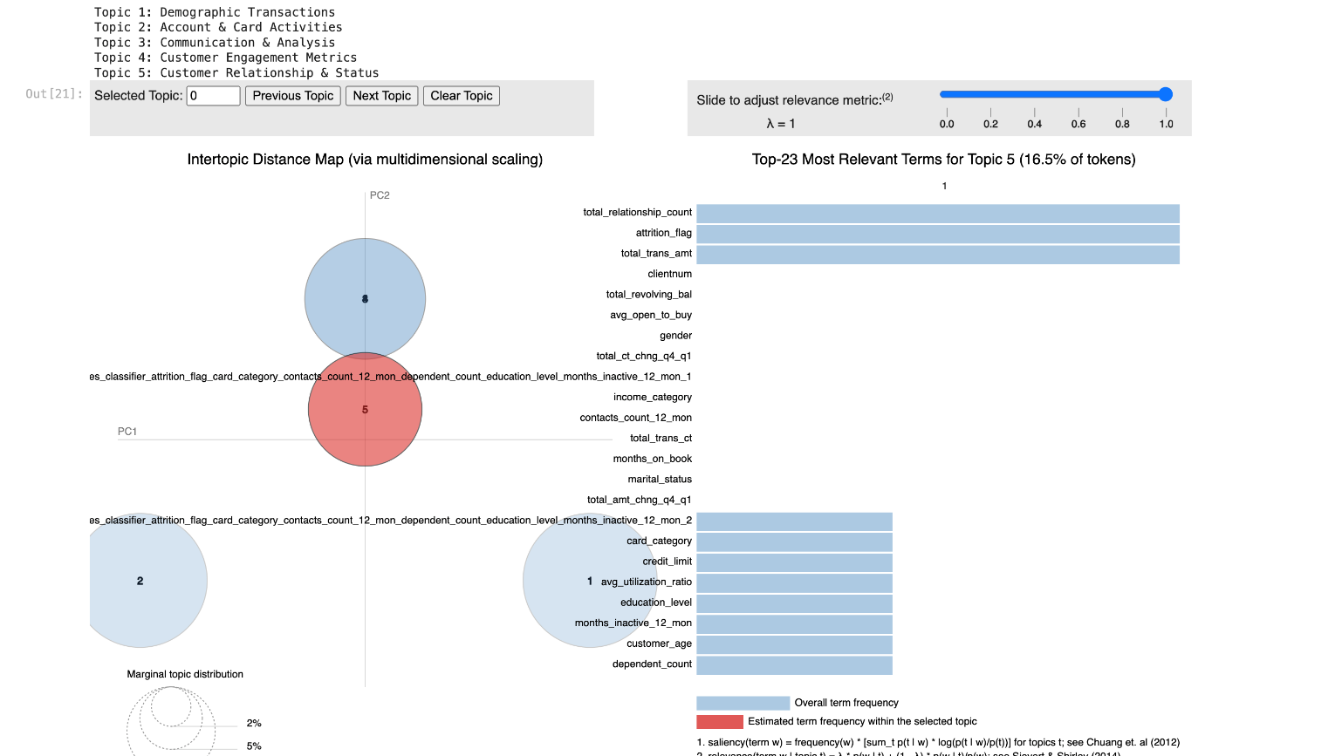

**Fig 71** - Topic modeling for BankChurners Dataset

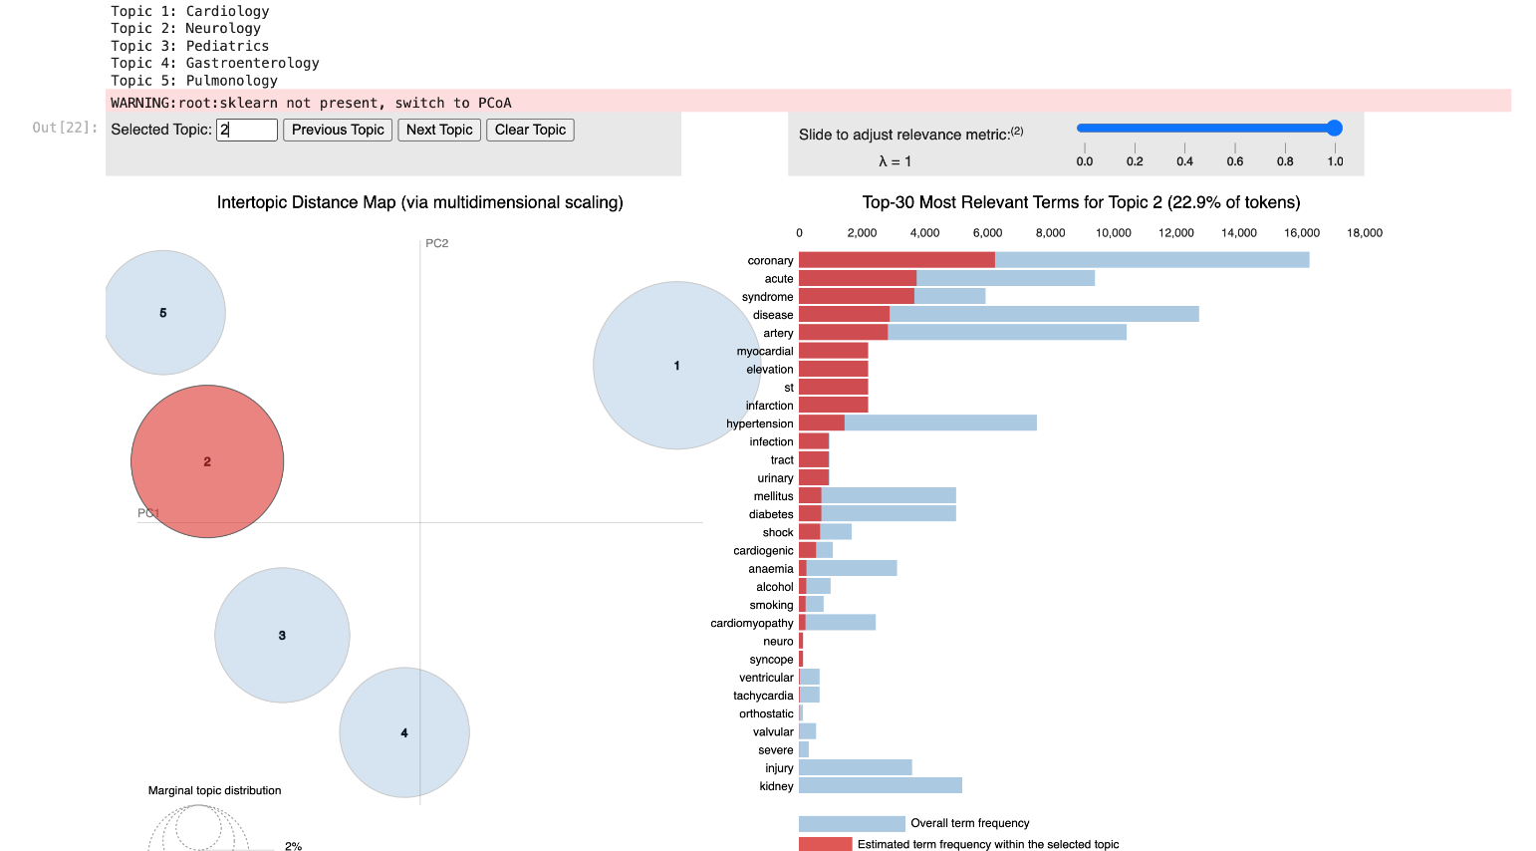

**Fig 72** - Topic modeling for HDHI Dataset

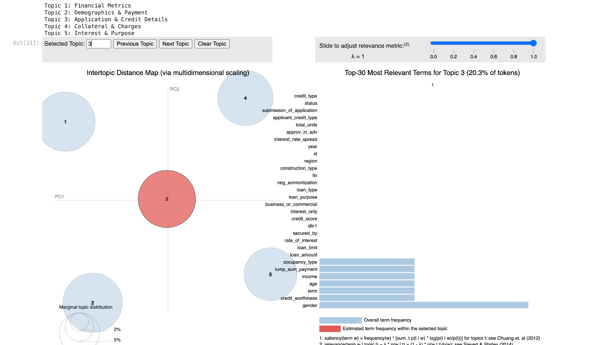

**Fig 73** - Topic modeling for Loan_Default Dataset

* **Circles Represent Topics**: Each circle symbolizes a topic, with its size indicating the topic's prevalence in the dataset.
* **Distance Between Circles:** Closer circles imply greater topic similarity, calculated from term distributions.
* **Hover Over a Circle:** Hovering over a topic reveals its key representative terms. Red bars show term frequency in the topic, blue bars display overall corpus frequency.
* **Lambda Slider:** Adjusting λ balances term ranking by topic probability (λ=1) or lift (λ=0), enhancing relevance.
* **Projection:** Commonly PCA or t-SNE, it simplifies high-dimensional topic-term data into a 2D plot for clarity.
* **Selection:** Clicking a topic rearranges term bars based on the chosen topic, highlighting its relevance.
* **Topic Proportion:** A bar chart on the left shows topic proportions in the entire corpus[[4](https://jmlr.org/papers/volume3/blei03a/blei03a.pdf)].

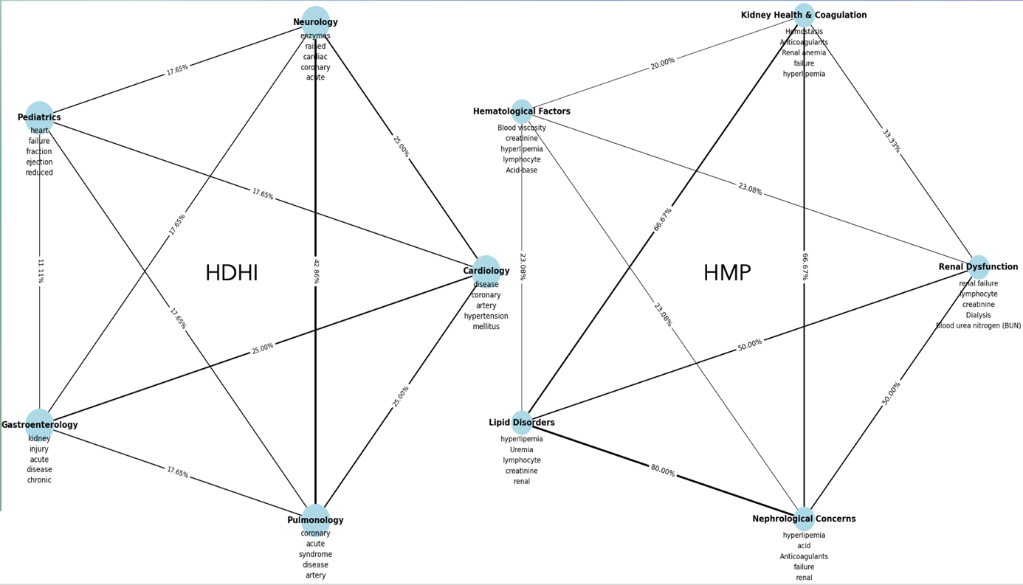

**Fig 74** - Key Topics and Shared Words Percentages for Healthcare Datasets

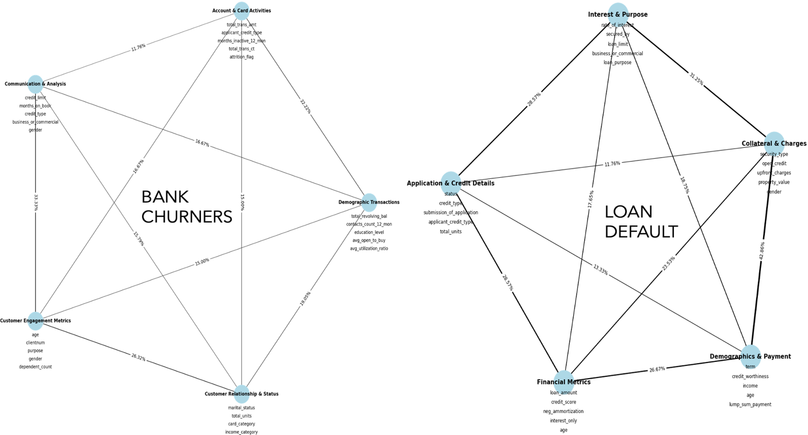

**Fig 75** - Key Topics and Shared Words Percentages for Finance Datasets

### Model Training for UMAP

Before starting UMAP modeling, other dimensionality reduction algorithms were also considered. We did a comparison of three algorithms and concluded that UMAP covers all the dimensions better.

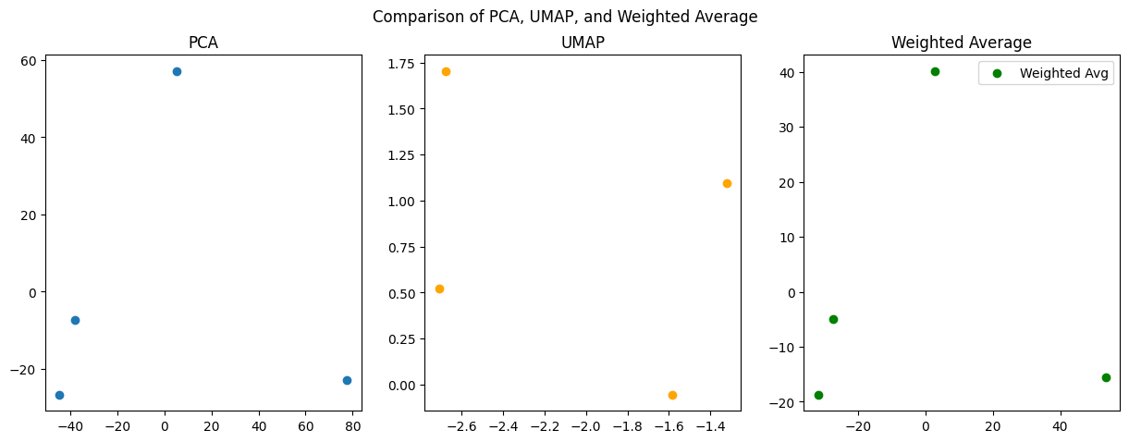

**Fig 76** Comparison of PCA, UMAP & Weighted Avg

We employed the UMAP (Uniform Manifold Approximation and Projection) algorithm to create a low-dimensional representation of our dataset and subsequently find a fitness score that quantified the quality of the projection. Here's a detailed account of how we conducted the model training and fitness score assessment:

**1. Data Preprocessing:**

* Data Collection: We initiated the process by collecting a dataset that was relevant to our project's objectives. This dataset contained various features, including numerical, categorical, and text data.
* Data Preprocessing: To prepare the data for UMAP, we conducted thorough preprocessing, including handling missing values, encoding categorical features (one-hot encoding or label encoding), standardizing or scaling numerical features, and text processing (e.g., tokenization and vectorization).

**2. Feature Selection and Transformation:**

* Feature Engineering: In some instances, we engaged in feature engineering to create new features or transform existing ones. This step was crucial for enhancing the quality and relevance of the data used for UMAP.

**3. UMAP Model Training:**

* UMAP Configuration: We configured the UMAP model by selecting the number of dimensions in the low-dimensional space and other hyperparameters such as n_neighbors, min_dist, and metric. These hyperparameters were adjusted to tailor the UMAP projection to our dataset's characteristics.
* Model Training: We then trained the UMAP model using our preprocessed and transformed data. The UMAP algorithm performed dimensionality reduction while maintaining the topological relationships between data points.
* Embedding Generation: The UMAP model generated an embedding, which was a low-dimensional representation of the original data. This embedding preserved the essential structure and patterns present in the data.

**4. Fitness Score Calculation:**

* Fitness Metric Definition: To assess the quality of the UMAP projection, we defined a fitness score or fitness metric that captured the desired characteristics or objectives of our project. This fitness metric could vary depending on the project's goals and might encompass aspects like data separability, clustering quality, or visualization effectiveness.
* Fitness Score Calculation: We computed the fitness score by quantifying how well the UMAP projection aligned with our project's objectives. This calculation was tailored to our specific goals and often involved domain-specific considerations.

**5. Result Analysis:**

* Visualization and Interpretation: We visualized the UMAP projection to gain insights into the data's structure and relationships in the reduced-dimensional space. Visualization aided in understanding how data points were distributed and clustered.
* Fitness Score Assessment: We used the calculated fitness score to evaluate the quality of the UMAP projection. The fitness score served as a quantitative measure of how well the UMAP model achieved our project's objectives.

**6. Hyperparameter Tuning and Optimization:**

* Hyperparameter Adjustment: We iteratively refined the UMAP model by experimenting with different hyperparameter configurations. This process allowed us to optimize the UMAP projection to improve the fitness score.

**7. Comparative Analysis:**

* Comparison with Other Techniques: In some cases, we compared the UMAP results with those of alternative dimensionality reduction techniques like t-SNE or PCA to gain a comprehensive perspective on the quality of the UMAP projection.

**8. Iterative Refinement:**

* Model Refinement: We acknowledged that achieving the desired fitness score could be an iterative process. We made adjustments to the model, hyperparameters, and data as needed to enhance the UMAP projection's quality.

By following this approach to UMAP model training and fitness score assessment, we were able to create an effective low-dimensional representation of our data while quantitatively evaluating its quality in alignment with our project's objectives. This process allowed us to make informed decisions and gain insights from the reduced-dimensional data.

**UMAP Visualization:**

UMAP has gained popularity for its effectiveness in a wide range of applications, including visualizing complex datasets, identifying clusters in high-dimensional data, and exploring the structure of data. It is often used in combination with other machine learning and data analysis techniques to gain insights from complex datasets.

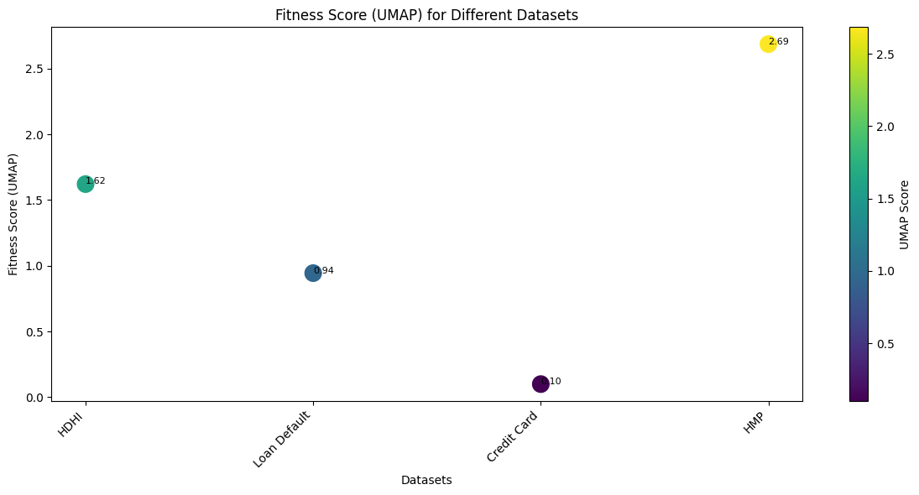

**Fig 77** – Viz showing Fitness Score using UMAP

### Model Evaluation

**Evaluating UMAP using KMeans:**

Evaluating the effectiveness of using Uniform Manifold Approximation and Projection (UMAP) for dimensionality reduction before applying K-Means clustering involves several steps, both qualitative and quantitative. Below is a detailed explanation of this process:

1. **Data Preparation and Preprocessing**

Before applying UMAP, it is crucial to preprocess the data. This can include scaling and normalizing the features so that they contribute equally to the analysis, handling missing values, and possibly encoding categorical variables if they are part of the dataset.

**2. Applying UMAP**

Once the data is preprocessed, UMAP is applied to reduce the dimensionality. UMAP has several hyperparameters that need to be tuned correctly:

* **n_neighbors**: Controls how UMAP balances local versus global structure in the data. It determines the size of the local neighborhood UMAP will look at when attempting to learn the manifold structure of the data.
* **min_dist**: The minimum distance between points in the low-dimensional representation. Smaller values will result in tighter clusters.
* **n_components**: The number of dimensions to project down to.
* **metric**: The metric used to measure distance in high-dimensional space.

The settings for these hyperparameters greatly affect the resulting lower-dimensional embedding and, consequently, the clustering results.

1. **K-Means Clustering**

K-Means is then applied to the low-dimensional data generated by UMAP. The choice of the number of clusters **K** can be informed by domain knowledge, or by using techniques like the Elbow Method or the Silhouette Score on the high-dimensional data before dimensionality reduction.

1. **Evaluating Clustering Performance**

After clustering, you evaluate the results to determine how well the clusters represent the data. Several metrics can be used:

* **Silhouette Score**: Provides a measure of how similar an object is to its own cluster (cohesion) compared to other clusters (separation). Values range from -1 to 1, with higher values indicating better-defined clusters.
* **Calinski-Harabasz Index**: Also known as the Variance Ratio Criterion, it measures the ratio of the sum of between-clusters dispersion to within-cluster dispersion. Higher scores are better and indicate that the clusters are dense and well separated.
* **Davies-Bouldin Index**: The average 'similarity' between clusters, where similarity is a measure that compares the distance between clusters with the size of the clusters themselves. Lower values indicate better clustering.

1. **Qualitative Analysis**

Beyond numerical metrics, it's essential to visually inspect the results:

* **UMAP Scatter Plot**: After UMAP reduction, a scatter plot of the data points labeled by their assigned cluster can give a visual cue of the clustering quality.
* **Cluster Profiles**: For each cluster, profile the centroids or the statistically significant features that characterize each cluster. This analysis can provide deeper insights into the meaning of each cluster in the context of your specific domain.

1. **Comparative Analysis**

For a comprehensive evaluation, you may compare the results of K-Means on the UMAP-reduced data with the results on the original high-dimensional data or other dimensionality reduction techniques like PCA or t-SNE:

* **Clustering Metrics Comparison**: Compare the silhouette score and other metrics across different approaches.
* **Cluster Stability**: Evaluate the stability of clusters by running the clustering multiple times or using a portion of your data for bootstrap samples.
* **Execution Time**: Dimensionality reduction can speed up the clustering process; thus, measuring the execution time is important for large datasets.

1. **Reporting and Interpretation**

Finally, you should report the findings in a way that is understandable and actionable:

* **Detailed Results**: Include all metric scores and visualizations to support the clustering quality.
* **Domain Relevance**: Relate the clustering outcomes to domain-specific questions or hypotheses.
* **Limitations**: Discuss any limitations in your evaluation, such as potential biases in the metrics or the interpretability of clusters.

**8. UMAP Evaluation by K-Means**

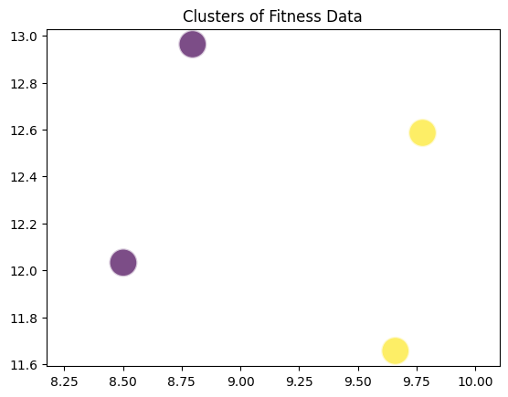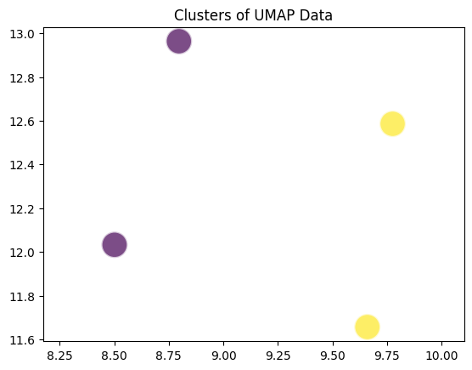

**Fig 78** – UMAP Evaluation by K-Means

By following these steps, you can systematically evaluate the impact of UMAP on the performance of K-Means clustering. The goal is to demonstrate that UMAP improves the clustering results by revealing the intrinsic structure of the data, thereby leading to more meaningful and distinct clusters that can be used for further analysis or to inform decision-making processes.

# Findings

**WIREFRAME**

Wireframes are fundamental visual blueprints in early design, outlining the structure and layout of a digital interface. Emphasizing functionality, they facilitate collaborative planning before detailed design stages, aiding efficient communication.

We employed wireframes solely to showcase our work. Acting as visual blueprints, these representations highlighted key aspects of our design during the initial phases. Emphasizing content placement, functionality, and user experience, the wireframes served as a collective tool for efficient communication within our group. By excluding intricate design elements, we used them to collaboratively understand and adjust the foundational structure of our digital product before advancing to detailed design stages.

**SCREEN 1**

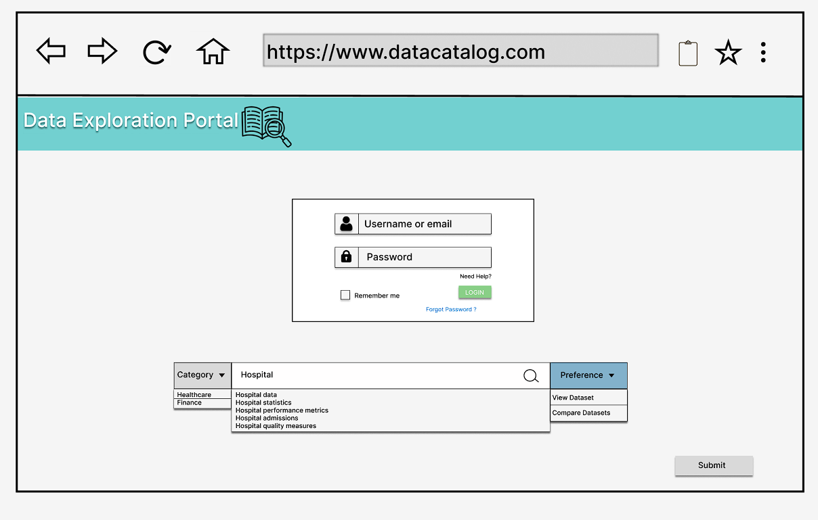

**Fig 79** – Screen 1 of UI

The user initiates the onboarding process on the data exploration portal by registering through their Gmail account. Upon successful registration, they proceed to sign in, directing them to Screen 1. Here, they encounter a categorical interface featuring two domain options: Healthcare and Finance. A search bar is prominently displayed, allowing the user to input keywords; for instance, they might type "HOSPITAL DATA" for specific data exploration. Additionally, the user is presented with a preferences section offering two choices: View Dataset and Compare Datasets. [2]

Having carefully selected "Healthcare" as the domain, typed "HOSPITAL DATA '' in the search bar, and opted for "View Dataset" in preferences, the user submits their choices. This action seamlessly progresses them to Screen 2. This subsequent screen presumably provides a tailored view of healthcare-related datasets, aligning with the user's specific preferences. The layout and functionalities at Screen 2 remain to be explored by the user, who is now positioned to engage with and analyze datasets relevant to their specific interests in the healthcare domain. This user-centric journey reflects the portal's intuitive design, guiding users through an efficient and personalized data exploration experience.

**SCREEN 2**

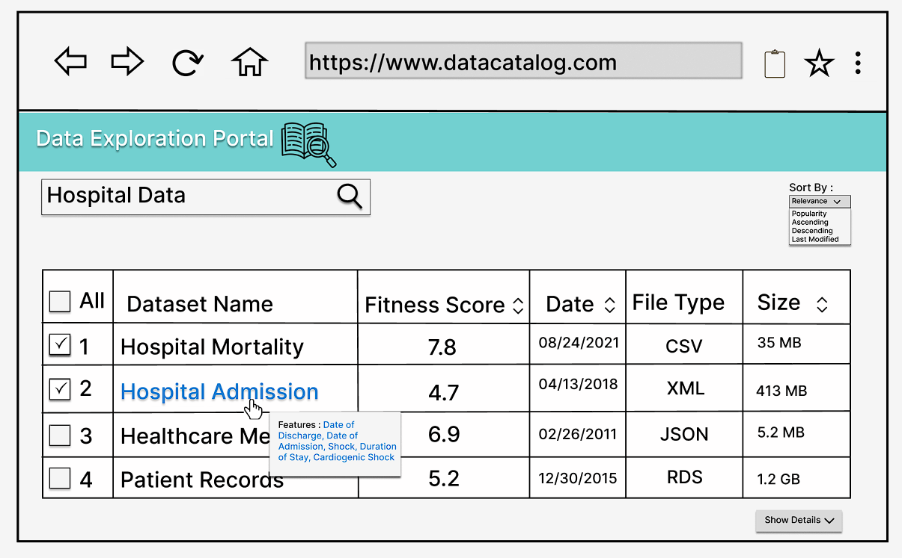

**Fig 80** – Screen 2 of UI

Upon initiating a search for "HOSPITAL DATA," the user is presented with relevant results on Screen 2. These results include crucial details such as Dataset Name, Fitness Score, Date, File Type, and Size. Additionally, the user is empowered with the ability to organize and refine the displayed datasets. Screen 2 offers sorting options, allowing the user to arrange datasets based on Relevance, Popularity, Ascending order, Descending order, or Last Modified.

In the scenario where the user opts for the "Compare Datasets" feature on Screen 1, they are directed to Screen 2, where they can select multiple datasets for comparison. Upon making these selections, the user proceeds to Screen 3. Here, a comparative analysis of the chosen datasets is facilitated, providing a comprehensive view of their distinct attributes.

Conversely, if the user chooses the "View Dataset" option on Screen 1, Screen 2 enables them to select a single dataset of interest. Subsequently, the user is redirected to Screen 4. On this screen, a detailed and focused exploration of the chosen dataset unfolds, allowing the user to delve into the specifics and intricacies of the selected data. This user-oriented design approach ensures flexibility, catering to diverse user needs and preferences in navigating and extracting insights from the data exploration portal.

**SCREEN 3**

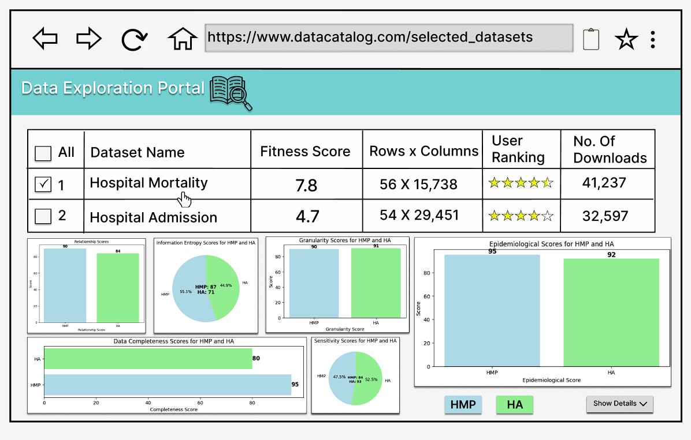

**Fig 81** – Screen 3 of UI

In the progression of user interactions within the data exploration portal, the transition from Screen 2 to Screen 3 signifies a dedicated space for comparative dataset analysis. Screen 3 is meticulously crafted to provide users with crucial information for a comprehensive evaluation of datasets. Key metrics such as Rows x Columns, User Rating, and Number of Downloads are prominently featured, offering users a concise overview of structural dimensions, popularity, and user feedback.

The comparative analysis on Screen 3 is complemented by visual aids in the form of domain-specific graphs, contingent on the user's selected domain. For instance, in the context of a user searching for "HOSPITAL DATA" and opting to compare Hospital Mortality and Hospital Admission datasets, the graphs on Screen 3 illuminate the comparative scores of essential parameters like Relationship, Information Entropy, Granularity, Data Completeness, Sensitivity, and Epidemiological factors.

It is noteworthy that the content displayed on Screen 3 dynamically adapts to the user's chosen domain. In the case of hospital data exploration, the presented graphs and metrics are tailored to healthcare-specific parameters, ensuring precision and relevance in the comparative results.

Screen 3 thus serves as a pivotal hub for users engaged in in-depth dataset comparison, delivering both quantitative metrics and visual representations aligned with the user's domain of interest. This approach underscores the data exploration portal's commitment to providing a nuanced and domain-specific user experience, showcasing adaptability to diverse user needs in the exploration and analysis of datasets.

**SCREEN 4**

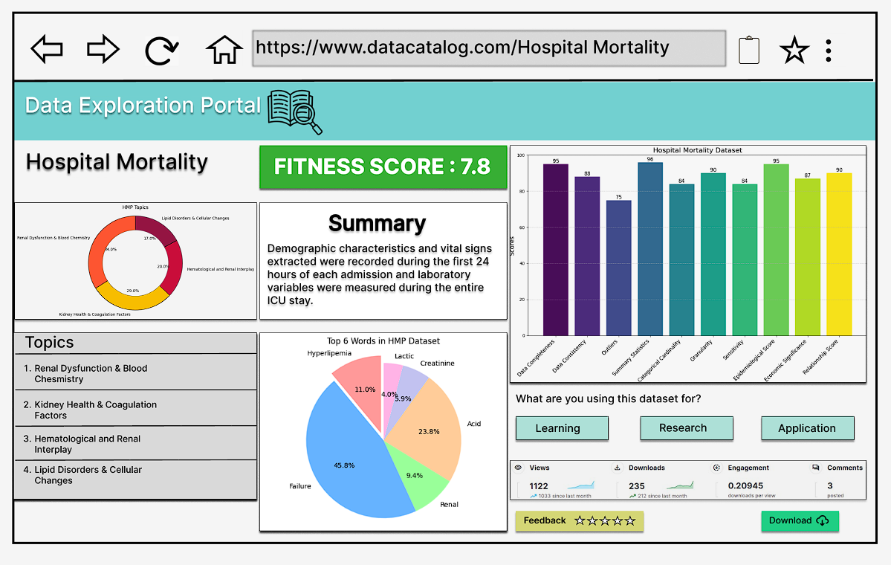

**Fig 82** – Screen 4 of UI

In the user journey through the data exploration portal, upon selecting a specific dataset from the comparative results displayed on Screen 3, individuals are seamlessly directed to Screen 4 for a detailed exploration. As an illustrative example, let's consider the user's choice of the "Hospital Mortality" dataset. Screen 4 is meticulously designed to provide an exhaustive examination of the selected dataset, offering a comprehensive set of information to enrich the user's understanding.

On Screen 4, users encounter a wealth of details, including the dataset's Fitness Score, a succinct textual summary, and scores for both general and domain-specific parameters. These parameters collectively contribute to an evaluation of the dataset's overall quality and relevance within the chosen domain, facilitating a holistic comprehension for users.

Additionally, Screen 4 presents further insights, unveiling the top six words and the top four topics covered within the dataset. These particulars provide users with a nuanced understanding of the dataset's content and thematic focus, aiding them in making informed decisions about its suitability for their specific requirements.

At the bottom left corner of Screen 4, an interactive feature enables users to provide feedback on the dataset. This collaborative aspect allows users to share their perspectives on the dataset's utility and quality. Notably, users can specify the intended purpose for utilizing the dataset, contributing valuable insights that enhance the overall user experience and inform dataset recommendations on the platform.

In summary, Screen 4 serves as a pivotal and interactive space within the data exploration portal, enabling users to gain in-depth insights into their selected dataset and actively participate in the platform's community by providing purpose-specific feedback. This user-centric design approach ensures informed decision-making and cultivates a collaborative environment for dataset exploration.

# Summary

Our study tackled the pressing challenge of enhancing the value and usability of data catalogs by embedding data fitness qualities. Recognizing the difficulty in sourcing reliable datasets due to inadequate quality indicators, we developed a methodology that integrates fitness parameters to streamline the process of dataset selection. Our research spanned datasets from two critical domains: healthcare and finance, each encompassing data related to approximately 10,000 entities.

We advanced the concept of 'data fitness' by instituting a thorough evaluation mechanism that incorporated both general and domain-specific parameters. These criteria, ranging from relevance to historical significance, provided a nuanced understanding of a dataset’s applicability and alignment with specific research objectives.

Our innovative approach utilized UMAP for dimensionality reduction, which, in conjunction with the computation of a fitness score, afforded a quantitative measure of a dataset's suitability. To enrich the data catalog further, we extracted three thumbnail features that encapsulate the essence of the datasets. This included:

1. A dataset summary created using the Text Rank algorithm, which encapsulates the core content of the datasets, providing a quick reference point for potential users.
2. An overview of dataset topics, identified through LDA (Latent Dirichlet Allocation), offering insights into the thematic structure and focus areas within the data.
3. Key descriptors based on the highest information gain, pinpointing the most significant elements that define the dataset.

These features serve as critical navigational tools, transforming raw data into actionable insights. Our model has proven instrumental in enabling users to efficiently evaluate datasets against a myriad of dimensions such as topic summaries, fitness scores, structural attributes (rows and columns), size, and file format. This comprehensive assessment tool ensures users can make informed decisions, aptly determining the congruence of a dataset with their specific research needs and objectives.

The implications of our study are significant, promising to elevate the standards of data catalogs, and by extension, the quality of research and analysis across domains where data-driven decision-making is paramount.

# Future Work

As we continue to develop and refine our system, the following key areas will be prioritized for future work:

**1. Performance Optimization and Scalability:** To ensure our system remains responsive and reliable, we will focus on optimizing its performance. This involves implementing advanced data processing techniques and enhancing our infrastructure to efficiently manage larger datasets and increased user load.

**2. Advanced Machine Learning Integration:** We will incorporate cutting-edge machine learning technologies, including sophisticated natural language processing (NLP) algorithms. This will improve our system's capability to process and analyze text-based datasets, making it more effective across various domains.

**3. Benchmarking and Validation:** Regular benchmarking against external datasets and standards will be conducted to validate our system's performance and accuracy. This will ensure that our scoring model remains robust and trustworthy.

**4. Research and Development Focus:** We plan to engage in extensive research to explore innovative AI methodologies. A detailed timeline will be established for the development, testing, and implementation of these new methods.

**5. Collaboration Initiatives:** Strategic partnerships with academic and industry leaders will be pursued. These collaborations will provide access to additional expertise, resources, and perspectives, significantly benefiting our development process.

**6. User Experience Enhancements:** We are committed to improving the user interface and experience. Efforts will be directed towards making our system more intuitive and user-friendly, catering to the evolving needs of our users.

**7. Data Privacy and Security Improvements:** As we scale, paramount importance will be placed on enhancing data privacy and security measures. This will involve implementing advanced security protocols and ensuring compliance with data protection regulations.

**8. Continuous Learning Mechanisms:** Our system will be designed to continuously learn and adapt, using feedback and performance data to refine its algorithms and functionalities.

**9. Environmental Impact Consideration:** We recognize the importance of sustainability. Efforts will be made to assess and minimize the environmental impact of our system, promoting eco-friendly practices in our operations.

**10. Regulatory Compliance:** We will ensure strict adherence to industry-specific regulations and standards, particularly in sensitive sectors like healthcare and finance.

Through these initiatives, we aim to not only enhance our system's capabilities but also ensure its relevance and effectiveness in the rapidly evolving landscape of machine learning and AI.

# Appendix

## Appendix A: Glossary

|  |  |
| --- | --- |
| Term | Definition |
| LDA | Latent Dirichlet Allocation (LDA) is a popular topic modeling technique to extract topics from a given corpus |
| UMAP | Uniform Manifold Approximation and Projection (UMAP) for dimensionality reduction |
| NLP | Natural Language Processing |
| K-Means | K-Means is then applied to the low-dimensional data generated by UMAP. The choice of the number of clusters **K** can be informed by domain knowledge, or by using techniques like the Elbow Method or the Silhouette Score on the high-dimensional data before dimensionality reduction. |
| PCA | Principal Component Analysis (PCA) is one of the most commonly used unsupervised machine learning algorithms |
| t-SNE | t-SNE (t-distributed Stochastic Neighbor Embedding) |
| IQR | Interquartile Range (IQR) to define lower and upper bounds for identifying outliers |

Table 1: Glossary Table

## Appendix B: GitHub Repository

Overview

The core objective of our project was to address prevalent issues within data catalogs, encompassing challenges related to feature comprehension, insights generation, awareness enhancement, and analytical scope. These are crucial elements missing in existing data catalogs, prompting us to devise a solution that elevates catalog functionality. In our endeavor, we introduced several key features to enhance the catalog's utility. Among these, the incorporation of Common Data Fitness stands as a pivotal tool to assess the data quality matrix comprehensively. Additionally, the integration of Domain-Specific Fitness serves to ascertain the relevance score, crucial in contextualizing data significance. Moreover, the inclusion of a thumbnail feature significantly enhances user understanding by providing a concise visual representation of the respective data catalog.

By synergizing both Common Data Fitness and Domain-Specific Fitness, we formulated an overarching fitness score for the data catalog, a metric crucial for users to gauge the overall data quality. Leveraging the TextRank algorithm, we adeptly distilled comprehensive summaries from the data catalogs, empowering users with condensed yet informative insights. Furthermore, our utilization of LDA Topic Modeling proved instrumental in identifying key topics within the catalogs—essentially pinpointing the pivotal columns that encapsulate vital information.

In our pursuit to empower users with tools for efficient data comprehension, we devised a systematic approach to identify key variables within datasets. Parameters such as information content, consistency, correlation, and variability were meticulously employed to discern the variables harboring the most significant data. This comprehensive approach ensures that users can discern and prioritize variables that contribute substantially to the dataset, thereby streamlining the analytical process and enhancing the utility of the data catalog.

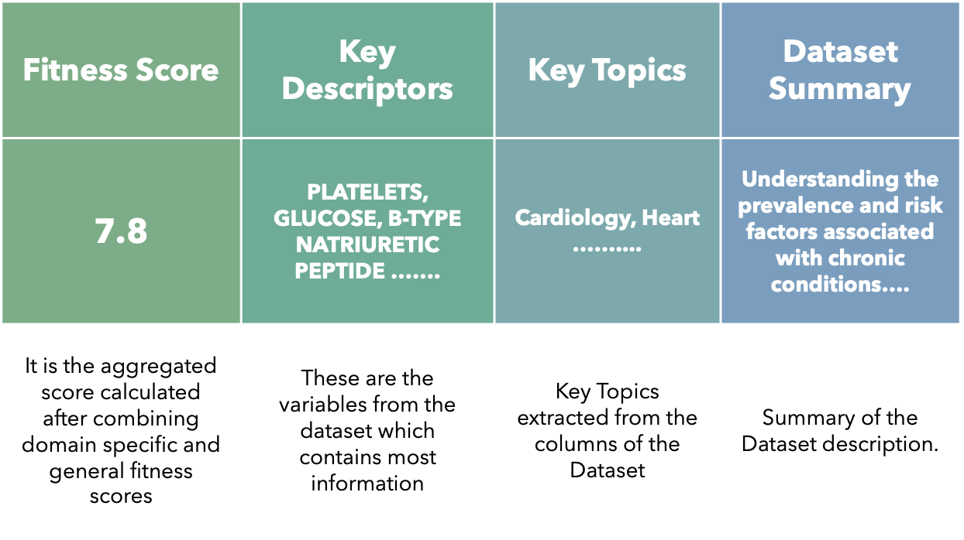

GitHub Repository Link

<https://github.com/Sohanbommidi/Fitness-Fusion>

GitHub Repository Contents

The GitHub repository contains the description and python files for data cleaning, data collection, data quality assessment, data relevance assessment, topic modeling and the final report and presentation slides.

## Appendix C: Risks

Sprint 1 Risks

|  |  |  |  |  |
| --- | --- | --- | --- | --- |
| Risk | Description | Probability | Impact | Mitigation |
| Data Quality | Poor quality data may lead to inaccurate results and analysis. | Moderate | High | Implement data quality checks and validation processes. Regularly audit and clean the data. Establish clear data quality standards and guidelines. |
| Restricted Dataset Access | Limiting datasets from the finance and health domains may restrict access to critical data, affecting the project's completeness and effectiveness. | Moderate | High | Establish a thorough data access policy that outlines clear guidelines for handling sensitive data. Implement role-based access controls to ensure that only authorized personnel can access restricted datasets. Collaborate with legal and compliance teams to ensure adherence to data privacy regulations. Consider anonymization or pseudonymization techniques to balance data privacy with project needs. Regularly review and update access permissions based on project requirements and regulatory changes. |

Table 2: Sprint 1 Risks

Sprint 2 Risks

|  |  |  |  |  |
| --- | --- | --- | --- | --- |
| Risk | Description | Probability | Impact | Mitigation |
| Data Privacy and Security | Inadequate protection of sensitive data may lead to breaches or unauthorized access. | Moderate | High | Implement robust security measures. Encrypt sensitive data. Ensure compliance with data protection regulations. Regularly conduct security audits. |

Table 3: Sprint 2 Risks

Sprint 3 Risks

|  |  |  |  |  |
| --- | --- | --- | --- | --- |
| Risk | Description | Probability | Impact | Mitigation |
| Algorithm Suitability | The choice of TextRank and LDA for extracting thumbnail features may not be suitable for the specific characteristics of the data in the catalog, leading to suboptimal results. | Moderate | Moderate | Conduct a thorough analysis of the data characteristics, structure, and content. Evaluate alternative algorithms and models to ensure that TextRank and LDA are appropriate for the given context. Run pilot tests to assess the performance of the selected algorithms on a small subset of the data before full-scale implementation. Regularly monitor the effectiveness of the chosen algorithms and be prepared to adapt based on ongoing evaluations. |
| Interpretability | The interpretability of results from TextRank and LDA may pose challenges, making it difficult to explain how the thumbnail features are generated, potentially impacting trust and understanding. | Low | Moderate | Provide clear documentation on the methodologies behind TextRank and LDA, explaining how they generate thumbnail features. Develop visualization tools or techniques to illustrate the relationship between input data and extracted features. Conduct user training sessions to enhance understanding of the algorithms and their outcomes. Encourage regular communication between data scientists and stakeholders to address questions and concerns related to interpretability. |

Table 4: Sprint 3 Risks

Sprint 4 Risks

|  |  |  |  |  |
| --- | --- | --- | --- | --- |
| Risk | Description | Probability | Impact | Mitigation |
| Algorithm Complexity | UMAP, being a sophisticated algorithm, may introduce challenges in terms of implementation complexity and understanding. | Moderate | Moderate | Ensure that the team has a good understanding of UMAP's principles and parameters. Provide training and resources to enhance team members' proficiency in working with UMAP. Collaborate with experts in dimensionality reduction to address any implementation challenges. Document the process thoroughly for future reference and knowledge transfer. |
| Sensitivity to Parameters | UMAP's performance may be sensitive to parameter tuning, and suboptimal choices may result in unexpected outcomes. | Moderate | High | Conduct extensive parameter tuning and sensitivity analysis during the model development phase. Utilize cross-validation techniques to identify optimal parameter configurations. Regularly review and update parameter choices based on ongoing performance evaluations. Document the rationale behind parameter selections for transparency and future adjustments. |

Table 5: Sprint 4 Risks

Sprint 5 Risks

|  |  |  |  |  |
| --- | --- | --- | --- | --- |
| Risk | Description | Probability | Impact | Mitigation |
| Data Incompatibility | Datasets from various sources may have different formats, structures, or quality standards, leading to challenges in integration. | Moderate | High | Standardize data formats and quality across sources. Conduct thorough data profiling and preprocessing to identify and address inconsistencies. Develop data integration processes that accommodate diverse data formats. |
| Model Overfitting | The machine learning models used for data fitness distributions may overfit to the training data, resulting in poor generalization to new datasets. | Moderate | High | Regularly validate and cross-validate models on diverse datasets. Implement techniques such as regularization to prevent overfitting. Use a robust testing environment that simulates real-world conditions. |

Table 6: Sprint 5 Risks

## Appendix D: Agile Development

Scrum Methodology

Sprint 1

08/21/23 - 09/11/23

Sprint 2

09/12/23 - 10/01/23

Sprint 3

10/02/23 - 10/23/23

Sprint 4

10/24/23 -11/13/23

Sprint 5

11/14/23 - 11/27/23

Figure 3: Sprint project datesScrum methodology has worked quite well for our team in terms of collaboration, flexibility, and iterative progress towards the final goal. In the initial stages of the project, we discussed and assigned roles among ourselves as the Product Owner, Scrum Master, and the Developers. We have a sprint planning meeting and then work on the tasks during the sprint. We meet twice/thrice a week to exchange status updates, reviewing the work done and identifying any issues. At the end of each week, we have a presentation, where we find areas of improvement based on the Professor's feedback. With YouTrack as the assigned project management tool, we were able to work together, track tasks and issues, and manage workflows. Since it is customizable, we could create our own workflows, issue types, and custom fields to fit our needs and processes. It has collaborative features with which we could add comments, mentions and notifications. We like that it integrates with GitHub, since we are creating a GitHub repository for the project. With YouTrack's dashboards and reports, it is quicker to gain insights based on progress and performance.

Sprint 1 Analysis

In Sprint 1, we learned about the data catalog. A problem statement and solution space were developed after conducting background research. We also set the project objectives, developing primary user stories and the product vision. We have had meetings twice or thrice a week. Tasks were assigned among the group members and were delivered before the deadlines.

Sprint 2 Analysis

This Sprint is crucial among all the Sprints as this is where we find our reliable datasets and most of the data selection and activities like data preprocessing took place. A schematic diagram is created that outlines the data sources, formats, and data preprocessing stages. Datasets have had their data quality assessments done, and working on the hyperparameters and topic modeling, domain classification, metadata extraction and text rank algorithm have all been evaluated.

Sprint 3 Analysis

Sprint 3 was full of ideas and thoughts. We came up with general data fitness where we have calculated the data quality score and the domain specific fitness where we have calculated the relevance score to find the overall fitness score for both healthcare and finance datasets. And we have also used a text rank algorithm for thumbnail extraction which is used for Summarizing a dataset that is incorporated in the catalog to provide an overview of the data description, Latent Dirichlet Algorithm is used as these would be better models for discovering the topics.

Sprint 4 Analysis

In Sprint 4, we worked on creating visualizations, training the machine learning models, then evaluating and validating them. We also refined our abstract by taking into consideration the changes we made as we progressed in each sprint.

Sprint 5 Analysis

In Sprint 5, we put together our findings, summary of the entire process and identified areas for future work. And also, we have worked on the final project presentation and final project report. It was a busy sprint with preparing ourselves for the showcase rehearsals.

# Reference

**Works Cited**

|  |  |
| --- | --- |
|  | 1. "Lorem ipsum - Generator, Origins and Meaning," Wasai - Brand Studio, 2023. [Online]. Available: https://loremipsum.io/. [Accessed 22 May 2023]. |
|  | 1. Wikipedia contributors, "Lorem ipsum," 18 May 2023. [Online]. Available: https://en.wikipedia.org/wiki/Lorem_ipsum. [Accessed 22 May 2023]. 2. Gensim: Topic modeling for humans. Radim Å˜ehÅ¯Å™ek: Machine learning consulting. (2022, December 21). https://radimrehurek.com/gensim/ 3. Latent dirichlet allocation - Journal of Machine Learning Research. (n.d.). https://jmlr.org/papers/volume3/blei03a/blei03a.pdf 4. https://www.aises.org/sites/default/files/documents/National%20Conference/Abstract%20Guidelines%20and%20Samples.pdf 5. *Data Integration*. Precisely. (n.d.). https://www.precisely.com/glossary/data-integration 6. *IDC Analyst Perspective: Controlling Data in the Future of Operations*. (2023, May 15). Database Trends and Applications. https://www.dbta.com/DBTA-Downloads/WhitePapers/IDC-Analyst-Perspective-Controlling-Data-in-the-Future-of-Operations-12753.aspx 7. *CAPM Calculator for Stock Analysis | MyCalcu*. (n.d.). Mycalcu.com. Retrieved November 13, 2023, from https://mycalcu.com/blog/capm-calculator-for-stock-analysis 8. Szlifka, S. (2023, May 23). *Behavioral Marketing strategies*. Trust Index. https://www.trustindex.io/behavioral-marketing-strategies/ 9. *Struggling with Bad Data? What to Do From the Enterprise*. (2016, June 28). StreamSets. https://streamsets.com/blog/bad-data-what-to-do/ 10. CoreyS. (2021, March 24). *Natural Language Processing: How It Works (In Plain English!)*. Dataiku Community. https://community.dataiku.com/t5/General-Discussion/Natural-Language-Processing-How-It-Works-In-Plain-English/td-p/15176 11. Team, A. P. (n.d.). *How Different Industries Develop & Use Data Products*. Www.acceldata.io. Retrieved November 13, 2023, from https://www.acceldata.io/blog/data-products-are-changing-the-dynamics-of-all-industries 12. Daytwo. (n.d.). *Ledidi | Z-scores*. Ledidi.com. Retrieved November 13, 2023, from https://ledidi.com/academy/z-scores 13. *Is Per-oral Endoscopic Myotomy (POEM) More Effective than Pneumatic Dilation and Heller myotomy? A Systematic Review and Meta-Analysis - A SAGES Publication*. (n.d.). SAGES. Retrieved November 13, 2023, from https://www.sages.org/publications/guidelines/is-per-oral-endoscopic-myotomy-poem-more-effective-than-pneumatic-dilation-and-heller-myotomy-a-systematic-review-and-meta-analysis/ 14. *The Full Guide to Embeddings in Machine Learning*. (n.d.). Encord.com. Retrieved November 13, 2023, from https://encord.com/blog/embeddings-machine-learning/ 15. *Normalization Definition | Encord*. (n.d.). Encord.com. Retrieved November 13, 2023, from https://encord.com/glossary/normalization-definition/ 16. *Basic UMAP Parameters — umap 0.3 documentation*. (n.d.). Umap.scikit-Tda.org. Retrieved November 13, 2023, from https://umap.scikit-tda.org/parameters.html 17. León, C. (2019). *Detecting anomalous payments networks: A dimensionality reduction approach*. https://doi.org/10.32468/be.1098 18. Wachen, J. (2018, May 1). *Media coverage of educational testing: Understanding issue dimensions using topic modeling*. Carolina Digital Repository. https://doi.org/10.17615/v2e2-dy94 19. Lu-Tao Zhao & Li-Na Liu & Zi-Jie Wang & Ling-Yun He. (1970, January 1). *Forecasting oil price volatility in the era of big data: A Text Mining for VaR Approach.* Sustainability. https://ideas.repec.org/a/gam/jsusta/v11y2019i14p3892-d249220.html |